Name…………………………………… …………………………..………… Index No:………………………….

233/1 Candidate’s Signature …………..……………
CHEMISTRY Date: …………………………
PAPER 1
THEORY
JULY/AUGUST 2014
TIME: 2 HOURS

Kenya Certificate of Secondary Education (K.C.S.E.)
233/1
Chemistry
Paper 1
2 Hours

INSTRUCTIONS TO CANDIDATES

- Write your name and indexnumber in the spaces provided above
- Sign and write the date of examination in the spaces provided.
- Answer all the questions in the spaces provided.
- Mathematical table and silent electronic calculators may be used.
- All working must be clearly shown where necessary.

FOR EXAMINERS USE ONLY
Question | Maximum score | Candidate’s score
1-28 | 80

This paper consists of 11printed pages. Candidates should check to ascertain that all pages are printed as indicated and that no questions are missing.
- The diagram below shows a Bunsen burner
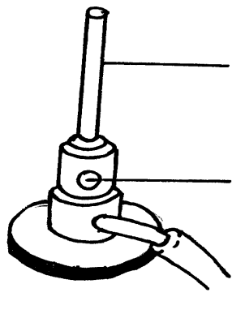
A

B

Name the parts lebelled A and B ( 2mks)
A………………………………………………………………………………..
B………………………………………………………………………………….
- The table below gives information about elements P, Q, R, and T.
Element | ATOMIC NUMBE | Ratomic radius(nm) | Ionic raidus (mn)
P  Q  R  T | 3  5  13  17 | 0.134  0.090  0.143  0.099 | 0.074  0.012  0.050  0.181

- In which period of the periodic table is element Q? Give a reason (2mks)
………………………………………………………………………………………………………..
………………………………………………………………………………………………………..
- Explain why the atomic radius of P is greater than that of Q (1mk)
………………………………………………………………………………………………………..
………………………………………………………………………………………………………..
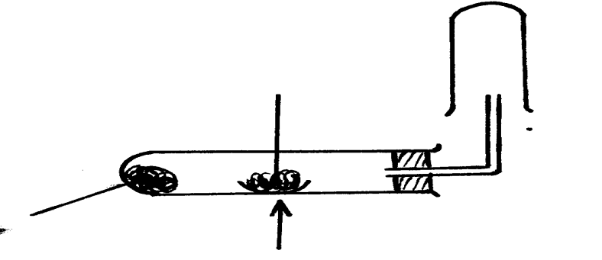
- When magnesium is reacted in steam it reacts rapidly forming awhite solid and hydrogen gas
Heat
Magnesium ribbon

Glass soaked in water

- Why is hydrogen collected as shown above? ( 1mk)
………………………………………………………………………………………………………

- How would you show that the gas collected is hydrogen? ( 1mk)
……………………………………………………………………………………………………
- When copper turning were used instead of magnesium in above reaction, hydrogen gas was not produced .explain (1mk)
………………………………………………………………………………………………………
- Solutions can be classified as acid, baser or neutral. The table below shows solutions and their PH values.
Solution | pH values
K  L  M | 1.5  7.0  14.0

- Select any four pair that would react to form a solution of pH 7 (1mk)
………………………………………………………………………………………………
- Identify two solutions that would react with Aluminium hydroxide. Explain ( 2mks)
………………………………………………………………………………………………………
………………………………………………………………………………………………………
- A certain carbonate, BCO₃, reacts with dilute hydrochloric acid according tot the equation given below.
BCO_{3 (s)} + 2HCl _{(aq)} BCl_{2(aq)} + CO _{2(g}) + H₂O _{(l)}
If 1g of the carbonate reacts completely with 200cm3 of 1m hydrochloric acid, calculate the
relative atomic mass of B ( C= 12.0, O = 16.0) (3mks)
………………………………………………………………………………………………………
………………………………………………………………………………………………………
………………………………………………………………………………………………………
………………………………………………………………………………………………………
- Name the process which takes place when:
(a) Gaseous carbon (IV) oxide changes directly into solid carbon(iv) Oxide ( dry ice) (1mk)
………………………………………………………………………………………………………
(b) Blue litmus paper turns white when dropped into chlorine water. (1mk)
………………………………………………………………………………………………………
- Ethene gas molecules are converted into a giant molecule. (1mk)
………………………………………………………………………………………………………
- Sulphuric acid is manufactured in large scale by the contact process. The basic reaction in the contact process is catalytic oxidation of sulphuric (IV) oxide.
(a) Name the catalytst used. (1mk)
………………………………………………………………………………………………………

- State one large scale use of sulphuric (VI) acid (1mk)
………………………………………………………………………………………………………
- Study the diagram below and answer the questions t hat follow:
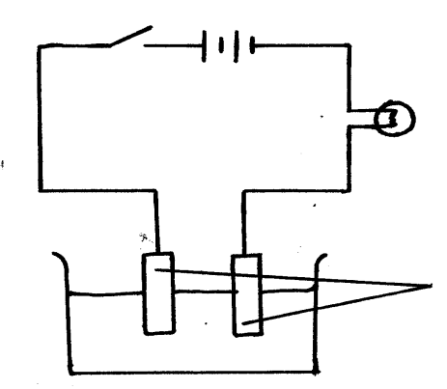
S

Zinc electodes

- Write equations for the reactions that occur when the switch S is closed for 30 minutes at; (2mks)
Anode:……………………………………….
Cathode ……………………………………….
- Comment on the concentration of the electrolyte after 30 minutes (1mk)
………………………………………………………………………………………………………
- Draw a chart- cross diagram to whose bonding in Cl2O (atomic numbers) ( Cl = 17, O = 8) (2mks)
………………………………………………………………………………………………………
………………………………………………………………………………………………………
………………………………………………………………………………………………………
………………………………………………………………………………………………………
………………………………………………………………………………………………………
………………………………………………………………………………………………………
………………………………………………………………………………………………………

- Archeologists can determine the age of organic matter by measuring the proportion of carbon – 14 present in a sample. Assuming that carbon- 14 has a half life of 5600 years, calculate the age of a piece of wood found to contain 1/8 as much carbon – 14 as in a living material. (3mks)
………………………………………………………………………………………………………
………………………………………………………………………………………………………
………………………………………………………………………………………………………
………………………………………………………………………………………………………

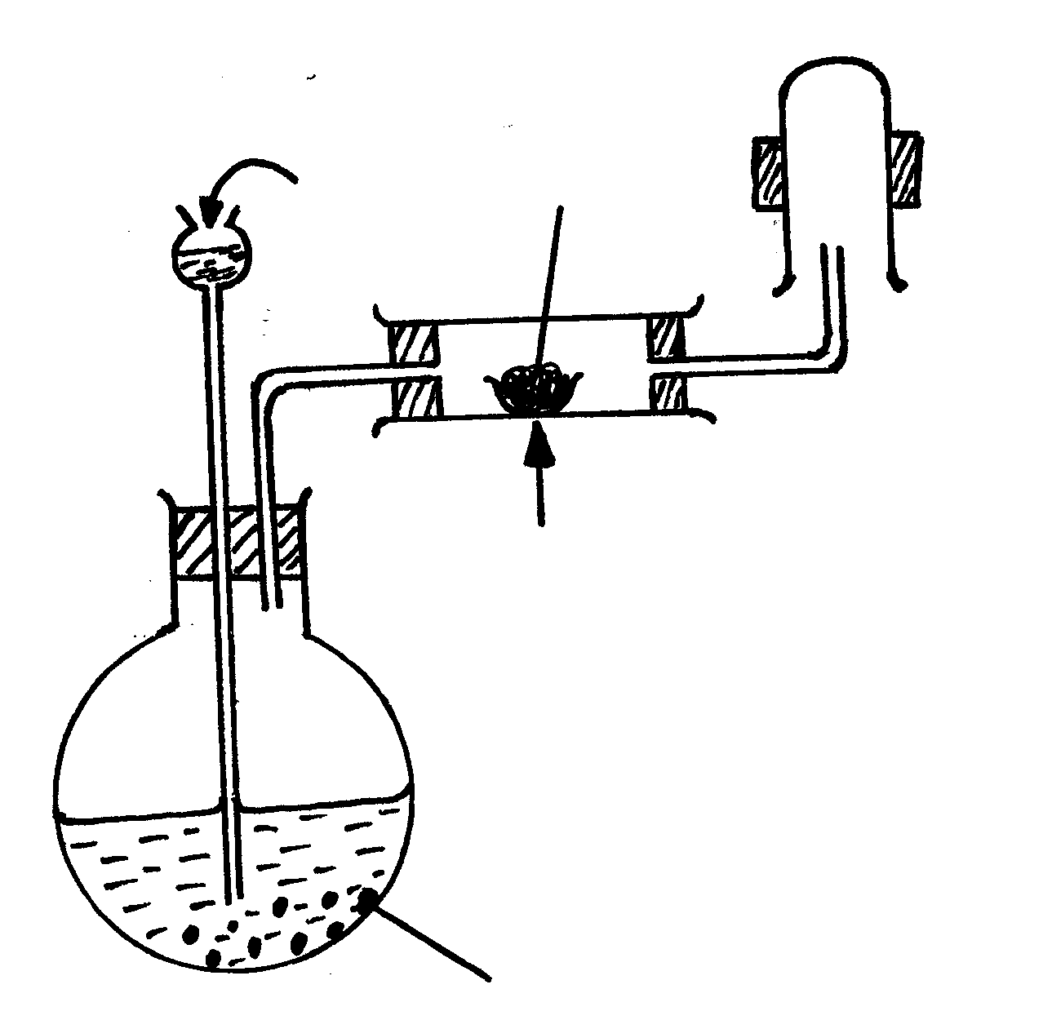
- The set up below was used to prepare a certain gas X
Concentrated sulphuric(VI) acid
Iron wool

Heat

Sodium chloride solid

- Name the gas X (1mk)
………………………………………………………………………………………………………
- Name the product formed in the combustion tube and write an equation for tis formation (2mks)
………………………………………………………………………………………………………
………………………………………………………………………………………………………
- Given the following Half cells;
Pb²⁺ _{(aq)} /Pb_{(s)} E^{θ} = - 0.13 V
Cu ²⁺ _{(aq)} /Cu_{(s)} E^{θ} = + 0.34V
- Write the ionic equation for half cell that undergoes;
(i) Oxidation……………………………………………………………………. (1mk)
(ii) Reduction:……………………………………………………………………. (1mk)
- Calculate the e.m.f for the resulting electrochemical cell. (1mk)
………………………………………………………………………………………………………
- Bromine and krypton are put on opposite sides of a dry tube and allowed to diffuse under same conditions.
- Find the relative rate of diffusion for the gases Krypton and Bromine
( Br= 79.9, Kr = 83.8) (2mks)
………………………………………………………………………………………………………
………………………………………………………………………………………………………
- If bromine gas moves 10cm in the dry tube what distance will Krypton move? (1mk)
………………………………………………………………………………………………………

- Given below are molar enthalpies of combustion of propane, hydrogen and carbon.
C₃H_{8(g)} + 5 O_{2 (g)} 3 Co_{2(g)} + 4H₂O_{(l)} ; ΔH = - 2220.6 kJ
H_{2(g)} + ½ O_{2(g)} H₂O _{(g)} ΔH = - 285.9 kJ
C_{(s)} + O_{2(g}) CO_{2(g)} ΔH = - 393.5 kJ
Use the above information to calculate the molar enthalpy of formation of propane. (3mks)
………………………………………………………………………………………………………
………………………………………………………………………………………………………
………………………………………………………………………………………………………
- The set up below was used to prepare nitric acid.
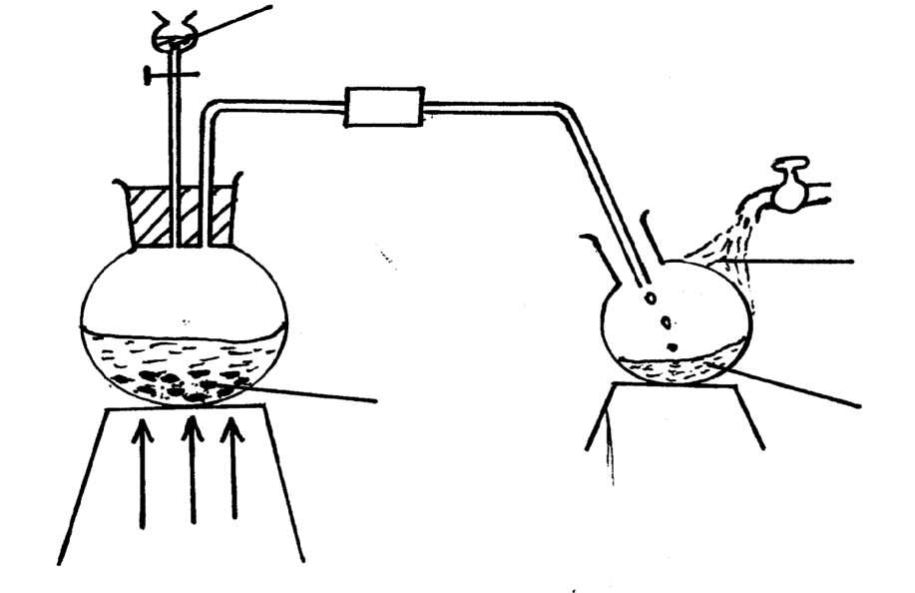

Heat
Liquid T
Nitric acid
Cold water

Sodium
nitrate

- Give the name of liquid T (1mk)
………………………………………………………………………………………………………
- Write the equation for the reaction which took place in the reaction flask ( 1mk)
………………………………………………………………………………………………………
- Explain why nitric acid is stored in dark bottles (1mk)

………………………………………………………………………………………………………
- In Migori county Magazine a journalist wrote “ On abusy road the proportion of carbon (ii) oxide has varied from 6 parts million to 180 parts per million”
(a) Explain why the proportion of carbon (II) oxide varies as above (1mk)
………………………………………………………………………………………………………
- Explain why carbon (II) oxide considered to be asilent killer ( 2mks)
……………………………………………………………………………………………………… ………………………………………………………………………………………………………

- The structure of a detergent is:
H H H H H H H
| | | | | | |
H C C C C C C C COO⁻ Na⁺
| | | | | | |
H H H H H H H

- Write the molecules formula of the detergent. (1mk)
………………………………………………………………………………………………………
- What type of detergent is represented by the formula? (1mk)
………………………………………………………………………………………………………
- Starting with aluminium sulphate describe how a solid sample of aluminium hydroxide could be prepared. (3mks)
………………………………………………………………………………………………………
………………………………………………………………………………………………………
………………………………………………………………………………………………………
- The table below shows the results obtained when soap solution was added to different sample of equal volumes of calcium hydroxide solution treated with different amounts of Carbon (IV) oxide.

sample | solution | volume of soap added to sample to lather
C  D | 50cm³ of calcium hydroxide + excess x carbon (IV) oxide  50cm³ of calcium hydroxide + little carbon (IV) oxide | 10cm³  2cm³

Explain the difference in the volume of soap required to form lather in different samples of calcium hydroxide C and D. (3mks)
………………………………………………………………………………………………………
………………………………………………………………………………………………………
- Element A has atomic mass 23 and element B atomic mass 7 and also have 12 neutrons and 14 neutrons respectively.
(a) Write the electron arrangement of A and B (1mk)
A……………………………………………………………………………
B…………………………………………………………………………….
(b) Which element has higher ionization energy? Explain (2mks)
………………………………………………………………………………………………………
………………………………………………………………………………………………………

- A mixture of heptane, boiling 98ºC and 2,2-dimethyl pentane of boiling point 80ºC was separated by fractional distillation. The graph below shows the temperature of vapour intensity entering the condenser over a period of time.
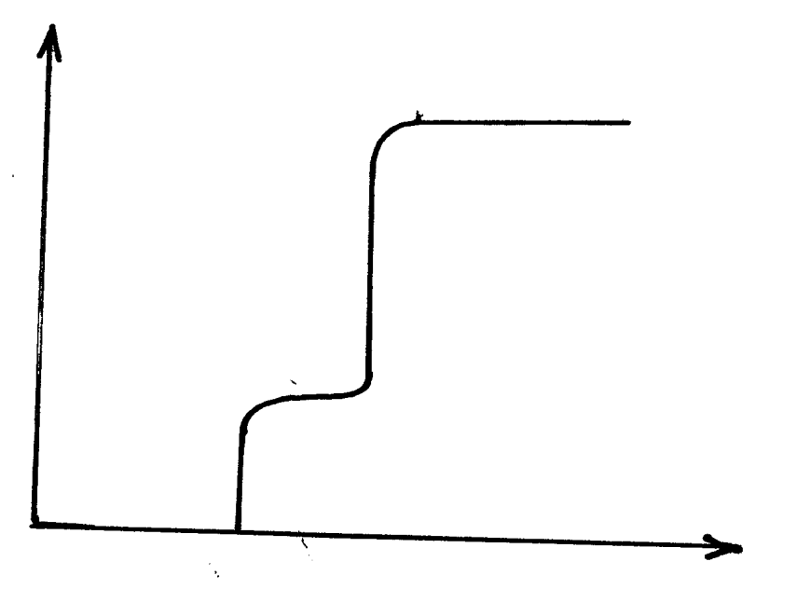

Temp ºC
A
B
C
D

Time

At what region of the graph does 2,2-dimethly pentane start to distil over. Explain. (2mks)
………………………………………………………………………………………………………
………………………………………………………………………………………………………
- Iron reacts with steam according to the equation given below;
3 Fe_{(s)} + 4 H₂O_{(g)}$⇌$ Fe₃ O_{4 (s)} + 4 H₂O_{(g)}
- Explain the effect of decreasing pressure on the position of equilibrium (2mks)
……………………………………………………………………………………………………………………………………………………………………………………………………
- What is the effect of adding more hydrogen gas to the equilibrium mixture? (1mk)
…………………………………………………………………………………………………
…………………………………………………………………………………………………
- (a) Define the term electrolyte. (1mk)
…………………………………………………………………………………………………
…………………………………………………………………………………………………
- Mercury is a good conductor but it is not an electrolyte. Explain (2mks)
…………………………………………………………………………………………………
…………………………………………………………………………………………………

- Curves R and Q shown below were obtained when equal masses of magnesium metal were reacted separately with two different aqueous acids of the same concentrations.
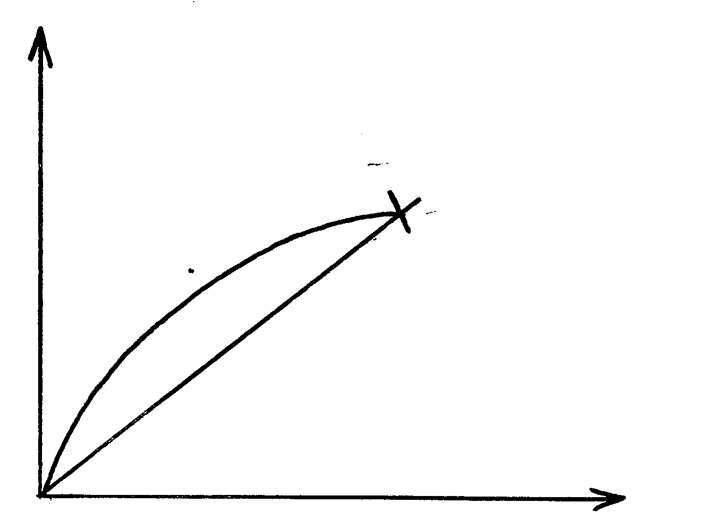

Q
Volume of H_{2(g)}

R
Z
Time (s)

- Explain which curve corresponds to ;
(i) 1.0M propionic acid……………………………………………… (1mk)
(ii) 1.0m Hydrochloric acid…………………………………………… (1mk)
- What is the significancne of point z ? (1mk)
…………………………………………………………………………………………………
…………………………………………………………………………………………………
- State the oxidation number of chlorine in:
(i) ClO₃ (1mk)
…………………………………………………………………………………………………
(ii) HClO (1mk)
…………………………………………………………………………………………………
- The melting point of aliminium oxide is 2054oC but the electrolysis is carried out at between 800oC – 900oC
(a) what is done to lower the temperature? (1mk)
(b) A typical electrolysis cell uses a current of 40,000 Amperes,calculate the mass in Kg of aluminium produced in one hour. ( IF = 96500C) (Al= 27) (2mks)
…………………………………………………………………………………………………
…………………………………………………………………………………………………
…………………………………………………………………………………………………

- The graph below shows the solubility of salts A and B
Solubility 9 g/100g of water)
40

30

20

10
A

| | | | | | | | |
0 10 20 30 40 50 60 70 80 90
Temp(ºC)
B

- Which of the salts is more soluble in water at below 90ºC? Explain (1mk)
…………………………………………………………………………………………………
…………………………………………………………………………………………………
- State and explain what happens when 100g of solutioncontaining 20g of salt A and 20g of salt B is cooled from 90ºC to 20ºC (2mks)
…………………………………………………………………………………………………
…………………………………………………………………………………………………
- The following tests were carried out on three separate portions of a colourless solution S.
Tests | Observations
- Addition of dilute hydrochloric acid to the first portion of solution S  - Addition of aqueous sodium carbonate to the second portion of solution S  - Addition of aqueous ammonia to the third portion of solution S | No observable change  A white precipitate was formed  A white precipitate was formed which dissolved on addition of excess aqueous ammonia.

- From the information in test (i), name a cation which is not present in solution S (1mk)
…………………………………………………………………………………………………
- Write a cation, which is likely to be present in solution S (1mk)
…………………………………………………………………………………………………
- Write an ionic equation for the reaction, which takes place in tests (iii) (1mk)
…………………………………………………………………………………………………

