312/1
GEOGRAPHY
PAPER 1
JULY/AUGUST - 2014
TIME: 2 3/4 HOURS

Kenya Certificate of Secondary Education (K.C.S.E.)
312/1
Geography
Paper 1
2 ¾ Hours

INSTRUCTIONS TO CANDIDATES

- This contains two sections A and B.
- Answer all questions in section A, In section B questions 6 and two other question.
- All answers must be written on booklet provided.

This paper consists of 4 printed pages. Candidates should check to ascertain that all pages are printed as indicated and that no questions are missing.

SECTION A

- (a) Give three ways in which air pressure affected humidity. (3mks)
(b)State two factors that determined the amount of solar radiation reaching the earth (2mks)

2. (a) Study the world map below and answer the questions that follow .
(i)Name the fold mountain found in the area marked A,B and C (3mks)
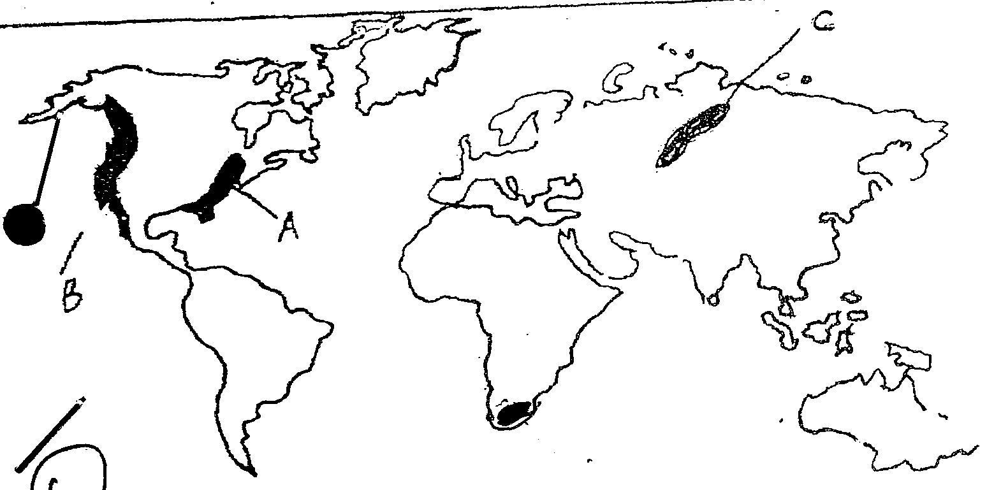

(b) Give two negative effects of faulting (2mks)

3. (a) Name three transitional zones of the atmosphere. (3mks)
(b) Give three reasons why cloudy concentration is higher in the troposphere (3mks)

4. (a) What is mass wasting ? (2mks)
(b) State three factors influencing the nature and speed of mass wasting , (3mks)

5. (a) Name two currents in the Atlantic ocean. (2mks)
(b) State three factors that influencing ocean water temperature . (3mks)

SECTION B
Answer question 6 and any other two questions from this section
6. Study the map of KARATINA 1:50 000(sheet$\frac{121}{3}$)provided and answer the following questions.
- (i)Give the latitude and longitude of the south east convert of the map extract (2mks).
(ii)Convert the scale of the map into a statement scale. (2mks)
(iii) Indentify two physical features found at Grid reference 0049. (2mks)
- (i)Using a scale of 1cm rep 40meters ,draw across- section along Easting so enclosed by northing 82and 89 .(convert feet into meters)
(ii) Nark the indivisibility line and confirm whether the two points are indivisible (1mk)
- (i) Citing evidence from the map state five factors that favour livestock keeping in karatina (5mks)
(ii) Describe the characteristics of the long –river profile of Rive Sagana. (6mks)

7. (a) (i) What is a mineral ? (2mks)
(ii) Rocks can be classified according to mode of formation .Give the class to which each one
of the following rocks belong.
- Marble
- Basalt
- Ironstone
(b) (i) Explain how intrusive Igneous rocks are formed (5 mks)
(ii)Describe why coral rocks are widespread at the coast
(c ) State four uses of soda ash (4mks)
(d) Students from kadika girls intend to carry out field study on rocks within the school’s vicinity .
(i) Give four reasons why they should prepare objectives four their field study. (4mks)
(ii) List any four instruments they would require and show how they are likely to use them. (4mks)
8. The diagram below shows some surface feature s in a karst region .Use it to answer question (a) .
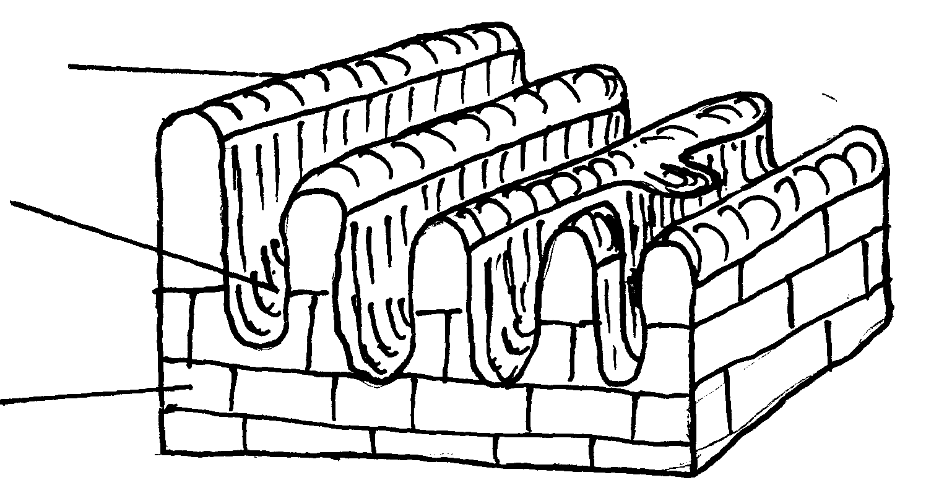
R

Q
P

a) Name the features marked P,Q and R (3mks)
b) Outline three factors that influence the development of Karst scenery (3mks)
c) Using suitable diagrams , describe how the following features which are found in limestone areas are found :
(i) A swallow hole (5mks)
(ii) A doline (5mks)
d) Explain three ways in which limestone landscapes influence human activities (6mks)
e) Form four student s of your school undertook field work on a karst landscape .
i) State two objectives of their study (2mks)
ii) Give one reason why they needed to previsit the area . (1mks).
9 . a) (i) Outline two factors that influence the development of damage pattern (2mks)
(ii) Give three features of a river in its old stage (3mks)
b) Briefly describe how the following factors influencing river erosion
(i)Gradient and velocity (2mks)
(ii)Nature and amount of the load (2mks)
(iii) Nature of the deed rock (2mks)
c) The diagram below represents a depresitional features of a river .Study it and answer the questions
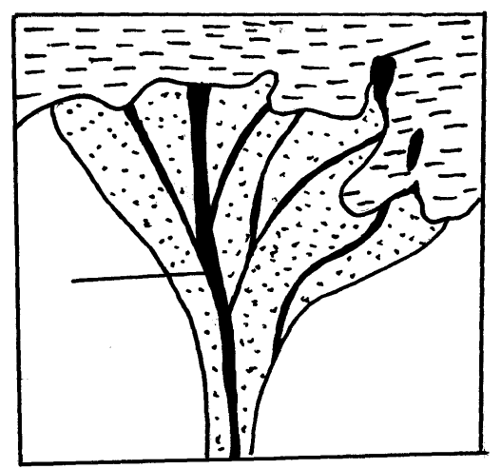
that below .
Sea

Land
F

i)Name the parts labeled E F and G bin the diagram (3mks)
ii) Give the example of the feature represented in the diagram in Kenya (1mk)
iii) State three conditions necessary for the formation of the features shown in the diagram (3mks)
d) A part from providing water for domestic and industrial uses ,highlight three other benefits of rivers in Kenya (3mks)
e) Your class intends to conduct afield study on rivers deposition around your school
(i) Name one stage along the profile of a river where your study conducted (1mks)
(ii) State two methods you would like to collect data during the study . (2mks)
(iii)Give one benefit of river deposition that you intend to verify during the study (1mk)

10. (a) (i) What is a glacier (1mk)
(ii) Apart from our Kenya name other two areas where we have permanent Snow in East Africa (2mks)
(b) The diagram below represents an upland glaciated landscape .use it to answer question b (i) and (ii)
P
N
M
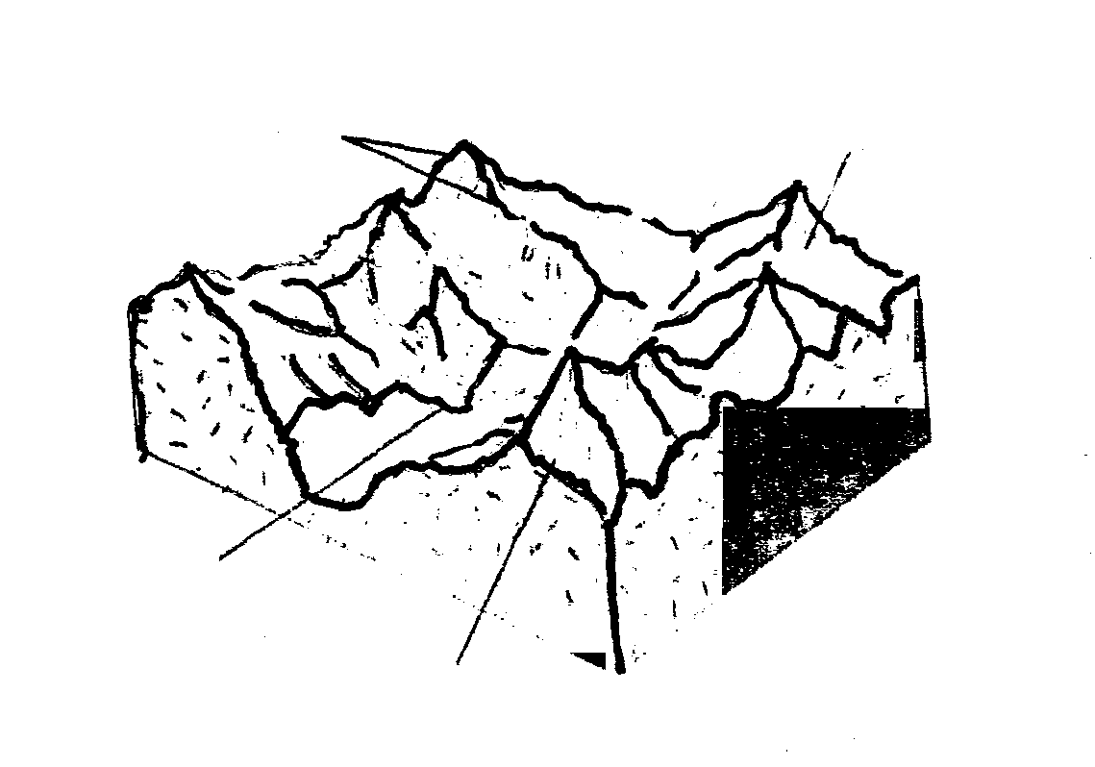

(i) Name features marked
- M (1mk)
- N (1mk)
- P (1mk)
(ii) Describe how feature Marked P is formed (5mks)
c) (i) Explain how movement of valley glacier is affected by the following featuers.
- With of glacier channel. (2mks)
- Size of glacier / thicker (2mks)
- Temperature (2mks)
(iii) Explain four positive effects of glaciations features in upland to human activities. (8mks)

