**NAME:………………………………………….ADM.NO………………………….**

**KITALA SECONDARY SCHOOL**

**CHEMISTRY FORM ONE**

**END OF TERM III EXAM 2017**

*Answer all the questions in this paper in the spaces provided.*

1.The graph below is a cooling curve of a substance from gaseous state to solid state.

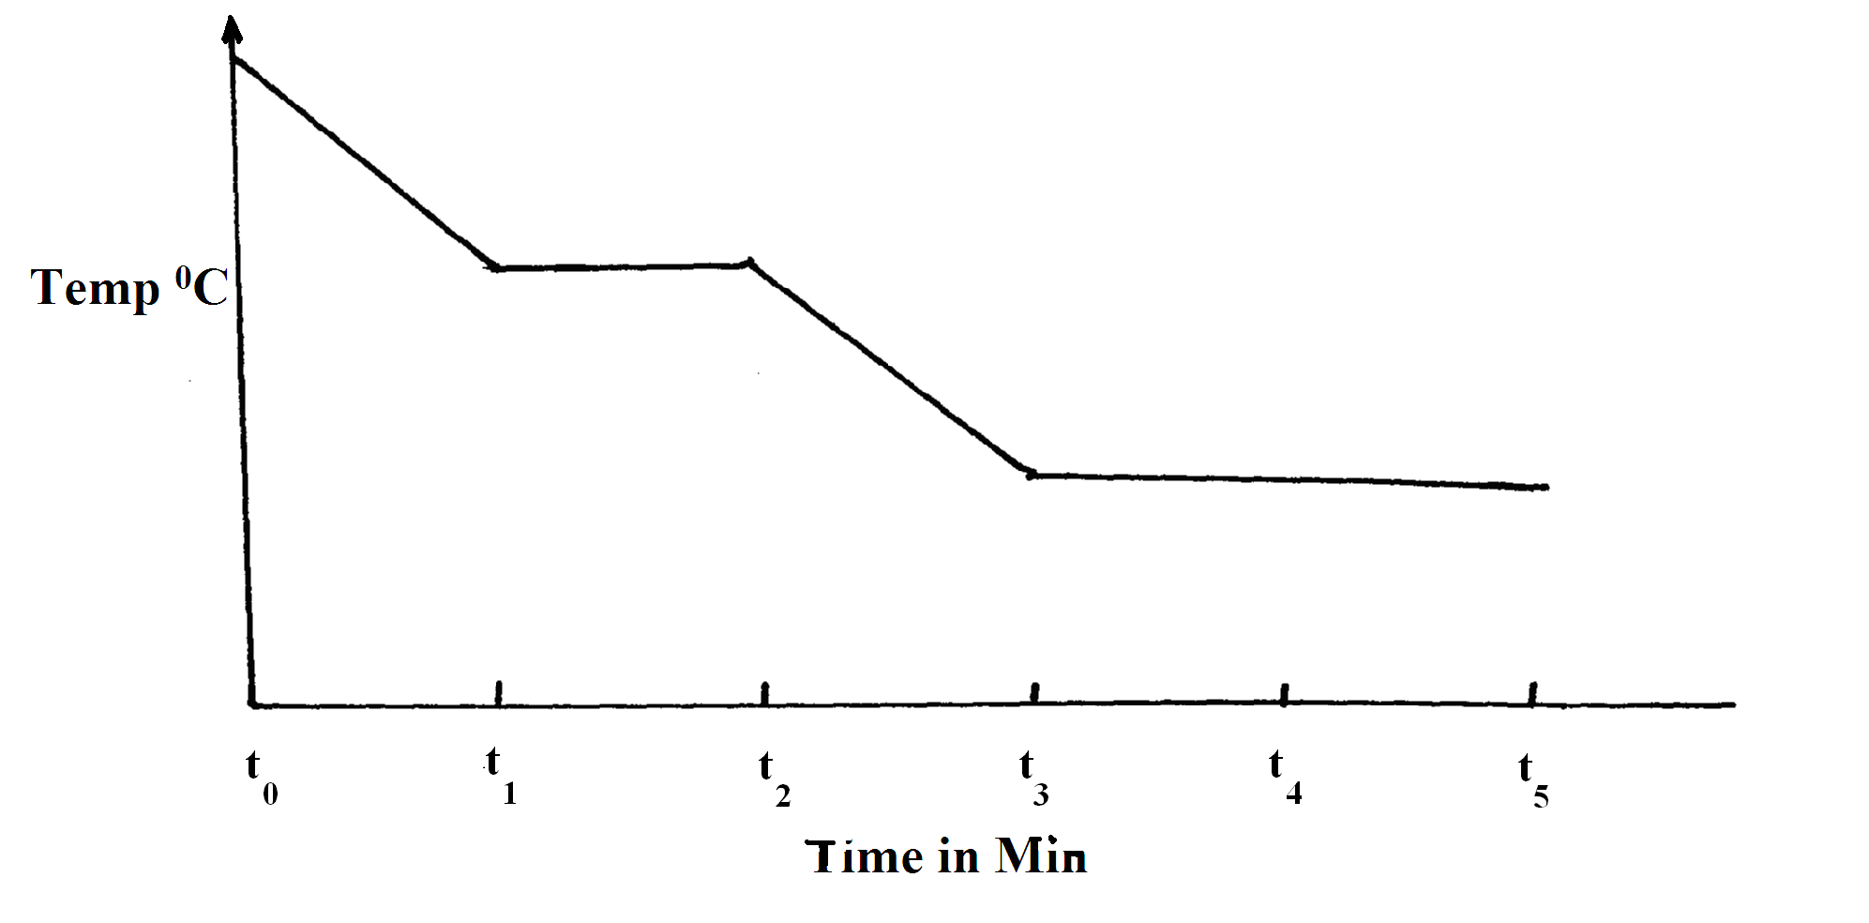

Name:

(a) The process taking place between t0 and t1. (1mk)

……………………………………………………………………………………………

(b) The energy change that occurs between t3 and t5. (1mk)

……………………………………………………………………………………………

2.The set up below was used to prepare a sample of oxygen gas . Study it and answer the questions that follow.

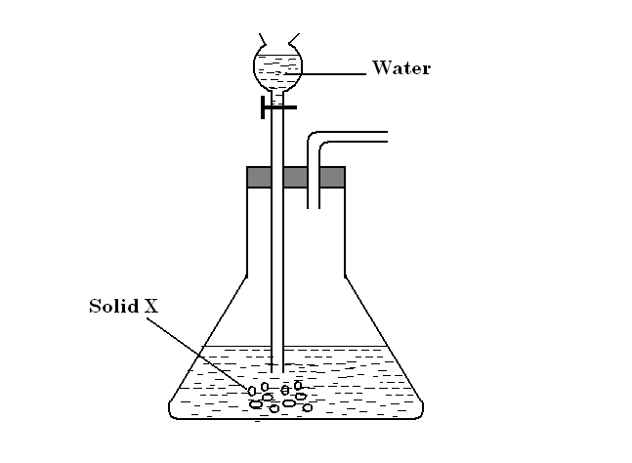

1. Complete the diagram to show how oxygen is collected. (2mks)
2. Identify solid X (1mk)
3. Write equation to the reaction between solid X and water. (2mks)

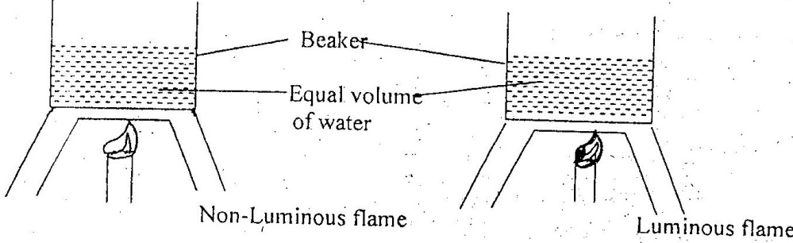3. The diagram below shows an experiment to compare the heating effects of luminous and non-luminous flame.

a) .State and explain the observation made at the bottom of each beaker at the end of the experiment. (3mks)

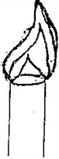b.) The diagram below represents a luminous flame.

On the diagram, mark and label the hottest and coolest parts of the flame.(2mks)

c) .When not in use, it is advisable to put off a non-luminous flame or turn it to a luminous flame. Explain. (2mks)

4. a) Name any two water pollutants (2mks)

b) Describe the chemical test for water (2mks)

5. a) State role of the following parts during fractional distillation of a mixture of water and ethanol.

(i) Fractionating column (2mks)

(ii) Glass beads in the fractionating column (1mk)

b) State any two applications of fractional distillation process. (2mks)

6. The set-up below was used by a form one student to determine the percentage of active air. Study it and answer the questions that follow.

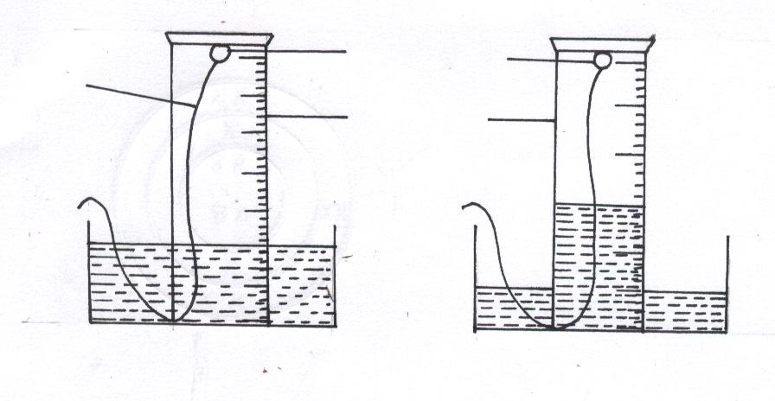

White phosphorous

Measuring cylinder

Wire

Beginning of the Expt

End of Expt

a) What is observed when white phosphorus is exposed to air? (2mks)

b) Calculate the percentage volume of air used up in the above experiment

(4mks)

c) How is phosphorus stored in the laboratory (1mk)

7. Study the arrangement below and answer the question that follow.

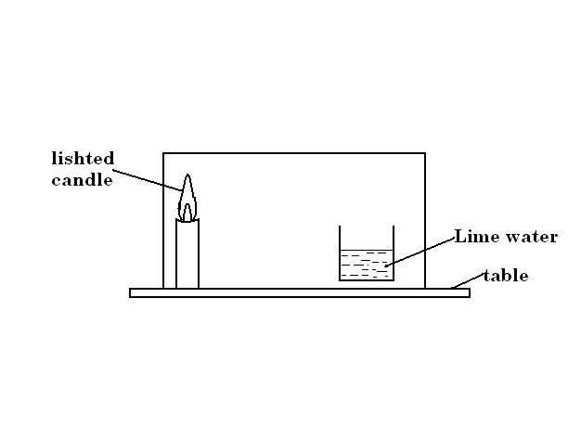

Explain what will be observed after sometime. (3mks)

8. When magnesium is burnt in air, it react with both nitrogen and oxygen. Write the formulae of the two products formed (2mks).

9. The pH values of some solutions are given below.

Substance pH

P 9.0

Q 2.2

R 13.5

S 4.8

a) Which substance is likely to be?

i) Nitric (v)acid (1 mk)

ii) Toothpaste (1mk)

b) Solution R is put in a beaker. Litmus solution is added, and then substance Q is added a little at a time until no further change is noted. Outline the observations made (2mks)

10. Name the most suitable method you would use to separate the following mixtures.

a) Calcium carbonate and ammonium chloride (1mk)

b) Kerosene from crude oil (1mk)

c) Oil and water (1mk)

11. Explain how you would separate a mixture of nitrogen and oxygen gases given that their boiling points are -196oC and -183oC respectively. (3mks)

12. Consider the chromatogram below.



A piece of chromatogram paper was spotted with colour inks obtained from pens labeled A to F. The diagram above shows the spots after the chromatograph was developed.

* + - 1. Which two pens contained the same pigment? (1mk)

* + - 1. According to the chromatogram which pigments are present in the inks of the pen number F . (2mks)

* + - 1. Describe how one could get a sample of yellow pigment (3mks)

13. State three differences between luminous and non-luminous flames. (6mks)

14. Write a word equation for the reaction between magnesium with: (6mks)

i)Oxygen

ii)Chlorine

iii)Sulphuric (VI)acid

15.a) Explain why cars in the coastal city of Mombasa rust faster than cars in Kisumu.(3mks)

b)State the conditions which are necessary for rusting to occur. (2mks)

16. Explain the differences between solid, liquid and gaseous states using the theoretical model of matter in terms of the kinetic theory. (6mks)

17. Give two examples of :

i) temporary physical change (2mks)

ii) temporary chemical change ( 2mks)

iii) permanent change (2mks)

***SUCCESS***