NAME…………………………..…………………………………. DATE …………………………

ADM NO. ……….……….…………………...…..… SIGNATURE …………..…………..

233/2
CHEMISTRY
PAPER 2
(THEORY)
TIME: 2 HOURS.

MALIET FORM THREE END YEAR 2017

INSTRUCTIONS TO CANDIDATES.
- Write your name and index number in the spaces provided above.
- Sign and write the date of exam in the spaces provided above.
- Answer ALL the questions in the spaces provided.
- Mathematical tables and silent electronic calculators may be used.
- All working MUST be clearly shown where necessary.

FOR EXAMINER’S USE ONLY.

Questions | Maximum score | Candidates score
1 | 12
2 | 10
3 | 10
4 | 10
5 | 12
6 | 13
7 | 13
Total score | 80
This paper consists of 12printed pages.
Candidates should check to ensure that all pages are printed as indicated and no questions are missing

- The table below has information about elements. A,B,C,D,E,F,G,H,I and J. the letters do not represent the actual symbols of the elements. Study the table and answer the questions that follow.
Element | Ion | Electron arrangement of ion | Atomic radii | Ionic radii
A | A⁻ | 2.8.8 | 0.109 | 0.120
B | B²⁻ | 2.8 | 0.105 | 0.109
C | C²⁺ | 2.8 | 0.126 | 0.124
D | D³⁺ | 2.8 | 0.125 | 0.120
E | E⁺ | 2.8 | 0.135 | 0.132
F | F⁺ | 2 | 0.108 | 0.100
G | G³⁺ | 2.8.8 | 0.111 | 0.119
H | H⁺ | 2.8.8 | 0.167 | 0.160
I | I⁻ | 2.8 | 0.101 | 0.105
J | J²⁻ | 2.8.8 | 0.103 | 0.109
- Write the electronic configuration of elements G and F. (2marks)
………………………………………………………………………………………………………………………………………………………………………………………………………………………………………………………………………………………………………………………………………………
- Write an equation for the formation of an ion of D. (1mark)
………………………………………………………………………………………………………………………………………………………………………………………………………………….…………
- Select element that belong to alkali metals family. (1½ mark)
…………………………………………………………………………………………………………………………………………………………………………………………………………………………………………………………………………………………………………………….……………………….

- Select elements that belong to period 2. (1 ½ mark)
…………………………………………………………………………………………………………………………………………………………………………………………………………………………………………………………………………………………….………………………………………………..
- Compare atomic radii of elements in d (i) above (1mark)
……………………………………………………………………………………………………………………………………………………………………………………………………………………..………
- Explain why the atomic radius of C of greater than its ionic radius. (1mark)
………………………………………………………………………………………………………………………………………………………………………………………………………………………………
- Compare reactivity of element F and H. Explain your answer. (2marks)
……………………………………………………………………………………………………………………………………………………………………………………………………….……….……………..
- Using dot (.) and cross (x) to represent electrons in the outermost energy level draw a diagram to illustrate bonding in the compound formed between H and A. (2marks)
…………………………………………………………………………………………………………………………………………………………………………………………………………………………………………………………………………………………………………………………………………………………………………………………………………………………………………….……………….
2. a) Give one reason why air is classified as a mixture and not a compound. (1mark)
…………………………………………………………………………….…………………………..…………………………………………………………………………………..………………………………..
- An experiment was set up as shown below.
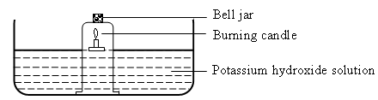
- Why did the candle go off after some time? (1mark)
……………………………………………………………………………………………………….……………………………………………………………………………………….………………………….
- Why was potassium hydroxide used and not tap water? (1mark)
………………………………………………………………………………………………………………………………………………………………………………..……………………………………………
- What volume of air was used up by the burning candle, given that the bell jar contained 800cm³ of
air at the start of the experiment? Show your working. (2marks)
………………………………………………………………………………………………………………………………………………………………………………………………………………………………

- What is the main component of air in the bell jar at end of experiment? (1mark)
………………………………………………………………………………………………………………………………………………………………………………………………………………………………

- An experiment to produce and collect oxygen was set up as shown below.
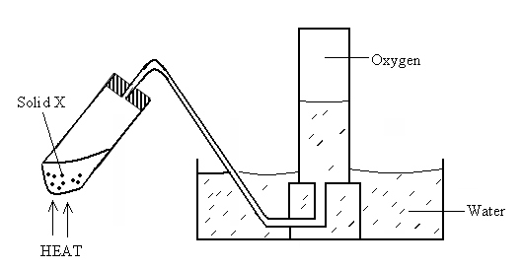

  - Identify solid X ………………………………..………………………….. (1mark)
  - Write a chemical equation for the reaction that produces oxygen above. (1mark)
…………………………………………………………………………………………………………………………………………………………….………………………………………………………………
  - State the physical property of oxygen gas that makes it possible to collect the gas as shown.
(1mark)
………………………………………………………………………………………………………………
  - Give one chemical properties of oxygen. (1mark)
……………………………………………………………………………………………………………………………………………………………………………………………………………….……………..
- Study the flow chart below and answer the questions that follow.
Ammonia
Nitrogen
Copper
Water
Copper (II)oxide
Step (VI) Heat
Gas J
Step I
Air
Platinum – Rhodium
High Temperature
Nitrogen (IV) Oxide
Step II
Air
Nitric (v) Acid
Ammonium Nitrate
Products
Water, Air
Step III
Ammonia
Step (IV)
Step (V)
Heat

- Identify gas J. ……………………………………………………. (½ marks)

- Name the process represented by step (VI) (1mark)
……………………………………………………………………………………………………………………………………………………………………………………..………………………………
- Write a balanced chemical equation for the reaction in step (VI) (2marks)
…………………………………………………………………………………………………………………………………………………………………………………...………………………………
- Write the equation of the reaction that occurs in step V. (2marks)
……………………………………………………………………………………………………………………………………………………………………………………………...……………………
- Give one use of ammonium nitrate. (½ mark)
…………………………………………………………………………………………………………Which is the best nitrogenous fertilizer between ammonium nitrate (NH₄NO₃) and Urea CO(NH₂)₂? (N= 14, H=1, O=16, C = 12, 4 = 1) (2marks)
……………………………………………………………………………………………………………………………………………………………………………………………………………………

b). The table below shows the observation made when aqueous ammonia was added to cations of
elements E, F and G until in excess.

Caution | Addition of a few drops aqueous ammonia | Addition of excess aqueous ammonia
E | White precipitate | Insoluble
F | No white precipitate | No white precipitate
G | White precipitate | Dissolves

- Select the cation that is likely to be Zn²⁺ (1mark)
………………………………………………………………………….……………………………………
- Given that the formula of the cation of element E is E²⁺, write the ionic equation for the reaction between E²⁺_{(aq)} and aqueous ammonia. (1mark)
4.
- Give the IUPAC names for the following compounds. (1 mark)
- CH₃(CH₂)₅CH₃
…………………………………………………………………….…………………………………………
- CH₃CH₂CCCH₃
……………………………………………………………….………………………………………………
- Petroleum (crude oil) is a source of many hydrocarbons.
  - Name the process used to separate the components of crude oil. (½ mark)
…………………………………………………………………………………….…………………………
  - State two physical properties upon which the separation of the components of crude oil is based. (1mark)
…………………………………………………………………………..……………………………………
- Pentane can be converted into two products by cracking one of the products formed has the formula C₂H_{6.}
  - Write the formula of the second product and name it (1 mark)
    - Formula
…………………………………………………………….…..……………………………………………
    - Name
…………………………………………………………….…..……………………………………………
  - Describe a simple chemical test that can be used to distinguish between the two products. (2marks)
………………………………………………………………………………………………………………………………………………………………………………………………………………………………………………………………………………………………………………………………………………
- Ethyne has the formula C₂H₂. One mole of ethyne was reacted with hydrogen gas.
  - How many moles of hydrogen were required to saturate ethyne? (1mark)
…………………………………………………………………………………………………………………………………………………………………………………………………………………….………..

  - When ethyne is reacted excess hydrogen bromide gas it forms two products P₁and P₂. Draw and name the two products P₁and P₂ (2marks)
………………………………………………………………………………………………………………………………………………………………………………………………………………………………………………………………………………………………………………………………………………………………………………………………………………………………………………………………………………………………………………………………………………………………………………
- The set up below was used to prepare ethene gas.

Conc. Sulphuric acid Ethene

Substance
S
Water

Heat
  - Name substance S……………………………………………………… (½ mark)
  - What property of ethene allows it to be collected by the method shown? (1mark)
………………………………………………………………………………………………………………………………………..…………………………………………………………………………………….
5.
- The set up below was used to obtain a sample of copper.
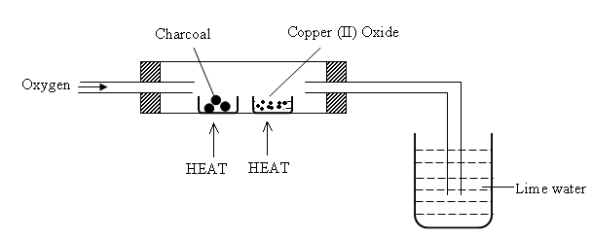

  - Write two chemical equations to represent the reactions taking place in the combustion tube. (2marks)
………………………………………………………………………………………………………………………………………………………………………………………………………………………………………………………………………………………………………………………………………………
  - Explain the observation made in the beaker containing lime water. (2marks)
………………………………………………………………………………………………………………………………………………………………………………………………………………………………………………………………………………………………………………………………………………
- The flow chart below shows how sodium carbonate is manufactured by solvay process. Study it and answer the questions that follow.
Solid B

Chamber

Limestone
Solid A, Air
Water

Ca(OH)_{2(aq)}

Chamber

Chamber

Gas P

Gas X

CaCl_{2(aq)}

Ammoniacal
Brine

Solid R

Chamber

Chamber

Filtrate D

- i )Name the following substance. (3marks)
  - Gas P ……………………………………………………………………
  - Gas X……………………………………………………………………
  - Solid A………………………………………………………………….
  - Solid B………………………………………………………………….
  - Filtrate D………………………………………………………………..
  - Solid R………………………………………………………………….
        - Explain how sodium chloride required for this process is obtained from sea water. (3marks)
………………………………………………………………………………………………………………………………………………………………………………………………………………………………………………………………………………………………………………………………………………
        - Name one industrial uses of sodium carbonate (1mark)
………………………………………………………………………………………………………………………………………………………………………………………………………………………………
        - Write a chemical equation for the reaction that occurs in chamber (II). (1mark)
………………………………………………………………………………………………………………………………………………………………………………………………..……………………………..
6. The diagram below illustrates how sulphur is extracted by the Frasch process.
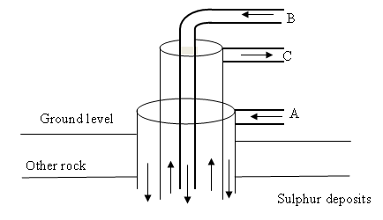

  - Name the substances and the conditions they are in when passing through pipes, A,B and C. (3 marks)
A ………………………………………………………………………………
B ………………………………………………………………………………
C ………………………………………………………………………………
  - The equation below show the oxidation of sulphur (iv) oxide to sulphur (vi) oxide.
2SO_{2(g)} + O_{2(g)} 2SO_{3(g)}
- Name the catalyst used in this reaction (1mark)
……………………………………………………………………………..
- Give one use of sulphur (VI) oxide (1mark)
…………………………………………………………………………….
  - Two samples of sulphur (IV) gas in water, K and L were treated as follows:-
I SAMPLE K was mixed with a few drops of acidified Barium Chloride solution soon after preparation.
…………………………………………………………………………………………………………………………………………………………………………………………………………..…………………
II Sample L was mixed with a few drops of acidified Barium Chloride solution 48hrs later.
Explain the difference in observation that would be made between solution K and L (1½ mark)

    - Solution k
……………………………………………………………………………………………………………………………………………………………………………………………………………………………………………………………………………..………………………………………………..
- Solution L (1 ½ mark)
………………………………………………………………………………………………………………………………………………………………………………………………………………………………………………………………………………………………………………………………………………
- State what is observed when sulphur (IV) oxide gas is passed through a solution of iron (iii) sulphate (2marks)
………………………………………………………………………………………………………………………………………………………………………………………………………………………………………………………………………………………………………………………………………………
- State the different between the bleaching action of sulphur (IV) gas and chlorine gas with aid of chemical equations (2marks)
………………………………………………………………………………………………………………………………………………………………………………………………………………………………………………………………………………………………………………………………………………
- Write an equation showing the bleaching action of sulphur (IV) oxide on moist coloured dye.
(1mark)
…………………………………………………………………………………………………………………………………………………………………………………………………………………..…………
7.
I)A sample of hydrogen chloride gas was dissolved in water to make 250cm³ of solution. 25cm³ of this solution required 46cm³ of 11.0M sodium hydroxide solution for complete neutralization.
    - Calculate the number of moles of hydrochloric acid in 25cm³of solution (3marks) ………………………………………………………………………………………………………………………………………………………………………………………………………………………………………………………………………………………………………………………………………………………………………………………………………………………………………………………………
    - Determine the mass of hydrogen chloride gas that was dissolved to make 250cm³ of the solution
(Cl= 35.5, H = 1.0) (2marks)
………………………………………………………………………………………………………………………………………………………………………………………………………………………………………………………………………………………………………….…………………………………

II) In the preparation of magnesium carbonate, magnesium was burnt in air and the product collected. Dilute sulphuric acid was then added and the mixture filtered and cooled. Sodium carbonate was added to the filtrate and the contents filtered. The residue was then washed and dried to give a white powder.
(a) Give the name of the product (1mk)

(b) Write the chemical equation for the formation of the product (1mk)

(c) (i) Name the filtrate collected after sodium carbonate was added.(1mk)

(ii) Write down the chemical formula of the white powder (1mk)

(d) Write a chemical equation for the reaction between product in (a) and the acid (1mk)

(e) Write an ionic equation to show the formation of the white powder(1mk).

(f) Write an equation to show what happens when the white powder is strongly heated. (1mk)

(g) Identify the ions present in the filtrate after addition of sodium carbonate. (1mk)

(h) What is the name given to the reaction that takes place when sodium carbonate was
added to the filtrate? (1mks)
SUCCESS AND ENJOY YOUR CHRISTMAS HOLIDAY

