**GEOGRAPHY**

**OCTOBER, 2017**

**TIME: 2 HRS 45 MINS**

**FORM TWO**

**STUDENT’S NAME: ……….……………………………..……………… ADM No: …….……….**

**NAME OF YOUR SCHOOL: ……………………………………………………………………….**

**DATE: ………………………………… SIGNATURE: ……………………………………**

**MALIET JOINT EVALUATION EXAMINATION**

**Kenya Certificate of Secondary Education**

**312**

**GEOGRAPHY**

**;**

***For Examiner’s use nly***

|  |  |  |  |  |  |  |
| --- | --- | --- | --- | --- | --- | --- |
| **SECTION A** | **SECTION B** | | | | | **TOTAL** |
| **Q 1 - 5** | **Q 6** | **Q 7** | **Q 8** | **Q 9** | **Q 10** |  |
|  |  |  |  |  |  |

**INSTRUCTIONS TO CANDIDATES:**

* This paper has two sections A and B.
* Answer ALL the questions in section A.
* In section B answer question 6 and any other TWO from the remaining.

**SECTION A: 25 MARKS**

**Answer all questions in this section**

1. a) Differentiate between latitudes and longitudes. (2 mks)

b) State three reasons why the interior of the earth is very hot. (3 mks)

2. a) Give the forces responsible for the earth’s shape (2 mks)

b) State **three** effects of revolution of the earth (3 mks)

3. The diagram below shows the formation of a certain type of rainfall.



1. Describe how the above type of rainfall is formed. (5 mks)

4. (a) What is the solar system? (1mk)

(b) State **four** proofs that the earth is spherical (4mks)

5 (a) **Differentiate** between extrusive and intrusive rocks. (2mks)

(b) **Classify** the following rocks: **Quartzite**, **granite** and **mudstone** into

(i) Igneous (1mk)

(ii) Sedimentary (1mk)

(iii) Metamorphic (1mk)

**SECTION B:75 MARKS**

**Answer Question 6 and any other TWO questions.**

6. Use the following table to answer the questions that follow.

Value of export crops Kenya ( Kshs. Millions)

|  |  |
| --- | --- |
| **Crop** | **1999** |
| Tea | 33065 |
| Coffee | 12029 |
| Horticulture | 17641 |
| Tobacco and products | 1554 |
| **TOTAL** | **64,289** |

(a) (i) Using a scale of 1 cm to represent Ksh. 5 millions, draw a divided rectangle for Kenya’s export in 1999. (9mks)

(b) (i)Differentiate between weather and climate (2mks)

(ii) State three elements of weather (3mks)

(ii) Explain how, the atmosphere is heated by absorbed heat from the earth under the following sub-headings:

* + - 1. Radiation (2mks)
      2. Conduction (2mks)

(c) (i) Describe a suitable site where you would locate a weather station in your School

(3 mks)

(ii) Give reasons why a Stevenson’s screen is:

* + - 1. Painted White (2 mks)
      2. Has louvers (2 mks)

1. (a) (i) **State two** factors that cause earth movements. (2mks)

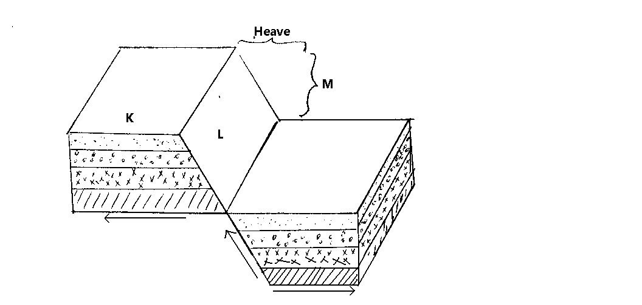

The diagram above shows features associated with faulting.

(ii) **Name** the type of fault above. (1mk)

(iii) **Name** the parts marked K, L, M. (3mks)

(b) (i) Apart from a rift valley, **name two** resultant features of faulting. (2mks)

(ii) With the aid of well labeled diagrams, **describe** how a rift valley is formed through anticlinal arching. (8mks)

(c) (i) **Distinguish** between basic lava and acidic lava. (2mks)

(ii) **State two** features of a composite volcano. (2mks)

(d)You are required to carry out a field study of an area which has been affected by vulcanicity.

(i) **Give three** sources of information that you would use in preparation for the study. (3mks)

(ii) **State two** advantages of using interview to collect information during a field study. (2mks)

8. The tables **below** represent rainfall and temperature of stations **X** and **Y**.

Use them to answer question (a) and (b).

**Station X**

|  |  |  |  |  |  |  |  |  |  |  |  |  |
| --- | --- | --- | --- | --- | --- | --- | --- | --- | --- | --- | --- | --- |
| *Months* | *J* | *F* | *M* | *A* | *M* | *J* | *J* | *A* | *S* | *O* | *N* | *D* |
| Temp in °C | 30 | 31 | 31 | 31 | 30 | 29 | 28 | 28 | 29 | 29 | 29 | 30 |
| Rainfall in mm | 250 | 250 | 325 | 300 | 213 | 25 | 25 | 25 | 100 | 275 | 380 | 200 |

**Station Y**

|  |  |  |  |  |  |  |  |  |  |  |  |  |
| --- | --- | --- | --- | --- | --- | --- | --- | --- | --- | --- | --- | --- |
| *Months* | *J* | *F* | *M* | *A* | *M* | *J* | *J* | *A* | *S* | *O* | *N* | *D* |
| Temp in °C | 21 | 20 | 20 | 17 | 15 | 13 | 12 | 13 | 15 | 16 | 18 | 20 |
| Rainfall in mm | 12 | 12 | 15 | 50 | 90 | 110 | 87 | 87 | 50 | 35 | 20 | 15 |

(a) (i) For each of the two stations, calculate the mean annual range of temperature (2mks)

(ii) Calculate the annual rainfall for station **Y**. (2mks)

(b) (i) Draw a bar graph to represent the rainfall for station **X**. Use a vertical scale

of 1cm to represent 50mm. (5mks)

(ii) Describe the climatic characteristic of station **Y**. (6mks)

(c) (i) Describe how convectional rainfall is formed. (6mks)

(ii) Explain **two** problems associated with convectional rainfall in the lake region of Kenya. (4mks)

9. (a) What is an earthquake? (1mk)

(b) Explain four causes of earthquakes (8mks)

(c) Name the two scales indicating what they record that are used to measure earthquakes (4mks)

(d) State the three seismic waves recorded on a seismograph when a strong earthquake occurs (3mks)

(e) Give four major regions of the world where earthquakes are likely to occur (4mks)

(f) Differentiate between epicenter and seismic focus (2mks)

(g) State four effects of earthquakes (3mks)

10. (a) (i) Identify two provinces where Gold is mined in South Africa. (2mks)

(ii) Describe the processing of Gold from the time the ore is lifted to the surface. (5mks)

(b) Explain four contributions of Gold to South African economy (8mks)

(c ) State four problems of Diamond mining in South Africa. (4mks)

(d) Explain three problems facing the mining industry in Kenya. (6mks)

THE END