Name: ………………………………………………………… Adm No: ……….………

Name of your school: ……………………………………….…………………………….

Student’s Sign: ……………..…………………… Date: ………………………………

GEOGRAPHY
OCTOBER, 2017
TIME: 2 HRS 45 MIN

FORM THREE

MALIET JOINT EVALUATION EXAMINATION
Kenya Certificate of Secondary Education

312
GEOGRAPHY

INSTRUCTIONS TO CANDIDATES.
- This paper has two sections A and B.
- Answer ALL the questions in section A.
- In section B answer question 6 and any other TWO from the remaining.

SECTION A: 25 MARKS
1. (a) Name any two constituents of the atmosphere. (2 marks)
(b) The diagram below represent the structure of the earth. Use it to answer the questions that follow.
L
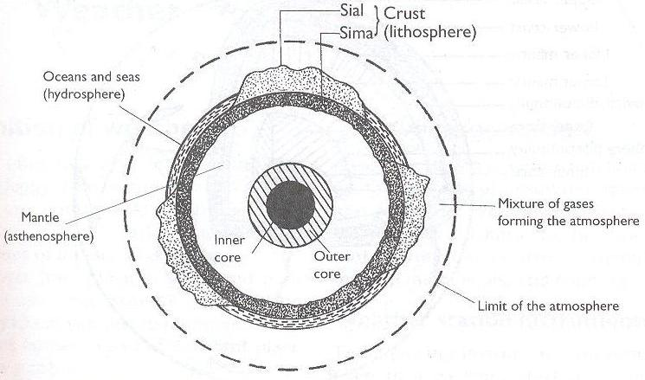
K
M
Name the parts markedK, Land M. (3 marks)
2. (a) State three characteristics of extrusive igneous rocks. (3 marks)
(b) Name the metamorphic equivalent of the following rocks. (2 marks)
- Peridotite
- Mud stone

3. Use the diagram below to answer the questions that follows.
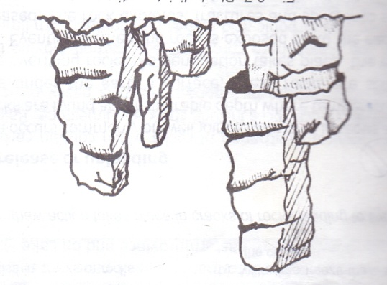
(a) Identify the weathering process shown above. (1 mark)
(b) Describe how rocks are weathered through the above process. (4 marks)

4. a) State three characteristics of a river in the Old Stage. (3 mks)
b) State two conditions that lead to deposition of silt at the mouth of a river(2 mks)

5. (a) What is underground water (1 mk)
(b) Give two main sources of underground water (2 mks)

(c) The diagram below shows an artesian basin. Name the parts marked X and Y.
(2mks)

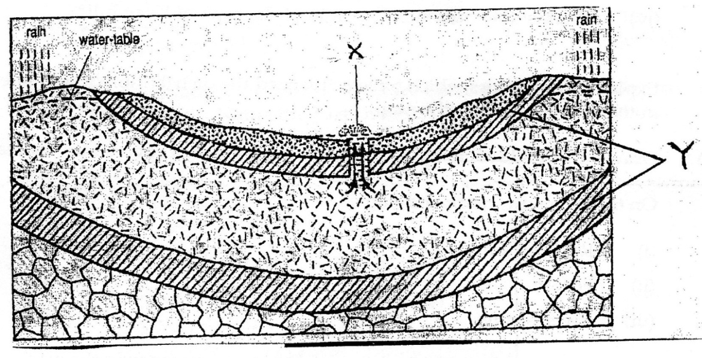

SECTION B: 75 MARKS
Answer question 6 (compulsory) and any other two from the remaining questions

6. Study the map of Kitale 1: 50,000 (sheet 7513). Provided and answer the following questions.
(a) (i) Identify one human made feature found at the grid 360179. (1mk)
(ii) State two methods used to show relief in the area covered by the map. (2mks) (iii) Calculate the magnetic declination as at the time the map was published. (2mks)
(b (i) Calculate the area of Kitale Municipality (2mks)
(ii) Measure the distance of the dry weather road C 637 from junction 254285 to 311211. Give your answer in kilometers. (2mks)
(c) (i) Draw a rectangle measuring 10cm by 12cm between Easting 24 and 29 and Northing12 and 18 (1mk)
(ii) On the rectangular, mark and name the following. (5mks)
Seasonal swamp.
River Koitobos.
Road C 641.
Sandrums’ bridge.
(iii) Describe how relief has influenced settlement in the area covered by the map. (4mks)
(iv) Describe the drainage of the area covered by the map. (4mks)
(d) Citing evidence from the map. Identify Two economic activities found in the area covered by the map. (2mks)

7. (a) Name;
(i) Two types of faults (2mks)
(ii) Three features resulting from faulting (3mks)
(b) (i) List three Horst mountains found in East Africa (3mks) (ii) With aid of a well labelled diagram, describe how a horst mountain is formed
(6mks)
(c) (i) State three causes of vulcanicity (3mks)
(ii) Give two characteristics of a shield volcano (2mks)
(d) Explain three ways through which faulting is of economic importance to man (6mks)

8. (a) (i) What is mining? (2mks)
(ii) Describe how deep-shaft mining is carried out. (4mks)
(b) (i) Name the method used in mining Trona on Lake Magadi in Kenya. (1mk)
(ii) Give three uses of Soda Ash. (3mks)
(iii) Explain three ways in which Trona mining contribute to the economy of Kenya. (6mks)
(c) (i) Name three oil producing countries in the Middle East. (3mks)
(ii) Explain three negative effects of mining on the environment. (6mks)

9. (a) (i) Distinguish between Aridity and desertification (2mks)
(ii) Identify two types of deserts surfaces (2mks)
(iii) Give two reasons why wind action is most active in hot deserts than in cold deserts. (4mks)
(b) Explain the following process of wind erosion
(i) Abrasion (2mks)
(ii) Deflation (2mks)
(iii) Attrition (2mks)
(c) (i) State two factors that influence the transportation of material by wind in deserts (2mks)
(ii) The diagram below shows some features of wind deposition.
Identify K,L and M (3mks)
M
Side wind
Steep leeward
slope
L
Gentle windward slope

K

(d) Your class is planning to carry out a field study of a desert environment.
(i) State three ways of preparing for the field study. (3mks)
(ii) Give three information that would be collected through observation in arid area (3mks)

10. (a) Differentiate between Agro-forestry and Afforestation. (2mks)
(b) (i) State five factors that have led to the reduction of the area under forests on the slopes of Mt. Kenya. (5mks)
(ii) Explain four measures that the Kenya Government is taking to conserve forests in Kenya. (8mks)

(c) Compare exploitation of softwood forests in Kenya and Canada under the following
sub-headings:-
(i) Period of harvesting. (2mks)
(ii) Transportation of logs (2mks)
(d) Explain three problems facing forestry in Canada. (6mks)

THE END

