NAME ____________________________________ INDEX NO. _______________
SCHOOL ____________________________________ SIGNATURE _______________ DATE _______________

232/1
PHYSICS
PAPER 1
(THEORY)
JULY / AUGUST, 2015
TIME: 2 HOURS

BRILLIANT

232/1
PHYSICS
PAPER 1
(THEORY)
TIME: 2 HOURS

INSTRUCTIONS TO CANDIDATES
- Write your name, school and index number in the spaces provided above.
- Sign and write the date of the examination in the spaces provided above.
- The paper consists of two sections, Section A and B.
- Answer ALL the questions in section A and B in the spaces provided.
- ALL answers andworking MUST be clearly shown.
- Mathematical tables and electronic calculators may be used.

FOR EXAMINER’S USE
SECTION | question | maximum score | Candidate’s score
A | 1−11 | 25
B | 12 | 10
 | 13 | 9
 | 14 | 12
 | 15 | 12
 | 16 | 12
Total score |  | 80

This paper consists of 12 printed pages.
Candidates should check to ensure that all pages are printed as indicated and no questions are missing
SECTION A (25 MARKS)
Answer ALL the questions in this section in the spaces provided.
- Before usinga vernier calipers to measure diameter of a steel ball, a student confirmed that it had a zero error of −0.03cm. The figure below shows the vernier calipers scale when in use.
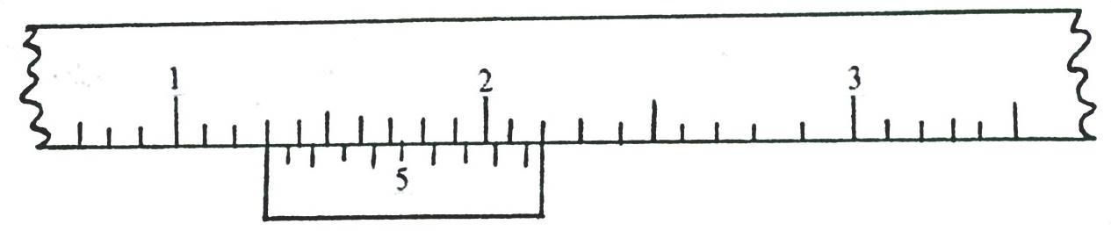
5

3

2

1

State the correct diameter of the steel ball. (2marks)

- Explain briefly why water will wet a glass surface but mercury will not. (2marks)
_______________________________________________________________________________________________________________________________________________________________________________________________________________________________________________________________________________________________________________________________________________________________________________________________________________________________
- The figure below is that of a uniform meter rule supported at the 30cm. A load of 5N is attached at
the 0cm mark and that of 2N to a pulley at the 100cm mark. Calculate the weight of the meter rule. (3marks)
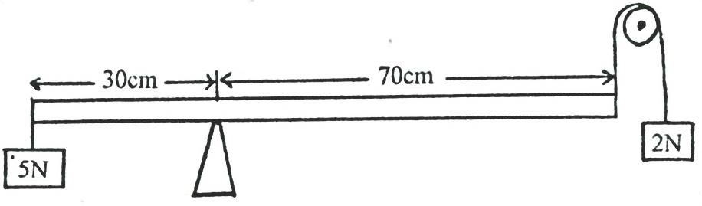

- A mercury barometer reads 75cmHg at the base of Mt.Kenya. Assuming that the height of
the mountain is 1088m and the average density of air is 1.25kg/m³. What is the reading of the
barometer at the top of the mountain? (Take density of mercury is 13.6g/cm³.) (3marks)

- The figure below is a rectangular block in a stable equilibrium, with a hollow section as shown. 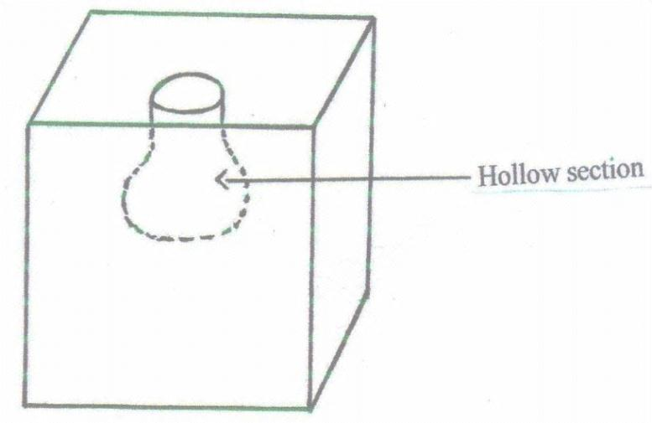
Hollow section
- What is the effect of adding water into the hollow section? (1 mark)
______________________________________________________________________________________________________________________________________________________________________
- What could be the reason for your answer above? (2 marks)
______________________________________________________________________________________________________________________________________________________________________

- The figure below is that of identical springs. A 60N weight is attached on the springs as shown
so that the total extension for the system is 6cm. Calculate the spring constant of one spring. (3 marks)
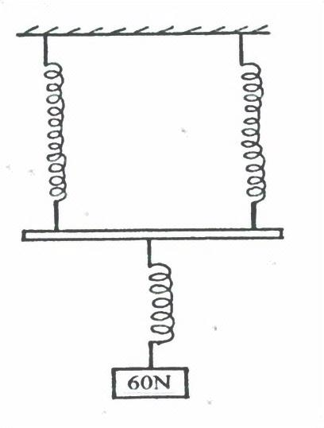
60N

- The system in the figure below is in equilibrium at room temperature. The system is taken
outside where the temperature is 10⁰C higher for some time.
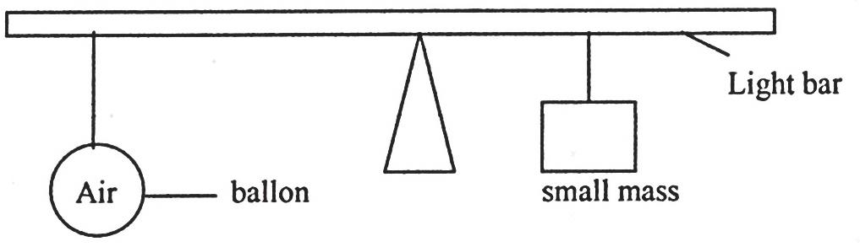
Balloon
Small mass
Light bar
Explain why it tips to the right when it is taken outside the room. (2 marks)
____________________________________________________________________________________________________________________________________________________________________________________________________________________________________________________________________________________________________________________________________________
- State one way of increasing sensitivity of mercury in glass thermometer. (1mark)
______________________________________________________________________________________________________________________________________________________________________
- A tightly fitted bottle cork will be easier to remove if the bottle is warmed.
Explain this using kinetic and thermal property of matter. (2marks)
____________________________________________________________________________________________________________________________________________________________________________________________________________________________________________________________________________________________________________________________________________
- A bullet of mass 20g moving with a velocity of 30m/s penetrates a sand bag and it’s brought
to rest in 0.05 seconds. Find the average retarding force of the sand. (3 marks)

- Explain why an iron gate feels colder when touched but its wooden gatepost feels warm at night. (1mark)
_________________________________________________________________________________________________________________________________________________________________________________________________________________________________________________________

SECTION B (55 MARKS)
Answer ALL the questions in this section in the spaces provided.
- a) Distinguish between streamline and turbulent flow. (2 marks)
____________________________________________________________________________________________________________________________________________________________________________________________________________________________________________________________________________________________________________________________________________
b) The figure below shows two light sheets of paper arranged as shown.
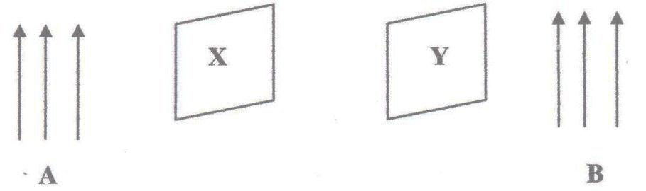
Y
X
B
A
Explain the observation made when air is blown at the same speed and time at points A and B. (2 marks)
_________________________________________________________________________________________________________________________________________________________________________________________________________________________________________________________
- The figure below shows an incompressible fluid moving through a tube of varied cross- sectional area. If the area of the small tube is 0.05m², calculate the diameter of the large tube in cm. (3 marks) 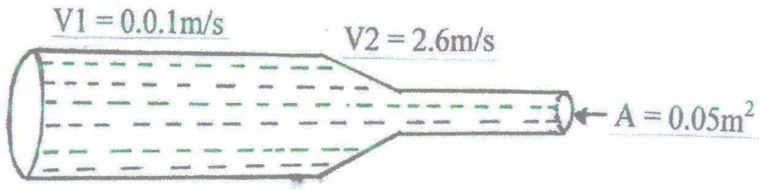
V₁ = 2.6 m/s
A = 0.05 m²
V₁ = 0.01 m/s

- Use the figure below to answer the questions that follow.
Gas in
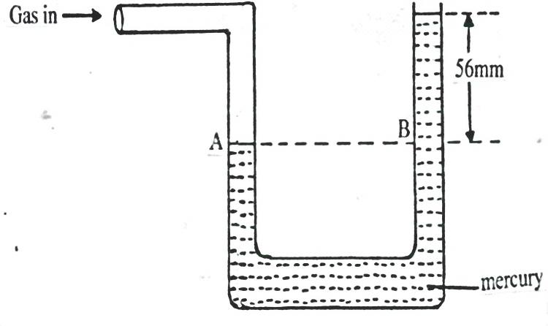
56mm
B
A

Mercury
- What pressure is acting on point A? (1 mark)
___________________________________________________________________________________
- What is the value of pressure difference in the instrument reading? (1 mark)

- If the atmospheric pressure is 760mm of mercury, what is the value of gas pressure? (2 marks)

- The diagram below shows a six’s maximum/ minimum thermometer.
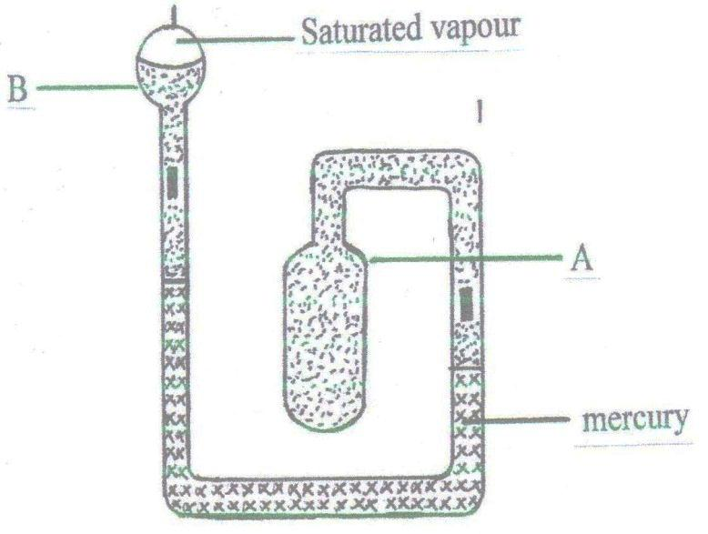
Saturated vapour
B
A
Mercury
- What is the thermometric liquid in this thermometer? (1mark)
___________________________________________________________________________________
- Why is it necessary for the vapour in bulb B to be saturated? (1 mark)
______________________________________________________________________________________________________________________________________________________________________
- Explain how the thermometer indicates maximum and minimum temperature. (4 marks)
_______________________________________________________________________________________________________________________________________________________________________________________________________________________________________________________________________________________________________________________________________________________________________________________________________________________________
- Indicate on the diagram the two points where the reading of the temperature shown by the
thermometer can be made. (2 marks)

- a) The figure below shows a velocity – time graph for the motion of a certain body.
Describe the motion of the body in the region:
- OA: (1 mark)
______________________________________________________________________________________________________________________________________________________________________
- AB: (1 mark)
______________________________________________________________________________________________________________________________________________________________________
- BC: (1 mark)
______________________________________________________________________________________________________________________________________________________________________
b) A car moving initially at 10m/s decelerates at 2.5m/s²
Determine:
- I) Its velocity after 1.5seconds. (2 marks)

- The distance travelled in 1.5 seconds. (2 marks)

- The time taken for the car to stop. (2 marks)

- Sketch the velocity – time graph for the motion of the car up to the time the car stopped. (1 mark)

- From the graph determine the distance the car travelled before stopping. (2 marks)

- a) The figure below shows a car of mass (m) moving along a curved part of the road with a constant acceleration.
Car
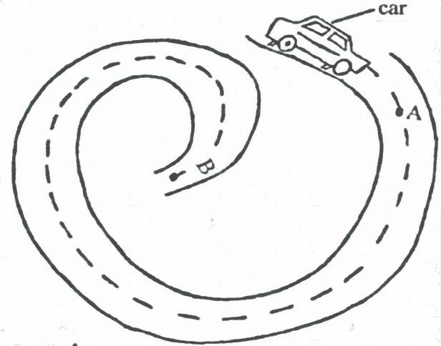
- Explain why the car is more likely to skid at B than at A. (1 mark)
____________________________________________________________________________________________________________________________________________________________________________________________________________________________________________________________________________________________________________________________________________
ii) If the radius of the path at B is 250m and the car has a mass of 6000kg, determine the maximum speed the car can be driven while at B without skidding. The coefficient of friction between the
roadand the tyre is 0.3. (3 marks)

b) A string of length 70cm is used to whirl a stone of mass 0.5kg in a circle of vertical plane at 5 rev/s. Determine:
- The period. (2 marks)

- The angular velocity (3marks)

c) The graph below shows how the velocity varies with time for a body thrown vertically upwards.
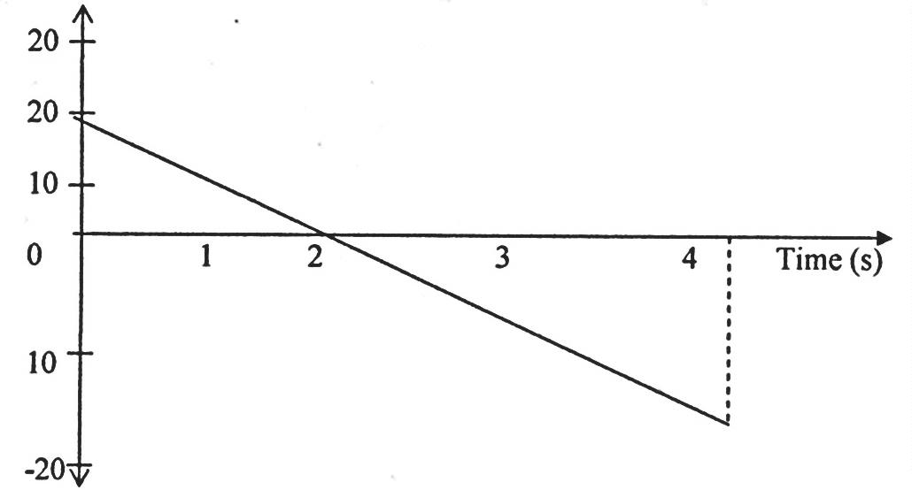
Determine the total displacement moved by the body. (2 marks)

- a) What is meant by specific latent heat of vapourisation? (1 mark)
______________________________________________________________________________________________________________________________________________________________________
b) In an experiment to determine the specific latent heat of vapourisation of water, steam at 100⁰C was passed into water contained in a well lagged calorimeter. The following measurements were made:
Mass of calorimeter = 50g
Initial mass of water = 70g
Initial temperature of water = 5⁰C
Final mass of water + calorimeter + condensed steam = 123g
Final temperature of mixture = 30⁰C
Specific heat capacity of water = 4200Jkg⁻¹K⁻¹
Specific heat capacity of copper = 390 Jkg⁻¹ K⁻¹

Determine:
- Mass of condensed steam. (2 marks)

- Heat gained by water and calorimeter. (2marks)

c) Given that L is the specific latent heat of vaporization of steam above.
i) Write down an expression for the heat given out by steam. (1mark)

ii) Determine the value of L. (2 marks)

d) 500g of water at 20⁰C is mixed with 200g of water at 55⁰C. Find the final temperature of the mixture. (4marks)

