NAME ____________________________________ INDEX NO. _______________
SCHOOL ____________________________________ SIGNATURE _______________ DATE _______________

232/3
PHYSICS
PAPER 3
(PRACTICAL)
JULY / AUGUST, 2015
TIME: 2½ HOURS

BRILLIANT
232/3
PHYSICS
PAPER 3
(PRACTICAL)
TIME: 2½ HOURS

INSTRUCTIONS TO CANDIDATES
- Write your name and index number in the spaces provided above.
- Answer ALL the questions in the spaces provided in the question paper.
- You are not allowed to start working with the apparatus for the first ¼ hours of the 2½ hours allowed for this paper. This time is to enable you read the question paper and make sure you have all the apparatus you may need.
- Marks are given for a clear record of the observations actually made, for their suitability and accuracy and the use made of them.
- Candidates are advised to record their observations as soon as they are made.
- Mathematical tables and electronic calculators may be used in calculations.

FOR EXAMINER’S USE ONLY
QUESTION | MAXIMUM SCORE | CANDIDATE’S SCORE
1 | 20
2 | 20
TOTAL | 40

This paper consists of 6 printed pages.
Candidates should check the question paper to ensure that all pages are printed as indicated and no questions are missing.

- a) You are provided with the following apparatus:
- Two metre rules
- Two stands and two clamps
- Two bosses
- Three pieces of threads
- A spring with a pointer
- One mass of 200g.
- One stop watch.
b)
i) Set the apparatus as shown in the diagram below. 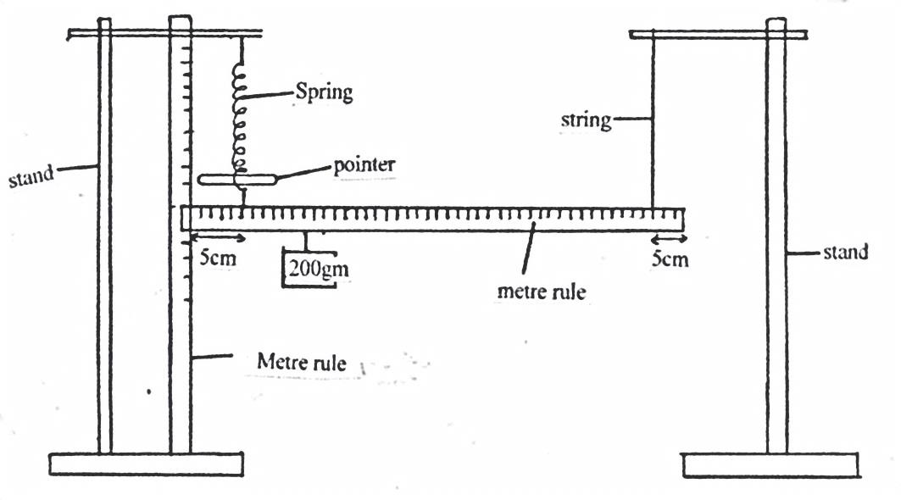
ii) Suspend one of the metre rule with a thread at 5cm mark from one end.
iii) Suspend the other end with a spring also 5cm from the end so that the metre rule is horizontal.
iv) Hold the other rule vertically on the bench so that the end with a pointer as shown in the diagram above.
v) Read the pointer position, L_{O} = ______________________________ cm (1 mark)
a) Hang on the horizontal metre rule the 200gm mass at a length, L = 10cm from the spring.
Record the extension, e, of the spring in the table below.
b) Displace the mass slightly downwards and release it to oscillate vertically. Take time for 20 oscillations and record in table below.
c) Repeat for other position of L of the mass.
NB: Before taking the reading ensure the reading is lead.
Length (L) | 10 | 20 | 30 | 40 | 50
Extension ,e, (cm)
Time for 20 oscillations (sec)
Periodic time, T sec
T² (sec)²
(8 marks)

vi) Plot a graph of extension, e, (m) (y - axis) against T² (sec)² (5 marks)

vii) Calculate the gradient of the graph. (3 marks)

viii) Given that e = $\frac{{RT}^{2}}{{4π}^{2}}$ + C, determine the value of R. (3 marks)

- You are provided with the following:
- An ammeter (0 – 1.0 A)
- A voltmeter (0 – 2.5 V)
- A resistance wire PQ mounted on a mm scale
- Two new dry cells
- A switch
- A cell holder
- Six connecting wires

Procedure.
- Set up the apparatus as shown below.
V
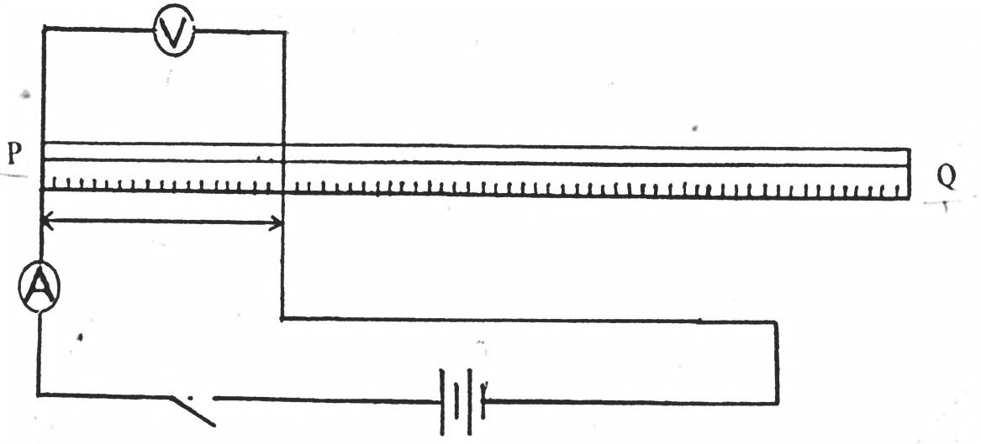

P
Q
A
- Starting with L = 0.2m, close the switch. Record the value of I, the current through the wire and V, the p.d across it. Enter your results in the table drawn below.
L (M) | 0.2 | 0.3 | 0.4 | 0.5 | 0.6 | 0.7 | 0.8
I (A)
p.d (V)
R = $\frac{V}{I}$ (Ω)
$\frac{1}{I}$A⁻¹

- Repeat part (b) above for the values of L shown in the table. (8 marks)
Recordthe corresponding values of I and V. Calculate the values of R and $\frac{1}{I}$ and enter the values in the table.
- On the grid provided, plot graph of R (y-axis) against $\frac{1}{I}$ (x-axis) (5 marks)

- Determine the slope, S, of your graph. (3 marks)

- If the graph obeys the equation R=$\frac{E}{I}$– r,
Determine:
- The value of E. (1 mark)

- The value of r. (2 marks)

- Draw a simple circuit you can use to determine the E.M.F of a single cell. (1 mark)

