NAME ____________________________________ INDEX NO. _______________
SCHOOL ____________________________________ SIGNATURE _______________ DATE _______________

443/2
AGRICULTURE
PAPER 2
July/August, 2017
TIME: 2 HOURS

BRILLIANT 1

443/2
AGRICULTURE
PAPER 2
TIME: 2 HOURS

INSTRUCTIONS TO CANDIDATES
- Write your name, school and index number, in the spaces provided above.
- Sign and write the date of the examination in the spaces provided above.
- This paper consists of three sections: A, B and C.
- Answer all the questions in section A and B and any two questions from section C.
- All answers must be written in the spaces provided in this booklet.
- This paper consists of 12 printed pages.
- Candidates should check the question paper to ascertain that all pages are printed as indicated and that no questions are missing

For OFFICIAL use only
SECTION | QUESTIONS | MAXIMUM SCORE | CANDIDATES SCORE
A | 1 −14 | 30
B | 15−18 | 20
C |  | 20
C |  | 20
 | TOTAL SCORE | 90

SECTION A (30MARKS)
Answer ALL the questions in the spaces provided
- State four control measures of a liver fluke in livestock. (2marks)
_______________________________________________________________________________________________________________________________________________________________________________________________________________________________________________________________________________________________________________________________________________________________________________________________________________________________
- What is “dry cow therapy” in dairy cattle management? (1mark)
______________________________________________________________________________________________________________________________________________________________________
- State four causes of stress in poultry. (2 marks)
_______________________________________________________________________________________________________________________________________________________________________________________________________________________________________________________________________________________________________________________________________________________________________________________________________________________________
- Highlight two management practices carried out on a broody hen. (2 marks)
_________________________________________________________________________________________________________________________________________________________________________________________________________________________________________________________
- Distinguish between mothering ability and prolificicacy as used in livestock breeding. (2 marks)
____________________________________________________________________________________________________________________________________________________________________________________________________________________________________________________________________________________________________________________________________________
- Outline four activities that necessitate handling of livestock. (2 marks)
_______________________________________________________________________________________________________________________________________________________________________________________________________________________________________________________________________________________________________________________________________________________________________________________________________________________________

- State four symptoms shown by an animal attacked by round worms. (2 marks)
_______________________________________________________________________________________________________________________________________________________________________________________________________________________________________________________________________________________________________________________________________________________________________________________________________________________________
- Name four sources of protein for livestock nutrition. (2 marks)
_______________________________________________________________________________________________________________________________________________________________________________________________________________________________________________________________________________________________________________________________________________________________________________________________________________________________
- State four signs of parturition shown by aincalf cow. (2 marks)
_______________________________________________________________________________________________________________________________________________________________________________________________________________________________________________________________________________________________________________________________________________________________________________________________________________________________
- State the uses of the following farm tools and equipment.
- Secateurs (1 mark)
___________________________________________________________________________________
- Sickle (1 mark)
___________________________________________________________________________________
- Bolus gun (1 mark)
___________________________________________________________________________________
- State four maintenance practices carried out on a wheel barrow. (2 marks)
_______________________________________________________________________________________________________________________________________________________________________________________________________________________________________________________________________________________________________________________________________________________________________________________________________________________________

- Outline four factors considered when sorting and grading eggs for market. (2 marks)
_______________________________________________________________________________________________________________________________________________________________________________________________________________________________________________________________________________________________________________________________________________________________________________________________________________________________
- State four reasons for feeding colostrum to calves immediately after parturition. (4 marks)
_______________________________________________________________________________________________________________________________________________________________________________________________________________________________________________________________________________________________________________________________________________________________________________________________________________________________
- Name fourtractors drawn implement attached to power take off shaft (P.T.O) (2 marks)
_______________________________________________________________________________________________________________________________________________________________________________________________________________________________________________________________________________________________________________________________________________________________________________________________________________________________

SECTION B (20marks)
Answer ALL the questions in the spaces provides
- The diagrams below show some farm tools study them and answer the question that follow.
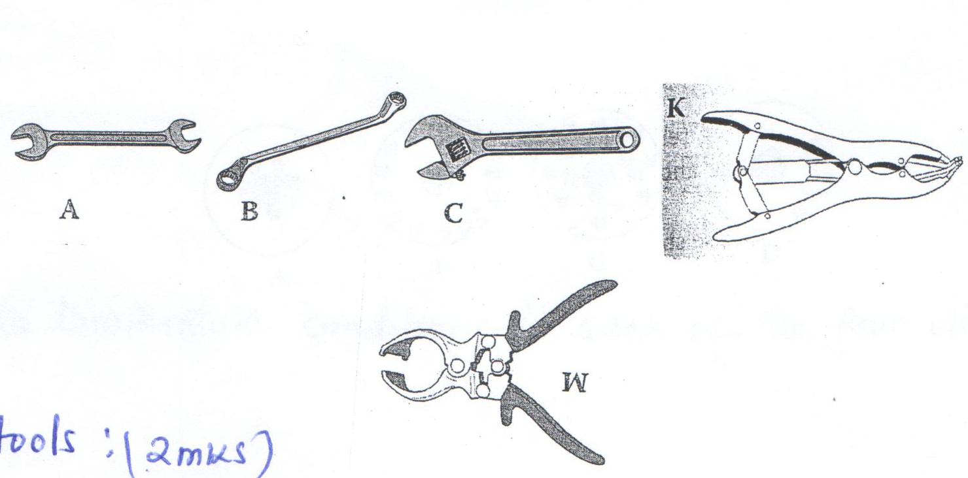
A
B
C
W
K

    - Name the tools. (2 marks)
A _________________________________________________________________________________
B _________________________________________________________________________________
C _________________________________________________________________________________
W _________________________________________________________________________________
    - State the functional differences between tools K and W. (1 mark)
_________________________________________________________________________________________________________________________________________________________________________________________________________________________________________________________
    - What advantage does C have over A and B? (1 mark)
_________________________________________________________________________________________________________________________________________________________________________________________________________________________________________________________
    - State one common maintenance practice carried out in tool C and W. (1 mark)
______________________________________________________________________________________________________________________________________________________________________
- The illustrations below show the behavior of chicks at different temperatures in the brooder.
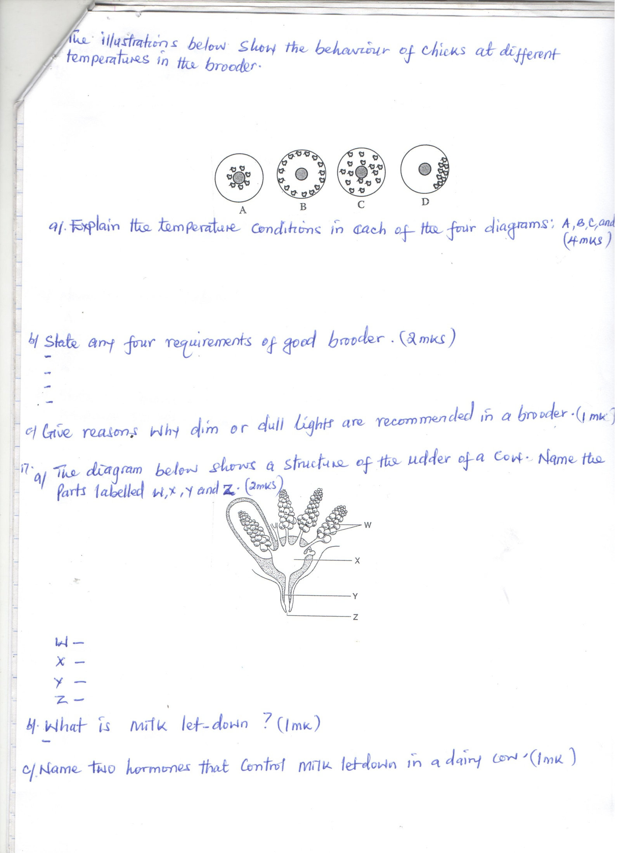

- Explain the temperature conditions in each of the four diagrams A, B, C and D. (4 marks)
A _________________________________________________________________________________
B _________________________________________________________________________________
C _________________________________________________________________________________
D _________________________________________________________________________________
- State any four requirements of good brooder. (2 marks)
_______________________________________________________________________________________________________________________________________________________________________________________________________________________________________________________________________________________________________________________________________________________________________________________________________________________________
- Give reasons why dim or dull lights are recommended in brooder. (1 mark)
______________________________________________________________________________________________________________________________________________________________________
- a) The diagram below shows a structure of the udder of a cow. Name the part labeled W, X,Y and Z. (2 marks)

Z
Y
X
W
W______________________________________________________________________________
X ______________________________________________________________________________
Y ______________________________________________________________________________
Z ______________________________________________________________________________
b) What is milk let down ? (1 mark)
______________________________________________________________________________________________________________________________________________________________________
c) Name two hormones that control milk let down in dairy cow. (1 mark)
_________________________________________________________________________________________________________________________________________________________________________________________________________________________________________________________

- Below is a diagram of knapsack sprayer. Study it carefully and answer the questions that follow
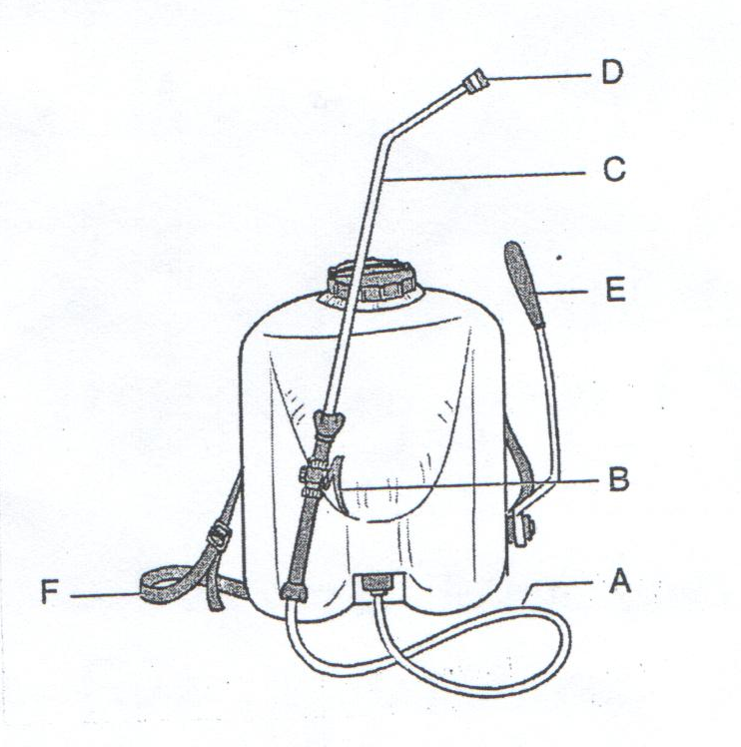
A
B
E
C
D
- Name the parts labeled A, B, C and D. (2 marks)
A _________________________________________________________________________________
B _________________________________________________________________________________
C _________________________________________________________________________________
D _________________________________________________________________________________
- State two maintenance practices that should be carried out on the Knapsack sprayer. (1 mark)
_________________________________________________________________________________________________________________________________________________________________________________________________________________________________________________________
- State the functions of the part labeled E and F. (1 mark)
E _________________________________________________________________________________
_________________________________________________________________________________
F _________________________________________________________________________________
_________________________________________________________________________________

SECTION C (40MARKS)
Answer any TWO questions in this section in the spaces provided after question 21
- a) State five differences between ruminants and non- ruminants. (5 marks)
b) Describe five maintenance practices carried on tractor drawn disc plough. (5 marks)
c) Discuss calf rearing from birth to first calving. (10 marks)

- a) State five reasons why bees swarm. (5 marks)
b) Describe five maintenance practices carried out on a tractor battery. (5 marks)
c) State signs shown by a cow on heat. (5 marks)
d) Explain five methods of tick control. (5 marks)

- a) State five qualities of eggs for incubation. (5 marks)
b) Describe the management carried out in artificial egg incubator.
c) Describe the preparations you would make in brooder before the arrival of day old chicks and their care for the first two days. (10 marks)

____________________________________________________________________________________________________________________________________________________________________________________________________________________________________________________________________________________________________________________________________________________________________________________________________________________________________________________________________________________________________________________________________________________________________________________________________________________________________________________________________________________________________________________________________________________________________________________________________________________________________________________________________________________________________________________________________________________________________________________________________________________________________________________________________________________________________________________________________________________________________________________________________________________________________________________________________________________________________________________________________________________________________________________________________________________________________________________________________________________________________________________________________________________________________________________________________________________________________________________________________________________________________________________________________________________________________________________________________________________________________________________________________________________________________________________________________________________________________________________________________________________________________________________________________________________________________________________________________________________________________________________________________________________________________________________________________________________________________________________________________________________________________________________________________________________________________________________________________________________________________________________________________________________________________________________________________________________________________________________________________________________________________________________________________________________________________________________________________________________________________________________________________________________________________________________________________________________________________________________________________________________________________________________________________________________________________________________________________________________________________________________________________________________________________________________________________________________________________________________________________________________________________________________________________________________________________________________________________________________________________________________________________________________________________________________________________________________________________________________________________________________________________________________________________________________________________________________________________________________________________________________________________________________________________________________________________________________________________________________________________________________________________________________________________________________________________________________________________________________________________________________________________________________________________________________________________________________________________________________________________________________________________________________________________________________________________________________________________________________________________________________________________________________________________________________________________________________________________________________________________________________________________________________________________________________________________________________________________________________________________________________________________________________________________________________________________________________________________________________________________________________________________________________________________________________________________________________________________________________________________________________________________________________________________________________________________________________________________________________________________________________________________________________________________________________________________________________________________________________________________________________________________________________________________________________________________________________________________________________________________________________________________________________________________________________________________________________________________________________________________________________________________________________________________________________________________________________________________________________________________________________________________________________________________________________________________________________________________________________________________________________________________________________________________________________________________________________________________________________________________________________________________________________________________________________________________________________________________________________________________________________________________________________________________________________________________________________________________________________________________________________________________________________________________________________________________________________________________________________________________________________________________________________________________________________________________________________________________________________________________________________________________________________________________________________________________________________________________________________________________________________________________________________________________________________________________________________________________________________________________________________________________________________________________________________________________________________________________________________________________________________________________________________________________________________________________________________________________________________________________________________________________________________________________________________________________________________________________________________________________________________________________________________________________________________________________________________________________________________________________________________________________________________________________________________________________________________________________________________________________________________________________________________________________________________________________________________________________________________________________________________________________________________________________________________________________________________________________________________________________________________________________________________________________________________________________________________________________________________________________________________________________________________________________________________________________________________________________________________________________________________________________________________________________________________________________________________________________________________________________________________________________________________________________________________________________________________________________________________________________________________________________________________________________________________________________________________________________________________________________________________________________________________________________________________________________________________________________________________________________________________________________________________________________________________________________________________________________________________________________________________________________________________________________________________________________________________
____________________________________________________________________________________________________________________________________________________________________________________________________________________________________________________________________________________________________________________________________________________________________________________________________________________________________________________________________________________________________________________________________________________________________________________________________________________________________________________________________________________________________________________________________________________________________________________________________________________________________________________________________________________________________________________________________________________________________________________________________________________________________________________________________________________________________________________________________________________________________________________________________________________________________________________________________________________________________________________________________________________________________________________________________________________________________________________________________________________________________________________________________________________________________________________________________________________________________________________________________________________________________________________________________________________________________________________________________________________________________________________________________________________________________________________________________________________________________________________________________________________________________________________________________________________________________________________________________________________________________________________________________________________________________________________________________________________________________________________________________________________________________________________________________________________________________________________________________________________________________________________________________________________________________________________________________________________________________________________________________________________________________________________________________________________________________________________________________________________________________________________________________________________________________________________________________________________________________________________________________________________________________________________________________________________________________________________________________________________________________________________________________________________________________________________________
____________________________________________________________________________________________________________________________________________________________________________________________________________________________________________________________________________________________________________________________________________________________________________________________________________________________________________________________________________________________________________________________________________________________________________________________________________________________________________________________________________________________________________________________________________________________________________________________________________________________________________________________________________________________________________________________________________________________________________________________________________________________________________________________________________________________________________________________________________________________________________________________________________________________________________________________________________________________________________________________________________________________________________________________________________________________________________________________________________________________________________________________________________________________________________________________________________________________________________________________________________________________________________________________________________________________________________________________________________

