MOKASA AGRICULTURE PAPER 1 EXAMINATION MARCH/APRIL 2014
NAME……………………………………………………………………INDEX NO……..........................
CANDIDATES SIGN……………………
DATE…………………………………………
443/1
AGRICULTURE
PAPER 1
MARCH/APRIL 2014
2 HOURS
INSTRUCTIONS TO CANDIDATES
[a]Write your name and index number in the spaces provided above .
[b]Sign and write the date of examination in the spaces provided above .
[c]This paper consists of three sections : A , B and C .
[d]Answer all the questions in sections A and B .
[e]Answer any two questions in section C .
[f]All answers should be written in the spaces provided .
[g]Candidates should check the question paper to ascertain that all the pages are printed as indicated and that no questions are missing .
[h]Candidates should answer the questions in English .
For Examiners
SECTION | QUESTIONS | MAX.SCORE | CAND.SCORE
A | 1------17 | 30
B | 18-----21 | 20
C | 22/23/24 | 20
 | 22/23/24 | 20
 | TOTAL SCORE | 90
SECTION A [30 MARKS]
Answer all the questions in this section in the spaces provided .
1.Give four reasons why timely weed control is advisable in crop production .[2 marks] ……………………………………………………………………………………………………………………………………………………………………………………………………………………………………………………………………..
……………………………………………………………………………………………………………………………………………………………………………………………………………………………………………………………………………………………………………………………………………………………………………………………………….
………………………………………………………………………………………………………………………………………………………………………………………………………………………………………………………………………………………………………………………………………………………………………………………………………
2.State four disadvantages of use of vegetative propagation in bananas [2 marks ]
………………………………………………………………………………………………………………………………… ……………………………………………………………………………………………………………………………………………………………………………………………………………………………………………………………………………………………………………………………………………………………………………………………………………………………………………………………………………………………………………………………………………………………………………………………………………………………………………………………………………………………………………………………………………………………………………………………………………..
3.Outline four functions of magnesium in crops .[2 marks ]
……………………………………………………………………………………………………………………………………………………………………………………………………………………………………………………………………………………………………………………………………………………………………………………………………………………………………………………………………………………………………………………………………………………………………………………………………………………………………………………………………………
4.State two conditions when you recommend fertilizer application by spraying method .[ 1 mark ]
……………………………………………………………………………………………………………………………………………………………………………………………………………………………………………………………………………………………………………………………………………………………………………………………………..
………………………………………………………………………………………….....................................
5.Name two macronutrients whose deficiency in crops causes chlorosis .[ 1 mark ]
…………………………………………………………………………………………………………………………………
6. State four characteristics 0f a good rootstock for grafting .[ 2 marks ]
…………………………………………………………………………………………………………………………………………………………………………………………………………………………………………………………………………………………………………………………………………………………………………………………………………………………………………………………………………………………………………………………………………
7.Give four precautions observed in pruning mature tea .[2 marks ]
……………………………………………………………………………………………………………………………………………………………………………………………………………………………………………………………………………………………………………………………………………………………………………………………………………………………………………………………………………………………………………………………………………………………………………………………………………………………………………………………………………………………………………………………………………………………………………………………………………..
8.List four morphological features of plants that influence the selectivity of herbicides . [ 2 marks ]
……………………………………………………………………………………………………………………………………………………………………………………………………………………………………………………………………………………………………………………………………………………………………………………………………………………………………………………………………………………………………………………………………………………………………………………………………………………………………………………………………………
9.State four conditions that may lead to land sub division in Kenya .[ 2 marks ]
…………………………………………………………………………………………………………………………………………………………………………………………………………………………………………………………………………………………………………………………………………………………………………………………………………………………………………………………………………………………………………………………………………
10.State two practices carried out to ensure field hygiene [ 1 mark ]
…………………………………………………………………………………………………………………………………………………………………………………………………………………………………………………………………..
11.State four roles of irrigation water in a rice field .[ 2 marks ]
………………………………………………………………………………………………………………………………………………………………………………………………………………………………………………………………………………………………………………………………………………………………………………………………………………………………………………………………………………………………………………………………………..
12.State two disadvantages of late defoliation in pasture management . [ 1 mark ]
……………………………………………………………………………………………………………………………………………………………………………………………………………………………………………………………………
13.Define the following terms as used in economics .
[a] National income .[ 1 mark] …………………………………………………………………………………………………………………………………………………………………………………………………………………………………………………………………..
[b] Per capita income [ 1 mark ]
…………………………………………………………………………………………………………………………………………………………………………………………………………………………………………………………………..
14. State four ways by which trees help in soil conservation . [ 2 marks ]
…………………………………………………………………………………………………………………………………………………………………………………………………………………………………………………………………………………………………………………………………………………………………………………………………………………………………………………………………………………………………………………………………………………………………………………………………………………………………………………………………………..
………………………………………………………………………………………………………………………………..
15.Give four characteristics of materials used in the preparation of compost manure.[2 marks ]
………………………………………………………………………………………………………………………………………………………………………………………………………………………………………………………………………………………………………………………………………………………………………………………………………………………………………………………………………………………………………………………………………………………………………………………………………………………………………………………………………….
16.Give four benefits of a good soil structure in crop production . [ 2 marks ]
………………………………………………………………………………………………………………………………………………………………………………………………………………....................................................
……………………………………………………………………………………………………………………………………………………………………………………………………………………………………………………………………………………………………………………………………………………………………………………………………..
17.State four objectives 0f land tenure reform . [ 2marks ]
……………………………………………………………………………………………………………………………………………………………………………………………………………………………………………………………………………………………………………………………………………………………………………………………………………………………………………………………………………………………………………………………………………………………………………………………………………………………………………………………………………………………………………………………………………………………………………………………………………..
SECTION B [20 marks ]
Answer all the questions in this section in the spaces provided .
18. The following is an agricultural structure common in a seedbed . Study it and answer questions that follow .
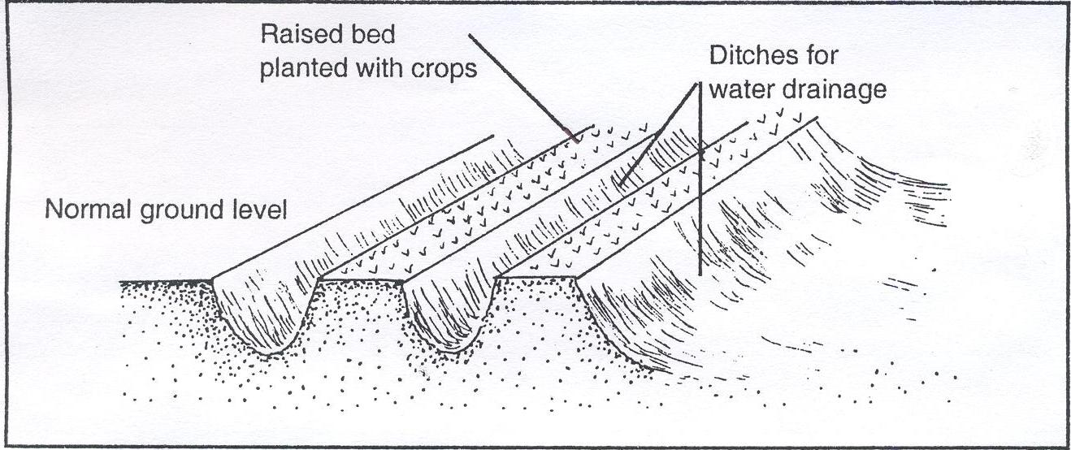
[a]Give the identity of the structure . [1 mark ]
……………………………………………………………………………………………………..
[b] State two functions of the above structure in agriculture . [2 marks ]
……………………………………………………………………………………………………………………………………………………………………………………………………………………………………………………………………
……………………………………………………………………………………………………………………………….

[c] Name two other methods that would supplement the above practice .[2 marks ]
……………………………………………………………………………………………………………………………..……………………………………………………………………………………………………………………………………
19.Study the following diagram of a tea nursery and answer questions that follow .
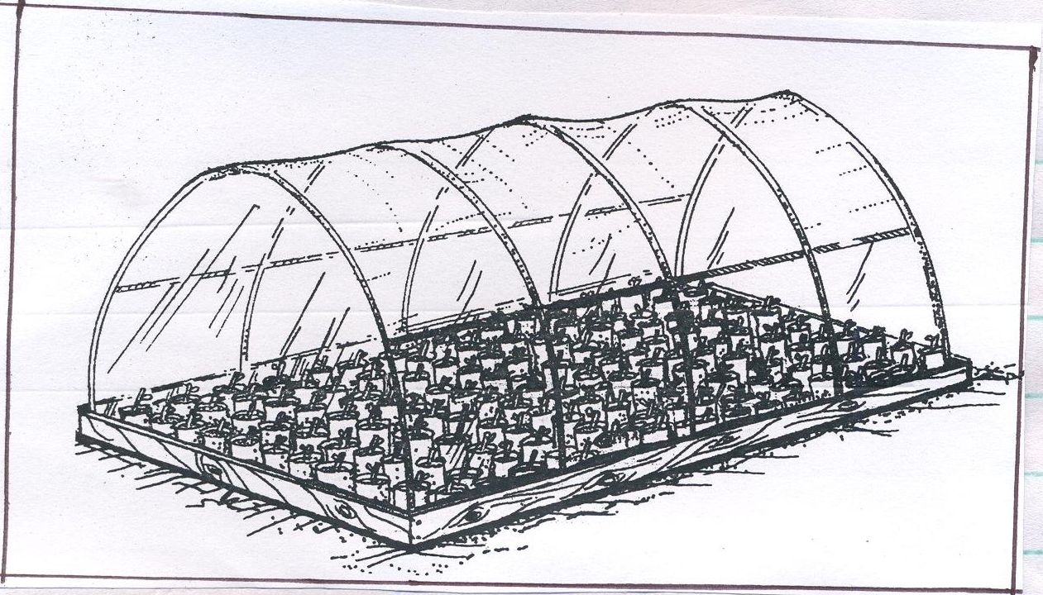
(a) State the importance of the transparent polythene sheet. (1 mark)
………………………………………………………………………………………………………………………………..
………………………………………………………………………………………………………………………………..
[b] Give two practices carried out when the tea seedlings are establishing in a nursery .[2marks]
…………………………………………………………………………………………………………………………………………………………………………………………………………………………………………………………………..
[c]State two advantages of using seedling boxes over ground nursery [ 2 marks ]
……………………………………………………………………………………………………………………………………………………………………………………………………………………………………………………………………………………………………………………………………………………………………………………………………..

20.Study the diagrams below and answer questions that follow .
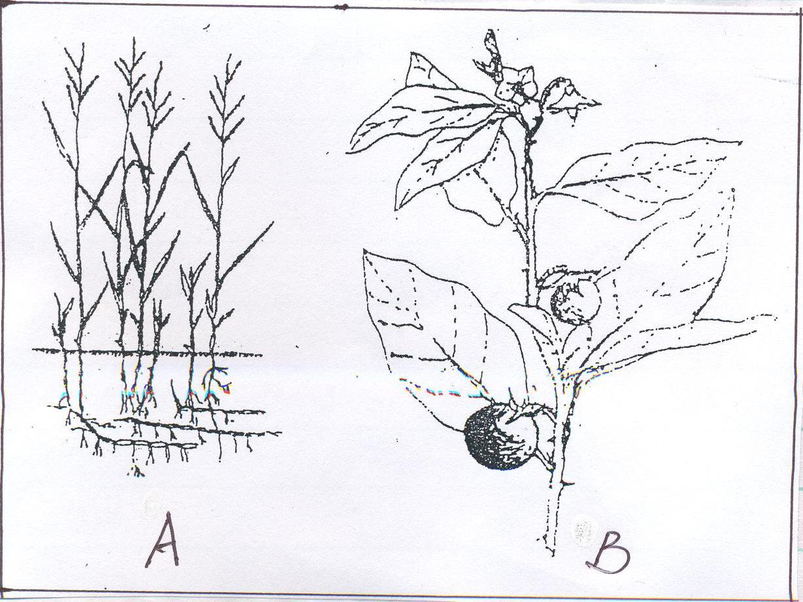
[a]Identify the above weeds . [ 2 marks ]
A……………………………………………………………………………………
B ……………………………………………………………………………………
[b]State two economic importance of the weed shown in diagram A [2marks]
……………………………………………………………………………………………………………………………………………………………………………………………………………………………………………………………………………………………………………………………………………………………………………………………………..
[c]Why is it difficult to control the weed in diagram A ? [1 mark ]
…………………………………………………………………………………………………………………………………………………………………………………………………………………………………………………………………….

21. The diagrams labeled E and H below are illustrations of coffee plants established using two different formative pruning systems .Examine the diagrams and answer the questions that follow .
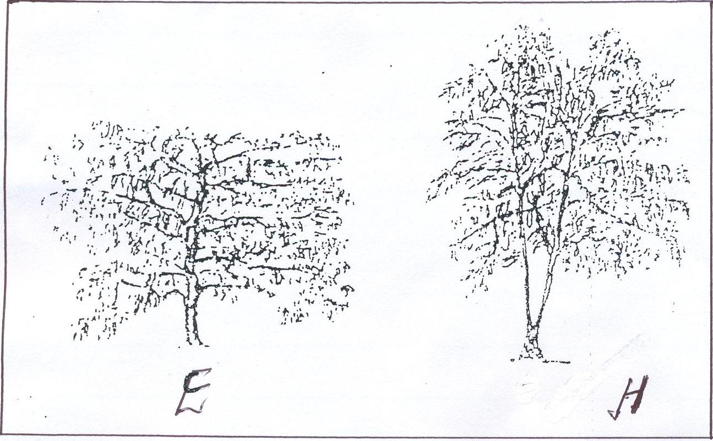
[a]Name the systems of pruning illustrated in diagram E . [1/2 mark ]
……………………………………………………………………………………………………………………….
[b] Name the system of pruning illustrated in diagram H . [ ½ mark ]
………………………………………………………………………………………………………………………
[c] Outline how the pruning system in the diagram H is carried out .[ 2 marks ]
………………………………………………………………………………………………………………………………………………………………………………………………………………………………………………………………………………………………………………………………………………………………………………………………………………………………………………………………………………………………………………………………………..
[d]Give two advantages of the pruning system illustrated in diagram E [2marks]
………………………………………………………………………………………………………………………………………………………………………………………………………………………………………………………………………………………………………………………………………………………………………………………………………………………………………………………………………………………………………………………………………….
SECTION C [40marks]
Answer any two questions from this section in the spaces provided after each question
22.[a]Explain seven effects of wind in agriculture .[7marks]
………………………………………………………………………………………………………………………………………………………………………………………………………………………………………………………………………………………………………………………………………………………………………………………………………………………………………………………………………………………………………………………………………………………………………………………………………………………………………………………………………………………………………………………………………………………………………………………………………………………………………………………………………………………………………………………………………………………………………………………………………………………………………………………………………………………………………………………………………………………………………………………………………………………………………………………………………………………………………………………………………………………………………………………………………………………………………………………………………………………………………………………………………………………………………………………………………………………………………………………………………………………………………………………………………………………………..
[b]Explain six reasons for carrying out minimum tillage . [6marks]
………………………………………………………………………………………………………………………………………………………………………………………………………………………………………………………………………………………………………………………………………………………………………………………………………………………………………………………………………………………………………………………………………………………………………………………………………………………………………………………………………………………………………………………………………………………………………………………………………………………………………………………………………………………………………………………………………………………………………………………………………………………………………………………………………………………………………………………………………………………………………………………………………………………………………………………………………………………………………………………………………………………..
[c]Explain seven methods of maintaining soil fertility . [7marks]
………………………………………………………………………………………………………………………………………………………………………………………………………………………………………………………………………………………………………………………………………………………………………………………………………………………………………………………………………………………………………………………………………………………………………………………………………………………………………………………………………………………………………………………………………………………………………………………………………………………………………………………………………………………………………………………………………………………………………………………………………………………………………………………………………………………………………………………………………………………………………………………………………………………………………………………………………………………………………………………………………………………………………………………………………………………………………………………………………………………………………………………………………………………………………………………………………………………………………………………………………………………………………………………………………………………………..
23.[a]Explain eight factors that influence soil erosion .[8marks]
……………………………………………………………………………………………………………………………………………………………………………………………………………………………………………………………………………………………………………………………………………………………………………………………………………………………………………………………………………………………………………………………………………………………………………………………………………………………………………………………………………………………………………………………………………………………………………………………………………………………………………………………………………………………………………………………………………………………………………………………………………………………………………………………………………………………………………………………………………………………………………………………………………………………………………………………………………………………………………………………………………………………………………………………………………………………………………………………………………………………………………………………………………………………………………………………………………………………..
[b] Outline seven cultural practices used to control crop diseases [ 7 marks ]
……………………………………………………………………………………………………………………………………………………………………………………………………………………………………………………………………………………………………………………………………………………………………………………………………………………………………………………………………………………………………………………………………………………………………………………………………………………………………………………………………………………………………………………………………………………………………………………………………………………………………………………………………………………………………………………………………………………………………………………………………………………………………………………………………………………
[c]Describe the precautions taken when harvesting the following crops :
Sugarcane [2marks]
………………………………………………………………………………………………………………………………………………………………………………………………………………………………………………………………………………………………………………………………………………………………………………………………………
Pyrethrum [3marks]
……………………………………………………………………………………………………………………………………………………………………………………………………………………………………………………………………………………………………………………………………………………………………………………………………………………………………………………………………………………………………………………………………………………………………………………………………………………………………………………………………………
24.[a]Discuss five factors that influence the quality of harvested rain water .[5marks]
………………………………………………………………………………………………………………………………………………………………………………………………………………………………………………………………………………………………………………………………………………………………………………………………………………………………………………………………………………………………………………………………………………………………………………………………………………………………………………………………………………………………………………………………………………………………………………………………………………..
[b]Outline five factors to be considered before deciding on irrigation in crop production .[8marks]
……………………………………………………………………………………………………………………………………………………………………………………………………………………………………………………………………………………………………………………………………………………………………………………………………………………………………………………………………………………………………………………………………………………………………………………………………………………………………………………………………………………………………………………………………………………………………………………………………………………………………………………………………………………………………………………………………………………………………………………………………………………………………………………………………………………………………………………………………………………………………………………………………………………..
[c] Give five pieces of information found in a breeding record .[5marks]
………………………………………………………………………………………………………………………………………………………………………………………………………………………………………………………………………………………………………………………………………………………………………………………………………………………………………………………………………………………………………………………………………………………………………………………………………………………………………………………………………………………………………………………………………………………………………………………………………………
Give two importance of keeping breeding records .[2marks]
………………………………………………………………………………………………………………………………………………………………………………………………………………………………………………………………………………………………………………………………………………………………………………………………………..

