Name……………………………………….Index No……………………Class………….
443/2
AGRICULTURE
PAPER 2
March/April 2014.
2 Hours
MOKASA JOINT EXAMINATION 2014
AGRICULTURE
PAPER 2
2 HOURS
INSTRUCTIONS TO THE CANDIDATES
-Write your name, admission number in the space provided above
-This paper consist of three sections: A,B and C. Answer all questions in sections A and B.
-Answer any two questions from section C
-Answers to all questions must be written in the spaces provided in this booklet.
FOR EXAMINER’S USE ONLY
SECTION | QUESTION | MAXIMUM SCORE | CANDIDATES SCORE
A | 1-18 | 30
B | 19-22 | 20
C |  | 20
C |  | 20
TOTAL |  | 90

SECTION A (30 Marks)
Answer all the questions in this section in the space provided.
- State three effects of tsetse fly on cattle (1 ^{½} mark)
………………………………………………………………………………………………………………………………………………………………………………………………………………………………………………………………………………………………………………………
- State four signs of furrowing observed in pigs (2marks)
………………………………………………………………………………………………………………………………………………………………………………………………………………………………………………………………………………………………………………………………………………………………………………………………………………………………

- Give three factors that affect the quality of honey (1 ½ mark)
………………………………………………………………………………………………………………………………………………………………………………………………………………………………………………………………………………………………………………………
- Give three factors that may make birds to lay eggs on the floor in a deep litter.
( 1 ½ mark)
………………………………………………………………………………………………………………………………………………………………………………………………………………………………………………………………………………………………………………………

- Give three characteristics of clean and high quality milk. (1 ½ mark)
………………………………………………………………………………………………………………………………………………………………………………………………………………………………………………………………………………………………………………………
- Name four products of milk (2marks)
………………………………………………………………………………………………………………………………………………………………………………………………………………………………………………………………………………………………………………………

- State four signs of liver fluke infestation in cattle (2marks)
………………………………………………………………………………………………………………………………………………………………………………………………………………………………………………………………………………………………………………………………………………………………………………………………………………………………
- Give four reasons of breeding in cattle (2marks)
………………………………………………………………………………………………………………………………………………………………………………………………………………………………………………………………………………………………………………………………………………………………………………………………………………………………
- List four methods of preserving fish (2marks)
………………………………………………………………………………………………………………………………………………………………………………………………………………………………………………………………………………………………………………………………………………………………………………………………………………………………
- Give two reasons for culling a breeding boar (1mark)
……………………………………………………………………………………………………………………………………………………………………………………………………………….
- List two factors a farmer should consider when grading eggs for marketing
(1mark)
………………………………………………………………………………………………………………………………………………………………………………………………………………
- Give two reasons for flushing in sheep (1mark)
………………………………………………………………………………………………………………………………………………………………………………………………………………

- Give four reasons for treating timber used in construction of farm building
(2marks) ………………………………………………………………………………………………………………………………………………………………………………………………………………………………………………………………………………………………………………………………………………………………………………………………………………………………

- State four factors that influence the daily water intake in an animal (2marks)
………………………………………………………………………………………………………………………………………………………………………………………………………………………………………………………………………………………………………………………………………………………………………………………………………………………………

- State two causes of egg eating in birds. (1mark)
………………………………………………………………………………………………………………………………………………………………………………………………………………………………………………………………………………………………………………………………………………………………………………………………………………………………
- Give four characteristics of a good calf pen. (2marks)
………………………………………………………………………………………………………………………………………………………………………………………………………………………………………………………………………………………………………………………………………………………………………………………………………………………………
- State four factors that influence the choice of the poultry system of rearing to use.
(2marks) ………………………………………………………………………………………………………………………………………………………………………………………………………………………………………………………………………………………………………………………………………………………………………………………………………………………………
- Give four methods of administering vaccines in poultry. (2marks)
……………………………………………………………………………………………………………………………………………………………………………………………………………………………………………………………………………………………………………………………………………………………………………………………………………………..

SECTION B (20 Marks)
Answer all questions in this section in the space provided.
- The diagram below is a cross section of part of a cow’s udder.
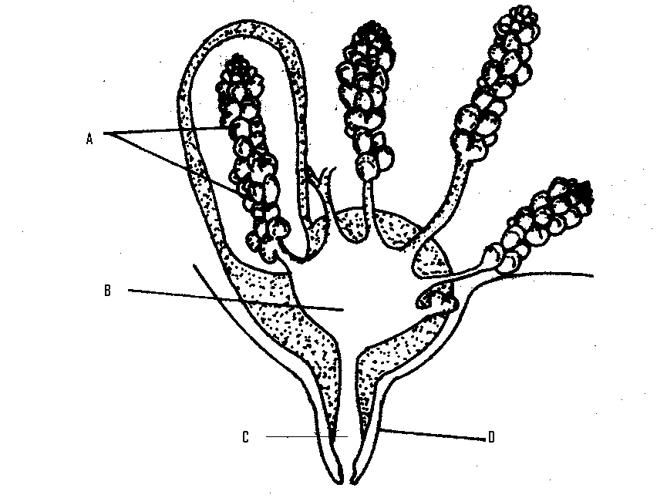
- Label the parts marked A,B,C and D (2marks)
A………………………………………………………………………………………

B………………………………………………………………………………………..

C………………………………………………………………………………………...

D………………………………………………………………………………………..

- Name two hormones that control milk – let down in a dairy cow. (2marks)
………………………………………………………………………………………………………………………………………………………………………………………………………………
- What is a dry cow therapy? (1mark)
……………………………………………………………………………………………………

- The diagram below shows the head of a chicken having symptoms of a poultry disease.
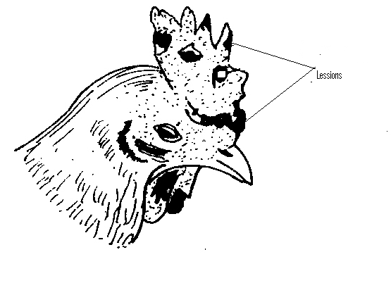
- Identify the disease. (1mark)
………………………………………………………………………………………………………………………………………………………………………………………………………………
- Give two reasons why the disease is of economic importance. (2marks)
……………………………………………………………………………………………………………………………………………………………………………………………………………………………………………………………………………………………………………………
- Outline two methods of controlling the above disease. (2marks)

………………………………………………………………………………………………………………………………………………………………………………………………………………………………………………………………………………………………………………………

- The following diagram shows parts of a roof. Study it carefully and answer the questions that follow.
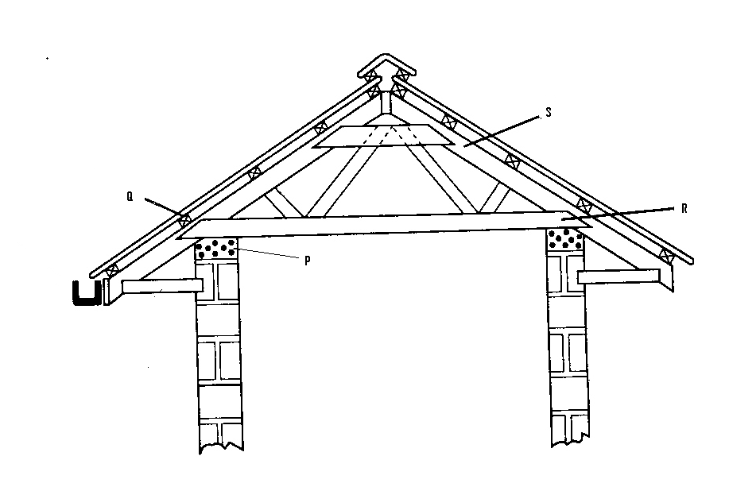
- Name the parts labeled P, Q, R and S (2marks)
p………………………………………………………………………………………...

Q………………………………………………………………………………………..

R………………………………………………………………………………………..

S………………………………………………………………………………………

- State the functions of P and Q (2marks)
P…………………………………………………………………………………….

Q……………………………………………………………………………………..

- Give one chemical preservative for treating timber before use in the construction of farm structures. (2marks)
……………………………………………………………………………………………………………………………………………………………………………………………………………

- Below is a diagram of power transmission system of a tractor engine. Study it and answer the questions that follow.
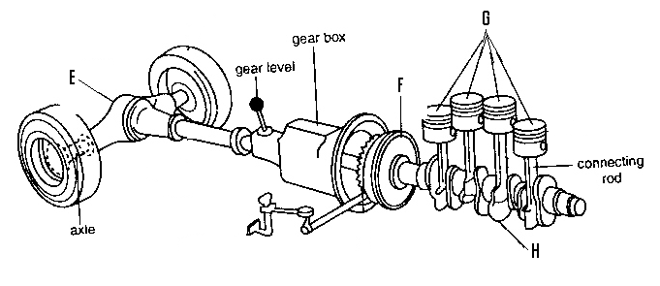
- Name the parts labeled E,F,G and H (2marks)
E………………………………………………………………………………………...

F………………………………………………………………………………………...

G………………………………………………………………………………………..

H………………………………………………………………………………………
- State the functions of E and H. (2marks)
E………………………………………………………………………………………..
H……………………………………………………………………………………….

SECTION C (40 Marks)
Answer any two questions in this section in the spaces provided after each question.
- (a) Describe five pre-disposing factor of livestock diseases. (5marks)
………………………………………………………………………………………………………………………………………………………………………………………………………………………………………………………………………………………………………………………………………………………………………………………………………………………………………………………………………………………………………………………………………………………………………………………………………………………………………………………………………………………………………………………………………………………………………………………………………………………………………………………………………………………………………………………………………………………………………………………………………………………………………………………………………………………………………………………………………………………………………………………………………………………………………………………………………………………………………………………………………………………………………………………………………………………………………………………………………………………………………………………………………………………………………………………………………………………
- Describe six mechanical methods of controlling ticks (6marks)

………………………………………………………………………………………………………………………………………………………………………………………………………………………………………………………………………………………………………………………………………………………………………………………………………………………………………………………………………………………………………………………………………………………………………………………………………………………………………………………………………………………………………………………………………………………………………………………………………………………………………………………………………………………………………………………………………………………………………………………………………………………………………………………………………………………………………………………………………………………………………………………………………………………………………………………………………………………………………………………………………………………………………………………………………………………………………………………………………………………………………………………………………………………………………………………………………………………
- Describe the factors that affect milk composition of a cow (9marks)

……………………………………………………………………………………………………………………………………………………………………………………………………………………………………………………………………………………………………………………………………………………………………………………………………………………………………………………………………………………………………………………………………………………………………………………………………………………………………………………………………………………………………………………………………………………………………………………………………………………………………………………………………………………………………………………………………………………………………………………………………………………………………………………………………………………………………………………………………………………………………………………………………………………………………………………………………………………………………………………………………………………………………………………………………………………………………………………………………………………………………………………………………………………………………………………………………………………………………………………………………………………..

- (a) (i) Describe the conditions where animal product is preferred to other source of power. (5marks)
………………………………………………………………………………………………………………………………………………………………………………………………………………………………………………………………………………………………………………………………………………………………………………………………………………………………………………………………………………………………………………………………………………………………………………………………………………………………………………………………………………………………………………………………………………………………………………………………………………………………………………………………………………………………………………………………………………………………………………………………………………………………………………………………………………………………………………………………………………………………………………………………………………………………………………………………………………………………………………………………………………………………………………………………………………………………………………………………………………………………………………………………………………………………………………………………………………………
(ii) Explain five advantages of using a mould board plough in seed bed preparation. (5marks)
………………………………………………………………………………………………………………………………………………………………………………………………………………………………………………………………………………………………………………………………………………………………………………………………………………………………………………………………………………………………………………………………………………………………………………………………………………………………………………………………………………………………………………………………………………………………………………………………………………………………………………………………………………………………………………………………………………………………………………………………………………………………………………………………………………………………………………………………………………………………………………………………………………………………………………………………………………………………………………………………………………………………………………………………………………………………………………………………………………………………………………………………………………………………………………………………………………………
(b) Describe the use of various materials in construction of a Kenya to hive
(5marks)
………………………………………………………………………………………………………………………………………………………………………………………………………………………………………………………………………………………………………………………………………………………………………………………………………………………………………………………………………………………………………………………………………………………………………………………………………………………………………………………………………………………………………………………………………………………………………………………………………………………………………………………………………………………………………………………………………………………………………………………………………………………………………………………………………………………………………………………………………………………………………………………………………………………………………………………………………………………………………………………………………………………………………………………………………………………………………………………………………………………………………………………………………………………………………………………………………………………

- Outline the care and maintenance of a tractor water cooling system. (5marks)
………………………………………………………………………………………………………………………………………………………………………………………………………………………………………………………………………………………………………………………………………………………………………………………………………………………………………………………………………………………………………………………………………………………………………………………………………………………………………………………………………………………………………………………………………………………………………………………………………………………………………………………………………………………………………………………………………………………………………………………………………………………………………………………………………………………………………………………………………………………………………………………………………………………………………………………………………………………………………………………………………………………………………………………………………………………………………………………………………………………………………………………………………………………………………………………………………………………
- (a) (i) State four physical body processes considered when assessing on animal health. (4marks)
………………………………………………………………………………………………………………………………………………………………………………………………………………………………………………………………………………………………………………………………………………………………………………………………………………………………………………………………………………………………………………………………………………………………………………………………………………………………………………………………………………………………………………………………………………………………………………………………………………………………………………………………………………………………………………………………………………………………………………………………………………………………………………………………………………………………………………………………………………………………………………………………………………………………………………………………………………………………………………………………………………………………………………………………………………………………………………………………………………………………………………………………………………………………………………………………………………………

(ii) Explain nine factors considered when selecting a breeding stock. (9marks)
………………………………………………………………………………………………………………………………………………………………………………………………………………………………………………………………………………………………………………………………………………………………………………………………………………………………………………………………………………………………………………………………………………………………………………………………………………………………………………………………………………………………………………………………………………………………………………………………………………………………………………………………………………………………………………………………………………………………………………………………………………………………………………………………………………………………………………………………………………………………………………………………………………………………………………………………………………………………………………………………………………………………………………………………………………………………………………………………………………………………………………………………………………………………………………………………………………………
(b) Describe milk fever in dairy cattle under the following sub-headings.
(i) the cause of the disease (1mark)
……………………………………………………………………………………………………..

(ii) Symptoms of the disease (4marks)
………………………………………………………………………………………………………………………………………………………………………………………………………………………………………………………………………………………………………………………………………………………………………………………………………………………………………………………………………………………………………………………………………………………………………………………………………………………………………………………………………………………………………………………………………………………………………………………………………………………………………………………………………………………………………………………………………………………………………
(iii) Control measures (2marks)
………………………………………………………………………………………………………………………………………………………………………………………………………………………………………………………………………………………………………………………………………………………………………………………………………………………………

