NAME ……………………………………………….. INDEX NO…………..……………..
CLASS……………… ADM. No………………SIGNATURE………………………………
DATE……………..…………………...
231/3
BIOLOGY
PAPER 3
(PRACTICAL)
MARCH/APRIL 2014
1³/₄ HOURS

MOKASA JOINT EXAMINATION 2014

Kenya Certificate of Secondary Education (K.C.S.E)

INSTRUCTIONS TO CANDIDATES

- Write your name, Index Number, Class and Admission Number in the spaces provided above.
- Sign and write date of examination in the spaces provided above.
- Answer ALL questions in the spaces provided in the question paper.
- You are not allowed to start working with the apparatus for the first 15 minutes of the 1³/₄ hours allowed for this paper. This time is to enable you to read the question paper and make sure you have all the chemicals and apparatus that you may need.
- All workings must be clearly shown where necessary.
- Answer the questions in English

For Examiners use only.
Question | Maximum Score | Candidates Score
1 | 15
2 | 13
3 | 12
Total score | 40

This paper consists of 6 Printed pages. Candidates should check the question paper to ensure that all the papers are printed as indicated and no questions are missing

- You are provided with two solids A and B in boiling tubes. Add 6ml of distilled water to boiling tube A mix and label the resulting mixture as solution A. Divide the solution A into equal portions in three separate test tubes all labelled A, each of which will be used for a food test in the table below.
Add 6ml of distilled water to boiling tube B mix and label the resulting mixture as solution B. Divide the solution B into equal portions in three separate test tubes all labelled B, each of which will be used for a food test in the table below.

- Using the reagents provided carry out food tests to determine the food substances present in solutions A and B in each of the test tubes. In each case, record the procedure followed, observation and conclusion made in the table below. (10mks)

Solution | Food substance | Procedure | Observation | Conclusion
A | Reducing sugars
A | Proteins
B | Reducing sugars
B | Proteins

(b) (i) Which of the two solids would be appropriate to be included in a diet of a family whose children suffer from Kwashiorkor? (1mrk)
………………………………………………………………………………………………………
(ii) Give a reason for your answer in (b) (i) above (1mrk)
………………………………………………………………………………………………………………………………………………………………………………………………………………
c) (i) Name the part of the digestive system where digestion of the food substance(s) found in solid B starts (1mrk)
……………………………..……………………………………………………..……………….
(ii) Name the enzyme which starts the digestion of the food substance in solid B. (1mrk)
………………………………………………………………………………………………………
d) State one way in which the food substance in solid A is important to living organisms. (1mrk)
……………………………………………………………………………………………………………………………………………………………………………………………………………… 2. The photomicrograph below shows the arrangement of different types of cells and tissues in a certain living organism. Study it carefully and answer the questions that follow.
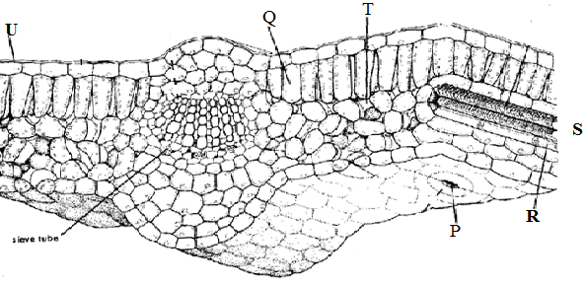
3rd cell
- i) From what part of the plant was the photograph obtained? (1mark)
…………………………………………………………………………………………………
ii) Name the parts labeled: - (5marks)
P. ……………………………………………………………………………………………….
Q. ……………………………………………………………………………………………….
U. ……………………………………………………………………………………………….
R………………………………………………………………………………………………..
T………………………………………………………………………………………………..
iii) Give two major components that make up structure S. (2marks)
…………………………………………………………………………………………………………………..…………………………………………………………………………………
iv) State the function of the part labeled Q and an adaptation to its function. (2marks)
Function…………………………………………………………………………………………………………………………………………………………………………………………Adaptation……………………………………………………………………………………………………………………………………………………………………………………………………………………………………………………………………………………………..
v) Give an environmental factor which regulates the function of the part labeled P. (1mark)
……………………………………………………………………………………………………………………………………………………………………………………………………..
- Measure the length of the third (3rd) cell at the right side of structure labeled Q on the photograph whose magnification is X5000. What is the actual length of the cell in micrometers (µm)? Show your working. (2marks)

- The photograph below represents human male urinary system. Study it carefully and answer the questions that follow.

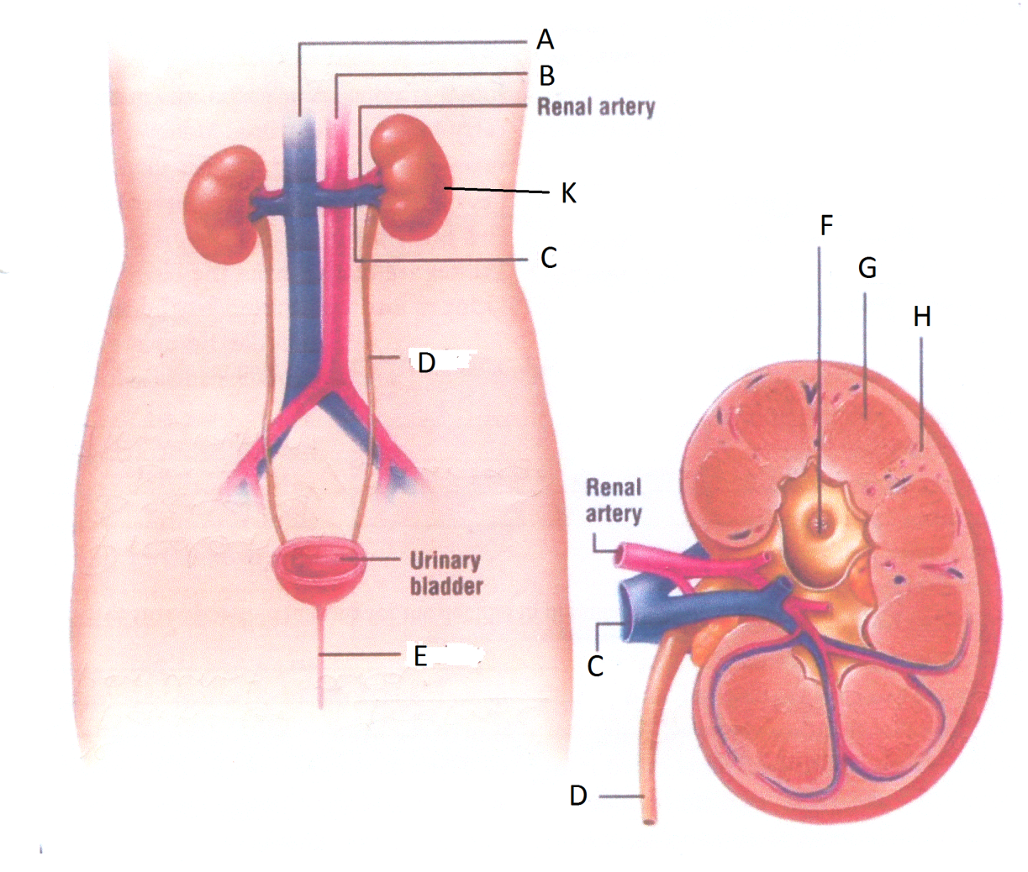
Longitudinal Section of K

- State two functions of the part labeled K. (2 Marks)
………………………………………………………………………………………………………………………………………………………………………………………………………………………………………………………………………………………………………………………
- Name the parts labeled A, B, C, D, F, G, and H. (7 Marks)

A………………………………………………………………………………………..............

B………………………………………………………………………………………………...

C………………………………………………………………………………………………...

D………………………………………………………………………………………………..

F………………………………………………………………………………………………...

G………………………………………………………………………………………………..

H………………………………………………………………………………………………...

- State the functions of each of the following parts;

- Renal artery (1 Mark)
………………………………………………………………………………………………………………………………………………………………………………………………………………
- Urinary bladder (1 Mark)

………………………………………………………………………………………………………………………………………………………………………………………………………………
- Part labeled E (1 Mark)

………………………………………………………………………………………………………………………………………………………………………………………………………………………………………………………………………………………………………………………

