312/2
GEOGRAPHY
PAPER 2
MARCH/APRIL 2014
TIME: 2³/₄ HOURS
MOKASA JOINT EXAMINATION
Kenya certificate of Secondary Education
312/2
Paper 2
GEOGRAPHY
INSTRUCTIONS TO THE STUDENTS
This paper has two sections A and B
Answer ALL the questions in section A. In section B answer question 6 and any other TWO questions.

SECTION A
Answer ALL the questions in this section.
1.(a) Name two main cattle breeds reared by nomadic pastoralists in Kenya. (2marks)
(b)State three environmental conditions which favour beef farming in
Argentina. (3marks)
2(a) Name two minerals mined using panning method (2marks)

(b) The diagram below shows the occurrence of oil in the rock structure. Use it to answer the question below.
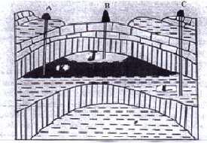
Name the parts marked J,K and L (3marks)
3. (a) What is Game Sanctuary? (2marks)
(b)Name three marine National Parks at the coast of Kenya. (3marks)
4(a) Identify sources of the following forms of energy:
Geothermal Energy. (1mark)
Nuclear energy. (1mark)
(b)State three reasons why geothermal energy sector is underdeveloped in
Kenya. (3makrs)
5. (a) Differentiate between transport and communication (2marks)
(b) State three reasons why there is decline in the use of letter writing in Kenya (3marks)
SECTION B
Answer question 6 and any other TWO questions from this section
6. The table below shows the amount of cocoa production in metric tones in the three countries of West Africa between 2008 to 2010 use it to answer the questions that follow.
Origin/year | 2008 | 2009 | 2010
Ghana | 80,000 | 50,000 | 45,000
Nigeria | 70,000 | 40,000 | 35,000
Cote de voire | 40,000 | 30,000 | 25,000
(a)(i)Using a scale of 1cm to represent 20,000 metric tonnes of cocoa, draw a compound bar graph to represent this data. (7marks)
(ii)Calculate the percentage of cocoa production in the year 2010 (1mark)
(iii)Explain two factors that might have caused a fall in cocoa production in the year 2010. (2marks)
(b)Draw the map of Ghana and on it mark (1mark)
(i) Shade the cocoa growing area. (1mark)
(ii)Mark and name Kumasi and Accra town (2marks)
(c)(i)State three physical conditions that favour cocoa growing. (3marks)
(ii)Describe cocoa growing from land preparation to harvesting (6marks)
(d)State three economic benefits of Cocoa in Ghana. (2marks)
7(a)(i) what is fish farming? (2marks)
(ii)Explain three ways through which fish farming contributes to the economy of
Kenya. (6marks)
(b)Study the map of Africa below and use it to answer the questions that follow.
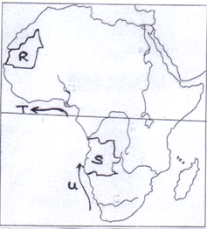
(i)Name the country marked S and R. (2marks)
(ii)Name the ocean currents marked T and U. (2marks)
(iii)Explain how the nature of the coastline of Africa discourages fishing (6marks)
(c)Study the diagram below and use it to answer the questions (i) and (ii).
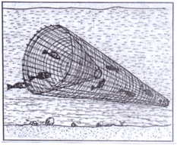
i)Name the method of fishing shown above. (1mark)
(ii)Describe how the method is used in fishing. (3marks)
(d)State three ways in which the Kenya government is promoting fishing industry in the country. (3marks)
8.(a)(i)Give two methods used to reclaim land in Kenya (2marks)
(ii)State three benefits that resulted from the reclamation of the Yala swam (3marks)
(b) (i)Explain four physical factors that made MweaTebere a suitable location for irrigation (8marks)
(ii)Name two major rivers that supply water to to the MweaTebere irrigation
Scheme. (2marks)
(c) (i)Describe the stages in the reclamation of land from the sea in the
Netherlands. (6marks)
(iii)Explain two differences between land reclamation in Kenya and the
Netherlands. (4marks)

9.(a)(i)What is eco-tourism? (2marks)
(ii)Differentiate between domestic tourism and international tourism (2marks)
(b)(i)Explain four reasons why Kenya attracts more tourists than other East African countries. (8marks)
(ii)Apart from encouraging domestic tourism describe three other measures which the government has taken to promote tourism in Kenya. (3marks)
(iii) Outline four tourism attractions that exist in Switzerland but not found in
East Africa (4marks)
(c)You are supposed to carry out a field study on the effect of tourism at the coast.
(i)State two methods you would use to collect the information (2marks)
(ii)State two reasons why you would need a time schedule (2marks)
(iii)State two negative problems associated with tourism that you would
observe. (2marks)
10.(a)(i)What is reafforestation? (2marks)
(ii) State four reasons why afforest ration should be encouraged in
Kenya. (4marks)
(b)(i)Name two main exotic softwood trees grown in Kenya. (2marks)
(ii)State five characteristics of softwood forests in Canada. (5marks)
(c)Explain three problems which hinder the Kenya governments’ effort to manage and conserve her forests. (6marks)
(d)Compare forestry in Kenya and Canada under the following –headings:
(i)Transportation of the logs. (2marks)
(ii)Felling of trees. (2marks)
(iii)Tree species. (2marks)

