NAME ……………………………………..……………….. DATE …………………………………

ADM NO. …………….……….……..…..… CANDIDATE’S SIGNATURE …………..…..………..

443/1
AGRICULTURE
PAPER 1 (THEORY)
TIME: 2 HOURS

MBOONI WEST SUB - COUNTY FORM FOUR JOINT EVALUATION TEST, 2014

Kenya Certificate of Secondary Education

443/1
AGRICULTURE
PAPER 1 (THEORY)
JULY/AUGUST 2014
TIME: 2 HOURS

INSTRUCTIONS TO CANDIDATES
- Write your name and ADM number in the spaces provided above.
- This paper has THREE sections: A , B and C
- Answer ALL the questions in section A and B and any TWO questions in section C
- ALL answers MUST be written in the spaces provided.
- Do not remove any pages from this booklet.
- This paper consists of 10 printed pages. Candidates should check to ensure that all pages are printed as indicated and no questions are missing

FOR EXAMINER’S USE ONLY

 | Questions | Maximum score | Candidate’s score
A | 01 - 16 | 30 marks
B | 17 - 21 | 20 marks
C | 22 - 24 | 40 marks
 |  | Total score

© 2014, Mbooni West Sub – County Form Four Joint Evaluation test
443/1
Agriculture
Paper 1 (theory)

SECTION A (30 MARKS)
Answer all the questions in this section in the spaces provided.
- Name the method used in propagating each of the following crops. (1½ marks)
- Carrot
................................................................................................................................................................................................................................................................................................................................................
- Sugarcane
................................................................................................................................................................................................................................................................................................................................................
- Pineapple
................................................................................................................................................................................................................................................................................................................................................
- Name two methods of farming considered out dated. (1mark)
................................................................................................................................................................................................................................................................................................................................................
- Name four books of account kept by a farmer (2marks)
................................................................................................................................................................................................................................................................................................................................................
................................................................................................................................................................................................................................................................................................................................................
- a) State two causes of accumulation of salts in the soil (1mark)
................................................................................................................................................................................................................................................................................................................................................
b) How does salt accumulation result into soil infertility (1mark)
................................................................................................................................................................................................................................................................................................................................................
- outline four properties of clean water (2marks)
................................................................................................................................................................................................................................................................................................................................................
................................................................................................................................................................................................................................................................................................................................................
- List three details contained in a field operation record. (1½ marks)
................................................................................................................................................................................................................................................................................................................................................
........................................................................................................................................................................

- Distinguish between (2marks)
- Soil sampling and soil testing
................................................................................................................................................................................................................................................................................................................................................
- Hybrid and composite as used in maize production
................................................................................................................................................................................................................................................................................................................................................
- Mention two factors that encourage damping off disease in the nursery (1mark)
................................................................................................................................................................................................................................................................................................................................................
- Give four causes of failure in pasture establishment (2marks)
................................................................................................................................................................................................................................................................................................................................................
................................................................................................................................................................................................................................................................................................................................................
- State four effects of post-election violence in agriculture (2marks)
................................................................................................................................................................................................................................................................................................................................................
................................................................................................................................................................................................................................................................................................................................................
- State four properties of the soil influenced by soil texture (2marks)
................................................................................................................................................................................................................................................................................................................................................
................................................................................................................................................................................................................................................................................................................................................
- State two role of household firm relationship in Kenyan economy (2marks)
................................................................................................................................................................................................................................................................................................................................................
- Highlight any four deficiency symptoms that will be observed in crops lacking potassium (2marks)
................................................................................................................................................................................................................................................................................................................................................
................................................................................................................................................................................................................................................................................................................................................
- State four objectives of land reform in Kenya. (2marks)
................................................................................................................................................................................................................................................................................................................................................
................................................................................................................................................................................................................................................................................................................................................
- State four methods used in clearing land before primary cultivation (2marks)
................................................................................................................................................................................................................................................................................................................................................
................................................................................................................................................................................................................................................................................................................................................
- Give four influences that soil depth has in crop production (2marks)
................................................................................................................................................................................................................................................................................................................................................
................................................................................................................................................................................................................................................................................................................................................
- State two factors that influence the type of farm records in a given farm (1mark)
................................................................................................................................................................................................................................................................................................................................................

SECTION B (20 MARKS)
Answer all the questions in this section in the spaces provided.

- Study the illustration given below and use it to answer the questions that follow
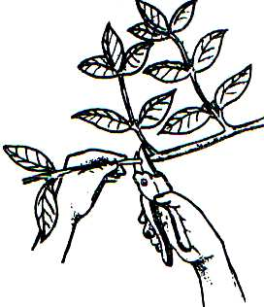

- Identify the operation illustrated above ( ½ mark)
................................................................................................................................................................................................................................................................................................................................................
- State four reasons for carrying out the operation named in (a) above (2marks)
................................................................................................................................................................................................................................................................................................................................................
................................................................................................................................................................................................................................................................................................................................................

- Name any two perennial crops which require the operation stated in (a) above (1mark)
................................................................................................................................................................................................................................................................................................................................................
- Below is a diagram of a weed. Study it and answer the questions that follow
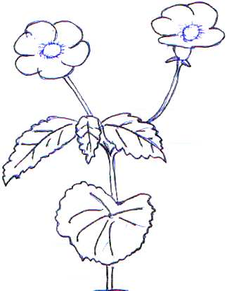

- Identify the weed above (½ mark)
................................................................................................................................................................................................................................................................................................................................................
- List two economic importance of the weed identified in (i) above (2mark)
................................................................................................................................................................................................................................................................................................................................................
- Give two methods that can be used to control the weed illustrated (1mark)
................................................................................................................................................................................................................................................................................................................................................
- The illustration below shows a method used in draining a water logged land. Use it to answer the question that follow.
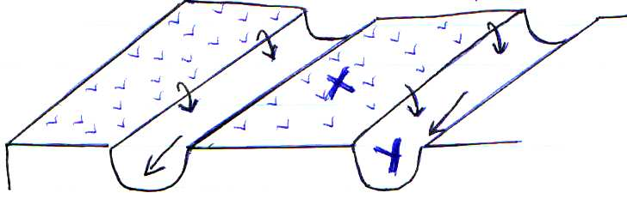

- Identify the structure (½ mark)
................................................................................................................................................................................................................................................................................................................................................
- Apart from the illustration name four other methods of drainage (2marks)
................................................................................................................................................................................................................................................................................................................................................
................................................................................................................................................................................................................................................................................................................................................
- Name the parts labelled X and Y (1mark)
................................................................................................................................................................................................................................................................................................................................................
- Name any two crops that can be planted in the part labelled X (1mark)
................................................................................................................................................................................................................................................................................................................................................
- Study the diagram below of the cut off drain and answer the questions that follow
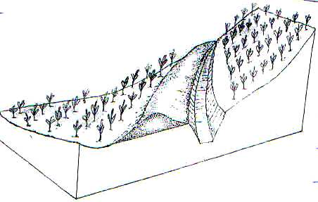

- Briefly outline the procedure of constructing a cut off drain (3marks)
................................................................................................................................................................................................................................................................................................................................................
................................................................................................................................................................................................................................................................................................................................................
................................................................................................................................................................................................................................................................................................................................................
- What type of slope are cut off drains constructed in (1mark)
................................................................................................................................................................................................................................................................................................................................................
- State two factors that determine the size of cut off drains (1mark)
................................................................................................................................................................................................................................................................................................................................................

- Study the diagram below of crop propagation and answer the following questions
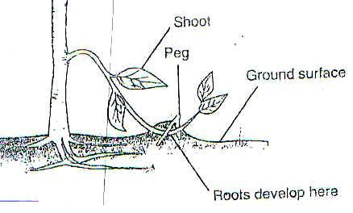

- Identify the propagation method (½ mark)
...............................................................................................................................................................................................................................................................................................................................................
- State two factors that encourage root formation in the above method of propagation (2marks)
...............................................................................................................................................................................................................................................................................................................................................
...............................................................................................................................................................................................................................................................................................................................................
- Name two crops that can be propagated using the above method (1mark)
...............................................................................................................................................................................................................................................................................................................................................
SECTION C (40 MARKS)
Answer only two questions in this section in the spaces provided.
- a) Mention and explain five sites for agroforestry trees in the farm (10marks)
b) Describe the production of bulrush under the following subheading
i) Ecological requirements (4marks)
ii) Field preparation and planting (6marks)
- a) Describe the precautions a farmer should put into consideration when harvesting cotton (5marks)
b) Give five safety measures that should be taken while spraying crops with fungicides (5marks)
c) Briefly describe the factors influencing demand (10marks)
- a) Identify 5 functions played by cotton board of kenya (5marks)
b) Mutua’s farm made the following purchases on credit from kenya farmers association on 30th March
2014.
10 bags dairy meal 70kgs @ Kshs. 1500
18bags of bran 70kgs @ Kshs. 1000
18bags of TSP 50kgs each @ Kshs,. 1500
30bags of maize seeds each 2kgs @ Kshs. 300
Prepare a purchase order that Mutua’s farm made to K.F.A (5marks)
c) State five factors that should be considered when classifying crop pests (5marks)
d) Describe the procedure of innoculating legume seeds before planting (5marks)

...............................................................................................................................................................................................................................................................................................................................................
...............................................................................................................................................................................................................................................................................................................................................
...............................................................................................................................................................................................................................................................................................................................................
...............................................................................................................................................................................................................................................................................................................................................
...............................................................................................................................................................................................................................................................................................................................................
...............................................................................................................................................................................................................................................................................................................................................
...............................................................................................................................................................................................................................................................................................................................................
...............................................................................................................................................................................................................................................................................................................................................
...............................................................................................................................................................................................................................................................................................................................................
...............................................................................................................................................................................................................................................................................................................................................
...............................................................................................................................................................................................................................................................................................................................................
...............................................................................................................................................................................................................................................................................................................................................
...............................................................................................................................................................................................................................................................................................................................................
...............................................................................................................................................................................................................................................................................................................................................
...............................................................................................................................................................................................................................................................................................................................................
...............................................................................................................................................................................................................................................................................................................................................
...............................................................................................................................................................................................................................................................................................................................................
...............................................................................................................................................................................................................................................................................................................................................
...............................................................................................................................................................................................................................................................................................................................................
...............................................................................................................................................................................................................................................................................................................................................
...............................................................................................................................................................................................................................................................................................................................................
...............................................................................................................................................................................................................................................................................................................................................
...............................................................................................................................................................................................................................................................................................................................................
...............................................................................................................................................................................................................................................................................................................................................
...............................................................................................................................................................................................................................................................................................................................................
...............................................................................................................................................................................................................................................................................................................................................
...............................................................................................................................................................................................................................................................................................................................................
...............................................................................................................................................................................................................................................................................................................................................
...............................................................................................................................................................................................................................................................................................................................................
...............................................................................................................................................................................................................................................................................................................................................
...............................................................................................................................................................................................................................................................................................................................................
...............................................................................................................................................................................................................................................................................................................................................
...............................................................................................................................................................................................................................................................................................................................................
...............................................................................................................................................................................................................................................................................................................................................
...............................................................................................................................................................................................................................................................................................................................................
...............................................................................................................................................................................................................................................................................................................................................
...............................................................................................................................................................................................................................................................................................................................................
...............................................................................................................................................................................................................................................................................................................................................
...............................................................................................................................................................................................................................................................................................................................................
...............................................................................................................................................................................................................................................................................................................................................
...............................................................................................................................................................................................................................................................................................................................................
...............................................................................................................................................................................................................................................................................................................................................
...............................................................................................................................................................................................................................................................................................................................................
...............................................................................................................................................................................................................................................................................................................................................
...............................................................................................................................................................................................................................................................................................................................................
...............................................................................................................................................................................................................................................................................................................................................
...............................................................................................................................................................................................................................................................................................................................................
...............................................................................................................................................................................................................................................................................................................................................
...............................................................................................................................................................................................................................................................................................................................................
...............................................................................................................................................................................................................................................................................................................................................
...............................................................................................................................................................................................................................................................................................................................................
...............................................................................................................................................................................................................................................................................................................................................
...............................................................................................................................................................................................................................................................................................................................................
...............................................................................................................................................................................................................................................................................................................................................

