NAME ……………………………………..……………….. DATE …………………………………

ADM NO. …………….……….……..…..… CANDIDATE’S SIGNATURE …………..…..………..

443/2
AGRICULTURE
PAPER 2 (THEORY)
TIME: 2 HOURS

MBOONI WEST SUB - COUNTY FORM FOUR JOINT EVALUATION TEST, 2014

Kenya Certificate of Secondary Education

443/2
AGRICULTURE
PAPER 2 (THEORY)
JULY/AUGUST 2014
TIME: 2 HOURS

INSTRUCTIONS TO CANDIDATES
- Write your name and ADM number in the spaces provided above.
- This paper has THREE sections: A , B and C
- Answer ALL the questions in section A and B and any TWO questions in section C
- ALL answers MUST be written in the spaces provided.
- Do not remove any pages from this booklet.
- This paper consists of 10 printed pages. Candidates should check to ensure that all pages are printed as indicated and no questions are missing

FOR EXAMINER’S USE ONLY

 | Questions | Maximum score | Candidate’s score
A | 01 - 16 | 30 marks
B | 17 - 20 | 20 marks
C | 21 - 23 | 40 marks
 |  | Total score

© 2014, Mbooni West Sub - County Form Four Joint Evaluation test
443/2
Agriculture
Paper 2 (theory)

SECTION A (30 MARKS)
Answer all the questions in this section in the spaces provided.
- Give two effects of inadequate rainfall in livestock production (2marks)
................................................................................................................................................................................................................................................................................................................................................
- State two roles of the queen in a colony (1mark)
................................................................................................................................................................................................................................................................................................................................................
- Name three diseases transmitted by keds in sheep (1½ marks)
................................................................................................................................................................................................................................................................................................................................................
........................................................................................................................................................................
- State three periods of specialised feeding in livestock (1½ marks)
................................................................................................................................................................................................................................................................................................................................................
........................................................................................................................................................................
- State four reasons why a farmer should breed his animal (2marks)
................................................................................................................................................................................................................................................................................................................................................
................................................................................................................................................................................................................................................................................................................................................
- List four practices in livestock production that may be observed as an art (2marks)
................................................................................................................................................................................................................................................................................................................................................
................................................................................................................................................................................................................................................................................................................................................
- Name the tools used to remove excess gasses accumulated in the rumen of cattle (1mark)
................................................................................................................................................................................................................................................................................................................................................
- Mention four control measures undertaken to control brucellosis in cattle (2marks)
................................................................................................................................................................................................................................................................................................................................................
................................................................................................................................................................................................................................................................................................................................................

- Name two factors that predispose a cow to mastitis (1mark)
................................................................................................................................................................................................................................................................................................................................................
- List two ways that can be used to improve the utilization of crop residue by livestock (1mark)
................................................................................................................................................................................................................................................................................................................................................
- State four functions of oiling farm machines (2marks)
................................................................................................................................................................................................................................................................................................................................................
................................................................................................................................................................................................................................................................................................................................................
- Give three routes through which disease causing organisms enter into the body of livestock animals
(1½ marks)
................................................................................................................................................................................................................................................................................................................................................
........................................................................................................................................................................

- State four observations on the behaviour of chicks under excess heat in the brooder (2marks)
................................................................................................................................................................................................................................................................................................................................................
................................................................................................................................................................................................................................................................................................................................................
- Differentiate between
- Gilt and sow (1mark)
................................................................................................................................................................................................................................................................................................................................................
- Bullock and steer (1mark)
................................................................................................................................................................................................................................................................................................................................................
- Give the mineral whose deficiency in livestock animals results to the following disease condition
(2marks)
- Head reaction in chicks
................................................................................................................................................................................................................................................................................................................................................
- Sway back in lambs
................................................................................................................................................................................................................................................................................................................................................
- Curfed toe paralysis
................................................................................................................................................................................................................................................................................................................................................
- Soft shelled eggs
................................................................................................................................................................................................................................................................................................................................................
- Highlight three factors considered when formulating a pig ration (1½ marks)
................................................................................................................................................................................................................................................................................................................................................
........................................................................................................................................................................
- State any two physiological conditions of livestock that may be assessed to determine the health status of the animal (1mark)
................................................................................................................................................................................................................................................................................................................................................
- Name four functions of rumen in ruminant animals (2marks)
................................................................................................................................................................................................................................................................................................................................................
................................................................................................................................................................................................................................................................................................................................................
- State two benefits of controlling parasitic organisms in livestock (1mark)
................................................................................................................................................................................................................................................................................................................................................
SECTION B (20 MARKS)
Answer all the questions in this section in the spaces provided.
- The diagram below illustrates a certain practice carried out in sheep management. Study carefully and answer the questions that follow
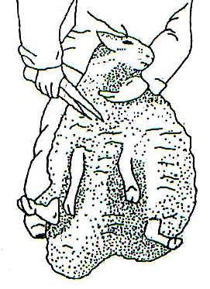

- Identify the practice illustrated above (½ mark)
................................................................................................................................................................................................................................................................................................................................................
- State two precautions a farmer should put into consideration when carrying out this practice. (2marks)
................................................................................................................................................................................................................................................................................................................................................
- How often should the practice be carried out? (1mark)
................................................................................................................................................................................................................................................................................................................................................
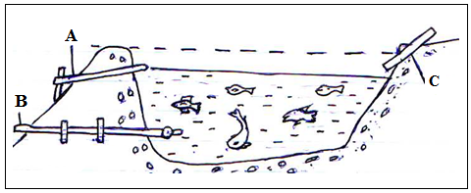
- The diagram below shows a farm structure, study it carefully and answer the questions that follow

- Identify the structure above (½ mark)
................................................................................................................................................................................................................................................................................................................................................
- Name the parts labelled A,B and C (1½ mark)
................................................................................................................................................................................................................................................................................................................................................ ........................................................................................................................................................................
- State four practices carried out on the above drawn structure (2marks)
................................................................................................................................................................................................................................................................................................................................................ ................................................................................................................................................................................................................................................................................................................................................
- Mention two methods used to maintain high level of oxygen in the above drawn structure (2marks)
................................................................................................................................................................................................................................................................................................................................................ ................................................................................................................................................................................................................................................................................................................................................
- The diagram below illustrates a general body shape of a cattle breed. Study it carefully and answer the questions that follow.
Head

- Identify the type and breed illustrated by the above diagram (½ mark)
................................................................................................................................................................................................................................................................................................................................................
- Give two examples of a breed in (i) above (1mark)
................................................................................................................................................................................................................................................................................................................................................
- State two physical characteristics of the type of breed in (i) (1mark)
................................................................................................................................................................................................................................................................................................................................................
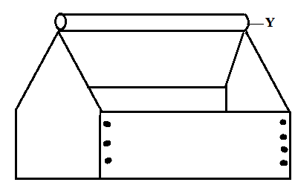
- Use the diagram below to answer the questions that follow

- Identify the structure (½ mark)
................................................................................................................................................................................................................................................................................................................................................
- Give a reason why part Y should be a rotating part (1mark)
................................................................................................................................................................................................................................................................................................................................................

- State two maintenance practices of the structure (2marks)
................................................................................................................................................................................................................................................................................................................................................
- Use the diagram below of the differential to answer the questions that follow
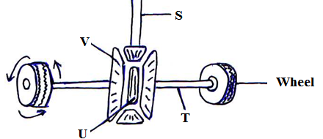

- Name the parts of the differential labelled (2marks)
S,
........................................................................................................................................................................
T,
........................................................................................................................................................................
U,
........................................................................................................................................................................
V
........................................................................................................................................................................
- State two functions of the differential (1mark)
........................................................................................................................................................................ ........................................................................................................................................................................
- Give three maintenance practices carried out to the differential drawn above (1½ marks)
........................................................................................................................................................................ ........................................................................................................................................................................ ........................................................................................................................................................................
SECTION C (40 MARKS)
Answer only two questions from this section in the spaces provided
- a) State and explain four factors that should be considered when choosing tools and equipment to use in
the farm (8marks)
b) Describe the procedure of constructing a barbed wire fence (7marks)
c) Describe the procedure of hand milking in a dairy cow (5marks)
- a) Explain five precautions observed when handling bees (5marks)
b) Describe the procedure followed when castrating a three old piglet using a scapel (5marks)
c) Explain five factors that dictate the amount of feed given to an animal per day (10marks)
- a) Outline ten factors considered when selecting dairy cattle for breeding (10marks)
b) Explain the factors considered when choosing the construction materials for farm building (10marks)

................................................................................................................................................................................................................................................................................................................................................ ................................................................................................................................................................................................................................................................................................................................................
................................................................................................................................................................................................................................................................................................................................................ ................................................................................................................................................................................................................................................................................................................................................
................................................................................................................................................................................................................................................................................................................................................ ................................................................................................................................................................................................................................................................................................................................................
................................................................................................................................................................................................................................................................................................................................................ ................................................................................................................................................................................................................................................................................................................................................
................................................................................................................................................................................................................................................................................................................................................ ................................................................................................................................................................................................................................................................................................................................................
................................................................................................................................................................................................................................................................................................................................................ ................................................................................................................................................................................................................................................................................................................................................
................................................................................................................................................................................................................................................................................................................................................ ................................................................................................................................................................................................................................................................................................................................................
................................................................................................................................................................................................................................................................................................................................................ ................................................................................................................................................................................................................................................................................................................................................
................................................................................................................................................................................................................................................................................................................................................ ................................................................................................................................................................................................................................................................................................................................................
................................................................................................................................................................................................................................................................................................................................................ ................................................................................................................................................................................................................................................................................................................................................
................................................................................................................................................................................................................................................................................................................................................ ................................................................................................................................................................................................................................................................................................................................................
................................................................................................................................................................................................................................................................................................................................................ ................................................................................................................................................................................................................................................................................................................................................
................................................................................................................................................................................................................................................................................................................................................ ................................................................................................................................................................................................................................................................................................................................................
................................................................................................................................................................................................................................................................................................................................................ ................................................................................................................................................................................................................................................................................................................................................
................................................................................................................................................................................................................................................................................................................................................ ................................................................................................................................................................................................................................................................................................................................................
................................................................................................................................................................................................................................................................................................................................................ ................................................................................................................................................................................................................................................................................................................................................
................................................................................................................................................................................................................................................................................................................................................ ................................................................................................................................................................................................................................................................................................................................................
................................................................................................................................................................................................................................................................................................................................................ ................................................................................................................................................................................................................................................................................................................................................
................................................................................................................................................................................................................................................................................................................................................ ................................................................................................................................................................................................................................................................................................................................................
................................................................................................................................................................................................................................................................................................................................................ ................................................................................................................................................................................................................................................................................................................................................
................................................................................................................................................................................................................................................................................................................................................ ................................................................................................................................................................................................................................................................................................................................................
................................................................................................................................................................................................................................................................................................................................................ ................................................................................................................................................................................................................................................................................................................................................
................................................................................................................................................................................................................................................................................................................................................ ................................................................................................................................................................................................................................................................................................................................................
................................................................................................................................................................................................................................................................................................................................................ ................................................................................................................................................................................................................................................................................................................................................
................................................................................................................................................................................................................................................................................................................................................ ................................................................................................................................................................................................................................................................................................................................................
................................................................................................................................................................................................................................................................................................................................................ ................................................................................................................................................................................................................................................................................................................................................
................................................................................................................................................................................................................................................................................................................................................ ...............................................................................................................................................................................................................................................................................................................................................

