NAME…………………………..……………….. DATE …………………………

INDEX NO. ……….……….…………………...…..… SIGNATURE ……………..…………..

231/1
BIOLOGY
PAPER 1
(THEORY)
TIME: 2 HOURS

MBOONI WEST SUB - COUNTY JOINT EVALUATION TEST, 2014
Kenya Certificate of Secondary Education

231/1
BIOLOGY
PAPER 1
(THEORY)
JULY /AUGUST 2014
TIME: 2 HOURS

INSTRUCTIONS TO CANDIDATES.
- Write your name and index number in the spaces provided above.
- Sign and write the date.
- Answer ALL the questions in the spaces provided.
- Answers must be written in the spaces provided in the question paper. Additional pages must not be inserted.
- This paper consists of 9 printed pages. Candidates should check to ensure that all pages are printed as indicated and no questions are missing

FOR EXAMINER’S USE ONLY.
Questions | Maximum score | Candidate’s score
1 - 27 | 80

© 2014, Mbooni West Sub – County Joint Evaluation Test
231/1
Biology Paper 1

- a) Name the organelle where Kreb’s/ citric cycle take place in a cell. (1mark)
……………………………………………………………………………………………………………………….
……………………………………………………………………………………………………………………….
- Where are lysosomes synthesized ( 1mark)
……………………………………………………………………………………………………………………….
……………………………………………………………………………………………………………………….
- Distinguish between ecological niche and habitat. (2mark)
……………………………………………………………………………………………………………………….
……………………………………………………………………………………………………………………….
……………………………………………………………………………………………………………………….
……………………………………………………………………………………………………………………….
- State the importance of osmo - regulation in organisms ( 2 marks)
……………………………………………………………………………………………………………………….
……………………………………………………………………………………………………………………….
……………………………………………………………………………………………………………………….
……………………………………………………………………………………………………………………….
- Explain why unicellular organisms such as paramecium lack complex organs for gaseous exchange. ( 2marks)
……………………………………………………………………………………………………………………….
……………………………………………………………………………………………………………………….
……………………………………………………………………………………………………………………….
……………………………………………………………………………………………………………………….
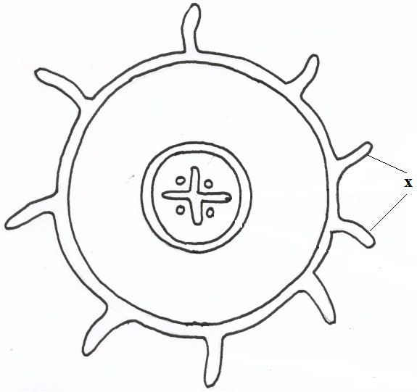
- The diagram below represents a transverse section of a plant part. Study it and answer the questions that follow.

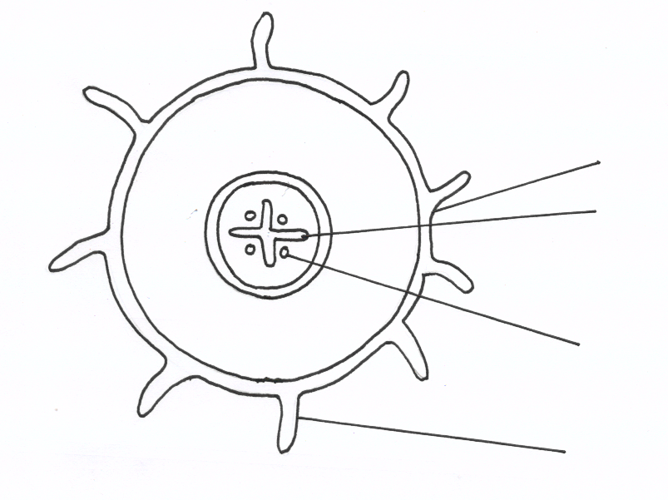
J
L
K
M
- Name the class in which the plant belongs. ( 1marks)
…………………………………………………………………………………………………………….…………

- Give a reason for answer (a) above ( 1mark)
……………………………………………………………………………………………………………….……………………………………………………………………………………………………………………………….
- State one adaptation for the structures labeled X to their functions. (1mark)
……………………………………………………………………………………………………………….……………………………………………………………………………………………………………………………….
- State the function of the following structures in the human n ear.
- Semi – circular canals. ( 1mark)
……………………………………………………………………………………………………………….……………………………………………………………………………………………………………………………….
- Eustachian tube. ( 1mark)
……………………………………………………………………………………………………………….……………………………………………………………………………………………………………………………….
- The diagram below shows the internal structure of a broad bean seed. Study it and answer the questions that
follow.
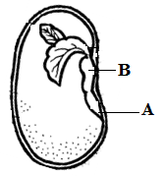

- Name the part labeled B. (1 mark)
……………………………………………………………………………………………………………….……………………………………………………………………………………………………………………………….
- Why is it important that the part labeled A develops first during germination? ( 2 mark)
……………………………………………………………………………………………………………….……………………………………………………………………………………………………………………………….
- Explain what causes global warming. ( 3 marks)
……………………………………………………………………………………………………………….……………………………………………………………………………………………………………………………….
……………………………………………………………………………………………………………….……………………………………………………………………………………………………………………………….

- The diagram below represents a mammalian bone.
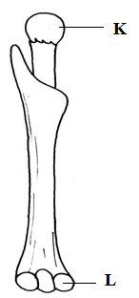

- Identify the bone ( 1mark)
……………………………………………………………………………………………………………….……………………………………………………………………………………………………………………………….
- i) Name the bones that articulate with this bone at points K and L ( 2 marks)
K
……………………………………………………………………………………………………………….………
L
……………………………………………………………………………………………………………………….
- The equation below represents a metabolic process that occurs in the mammalian liver.
Amino Acids Organic + Urea
Compounds
- Name the process (1 mark)
……………………………………………………………………………………………………………….……………………………………………………………………………………………………………………………….
- What is the importance of the process to the mammal? ( 2marks)
……………………………………………………………………………………………………………….……………………………………………………………………………………………………………………………….

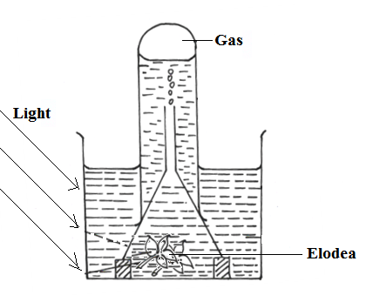
- The diagram below represents a set up that was used to investigate a certain process in a plant.

- State the process that was being investigated. (1 mark)
……………………………………………………………………………………………………………….………………………………………………………………………………………………………………………………
- Other than the factors shown, state two factors that would affect the process named in (a) above. ( 2 mark)
……………………………………………………………………………………………………………….………………………………………………………………………………………………………………………………
- Give an example of the sex linked trait in humans on
Y – Chromosomes (1mark)
……………………………………………………………………………………………………………………….
X – Chromosomes (1 mark)
……………………………………………………………………………………………………………….………
- Explain why a rat has a higher food intake compared to a lizard of the same body weight. ( 4 marks)
……………………………………………………………………………………………………………….………………………………………………………………………………………………………………………………
……………………………………………………………………………………………………………….………………………………………………………………………………………………………………………………
- (a) Mutua and Mwende used a light microscope to observe guard cells in a leaf surface.
They indicated a magnification of X 450 .Given that the eye piece was marked X10, work out the objective
lens magnification. (2 marks)

(b) State the function of fine adjustment knob. (1mark)
……………………………………………………………………………………………………………….………………………………………………………………………………………………………………………………
……………………………………………………………………………………………………………….………………………………………………………………………………………………………………………………
- State two structural differences between skeletal and smooth muscles. ( 2 marks)
……………………………………………………………………………………………………………….………………………………………………………………………………………………………………………………
……………………………………………………………………………………………………………….………………………………………………………………………………………………………………………………
- Outline two roles of active transport in human beings. ( 2 marks)
……………………………………………………………………………………………………………….………………………………………………………………………………………………………………………………
……………………………………………………………………………………………………………….………………………………………………………………………………………………………………………………
- State three advantages of asexual reproduction in plants. (3 marks)
……………………………………………………………………………………………………………….………………………………………………………………………………………………………………………………
……………………………………………………………………………………………………………….………………………………………………………………………………………………………………………………
- a).Name the causal organism for amoebic dysentery. ( 1 mark
……………………………………………………………………………………………………………….………………………………………………………………………………………………………………………………
b) state three preventive measures of schistosomiasis in human beings ( 3 mark)
……………………………………………………………………………………………………………….………………………………………………………………………………………………………………………………
……………………………………………………………………………………………………………….………………………………………………………………………………………………………………………………

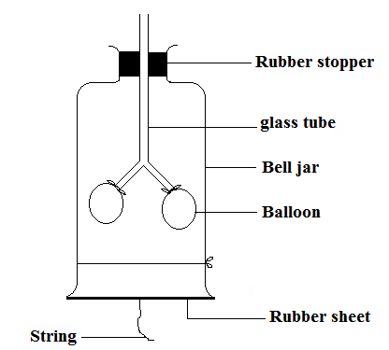
- Tom, a form two students set up the apparatus shown below to demonstrate the breathing mechanism in a mammal.

- What structure in a mammal is represented by each of the following? ( 2marks)
i) Glass tube
……………………………………………………………………………………………………………….……
ii) Rubber sheet
……………………………………………..……………………………………………………………………..
- Explain what will happen to the balloons if the rubber is pulled down wards. ( 2 marks)
……………………………………………………………………………………………………………….………………………………………………………………………………………………………………………………
- a) What is adaptive radiation? ( 2marks)
……………………………………………………………………………………………………………….………………………………………………………………………………………………………………………………
b) Explain why crossbreeding is important in animal breeding. (2 marks)
……………………………………………………………………………………………………………….………………………………………………………………………………………………………………………………
- a) state the most suitable biological tool for collecting the following organisms:-
- A moth from a coffee farm. ( 1 mark)
……………………………………………………………………………………………………………….………………………………………………………………………………………………………………………………
- Ants from a tree trunk. ( 1 mark)
……………………………………………………………………………………………………………….………………………………………………………………………………………………………………………………
b) State two distinguishing characteristics of the kingdom protoctista. (2 mark)
……………………………………………………………………………………………………………….………………………………………………………………………………………………………………………………
- a) Name the hormone that stimulate the maturation of the graafian follicles to release a mature ovum in female
reproductive cycle. (1mark)
……………………………………………………………………………………………………………….………………………………………………………………………………………………………………………………

b) Explain why menstruation does not take place after fertilization in human beings. (2marks)
……………………………………………………………………………………………………………….………………………………………………………………………………………………………………………………
- How does sunken stomata help in lowering transpiration? ( 3marks)
……………………………………………………………………………………………………………….……………………………………………………………………………………………………………………………………………………………………………………………………………………………………………….………………………………………………………………………………………………………………………………
- The diagram below shows a phenomenon which occurs during cell division.
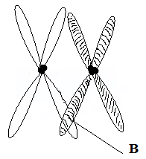

- Identify the stage of cell division in which this phenomenon occurs. (1 mark)
……………………………………………………………………………………………………………….…………………………………………………………………………………………………………….………………………………………………………………………………………………………………………………………….
- State the importance of the phenomenon taking place in the part labeled B. (2 marks)
……………………………………………………………………………………………………………….……………………………………………………………………………………………………………………………………………………………………………………………………………………………………………….………………………………………………………………………………………………………………………………

- a) An organism was found to have a dental formula
i 0 c 0 pm 3 m 3
3 1 2 3
- State the mode of feeding of the organism. (1mark)
……………………………………………………………………………………………………………….………………………………………………………………………………………………………………………………
- Give a reason for your answer in (i) above. ( 1 mark)
……………………………………………………………………………………………………………….………………………………………………………………………………………………………………………………
b) Name the vitamin which plays an important role in the formation of blood cells. (1mark)
……………………………………………………………………………………………………………….………………………………………………………………………………………………………………………………
- a) State one advantage of double circulation over single circulation. ( 1mark)
……………………………………………………………………………………………………………….………………………………………………………………………………………………………………………………
b) State two adaptations of blood capillaries to their functions. (2marks)
……………………………………………………………………………………………………………….………………………………………………………………………………………………………………………………
……………………………………………………………………………………………………………….………………………………………………………………………………………………………………………………
- a) Name a growth hormone that has inhibitory effects in plants growth. ( 1mark)
……………………………………………………………………………………………………………….………………………………………………………………………………………………………………………………
b) State two characteristics of a meristematic cells. (2marks)
……………………………………………………………………………………………………………….………………………………………………………………………………………………………………………………
……………………………………………………………………………………………………………….………………………………………………………………………………………………………………………………
- Write down two functions of exoskeleton in the phylum Arthropoda. (2 marks)
……………………………………………………………………………………………………………….………………………………………………………………………………………………………………………………
……………………………………………………………………………………………………………….………………………………………………………………………………………………………………………………

