NAME ……………………………… DATE ……………………..…………………

INDEX NO. …………….………………. CANDIDATE’S SIGNATURE …………..………

441/ 2
HOME SCIENCE
Paper 2 (Practical)
CLOTHING & CONSTRUCTION
JULY/AUGUST 2014
TIME: 2 ½ HOURS

MBOONI WEST SUB - COUNTY FORM FOUR JOINT EVALUATION TEST 2014
Kenya Certificate of Secondary Education (K.C.S.E)

441/ 2
HOME SCIENCE
Paper 2 (Practical)
CLOTHING & CONSTRUCTION
TIME: 2 ½ HOURS

This paper consists of 2 printed pages.
Candidates should check the question paper to ascertain that all pages are printed and no questions are missing

© Mbooni West Sub – County Form Four Joint Evaluation Test 2014
A pattern of a child’s skirt is provided. You are adviced to study the sketches, the question paper and the layout before the test
MATERIALS PROVIDED
- Pattern pieces
- Skirt front
- Skrit back
- Frill
- Pocket
- Back waistband
- Front waistband
NB: Interfacings for front and back waist bands are cut with pieces E and F from the same fabric
- Plain light weight cotton fabric 65cm by 90cm wide
- Zip size 15cm long
- A button, 1cm in diameter
- Sewing thread to match the fabric colour
- One large envelop

THE TEST
Using the materials provided, cut out and make up the LEFT HALF of the child’s skirt to show the following
- The making of the back and front darts
- The preparation and attachment of the patch pocket
- The making of a neatened side seam and attachment of the zip using the concealed method.
- The preparation of the interfaced front and back waistbands
- The attachment of waistband to the skirt
Finishing the front waistband by hemming and the back one by tacking
- The topstitching of the waistbands
- The preparation of the frill and attaching it using overlaid/ lapped seam
- The neatening of ONLY half of the frill seam
- The making of the buttonhole and attaching the button

OMIT
The hem management
At the end of the examination, firmly sew onto your work, on a single fabric a label bearing your name and index number. Remove the needle and pins from your work
Then fold your work carefully and place it in the envelope provided.
Do not put scraps of materials in the envelope

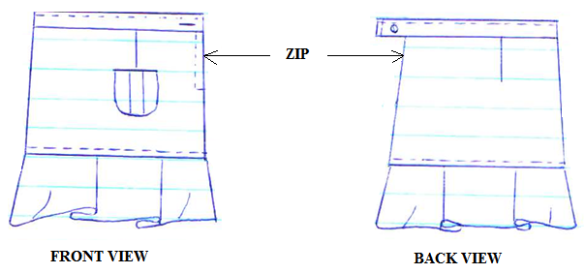
A CHILD’S SKIRT

LAYAOUT (NOT DRAWN TO SCALE)
