NAME ____________________________________ INDEX NO. _______________
SCHOOL ____________________________________ SIGNATURE _______________
DATE _______________

441/2
HOME SCIENCE
Clothing Construction
Paper 2
Practical
Time: 2½Hours
July / August 2017

BRILLIANT 1

441/2
HOME SCIENCE
Clothing Construction
Paper 2
Practical
Time: 2½Hours

INSTRUCTIONS TO CANDIDATES
- This paper consists of three printed Pages.
- Candidates should check the question paper to ascertain that all the pages are printed as indicated and thatno questions are missing.
They should also ensure that the pattern pieces match with sketches shown on question paper.

This paper consists of 3 printed pages.

Candidates should check to ensure that all pages are printed as indicated and no questions are missing.

You are advised to study the question paper together with the sketches and the material very carefully before you begin the test.

A pattern of a child’s bodice is provided. You are advised to study the sketches, instructions and the layout before you begin.

MATERIALS PROVIDED
1. Pattern pieces:
A –Front bodice
B–Back bodice
C–Back yoke
D–Collar
E – Back neck facing
NB: Interfacing of the collar is cut with D from the same fabric.

2. Light weight plain cotton fabric 50cm long by 91cm wide.
3. Sewing cotton thread to match the fabric.

THE TEST
Using the materials provided, cut out and make the right half of a child’s bodice as shown in the sketch below to show the following:
- The working of the bust dart.
- The preparation and top stitching of the inverted pleat
- The attachment of the back yoke to the back bodice using overlaid/ lapped seam and top stitching it.
- The working of double stitched seam at the shoulder.
- The working of an open seam at the side of bodice.
- The joining of the back and the front neck facings at the shoulder.
- The preparation of an interfaced collar and attaching it to the bodice.
- Under stitching the facing and the free edge.
- The working of the buttonhole.

At the end of the examination, remove all pins and unnecessary tacking from your work. Sew on a label bearing your name and index number on a single fabric. Fold your work neatly and place it in the envelope provided.
Do not put scraps of fabrics in the envelope

LAYOUT NOT DRAWN TO SCALE
CUT HERE
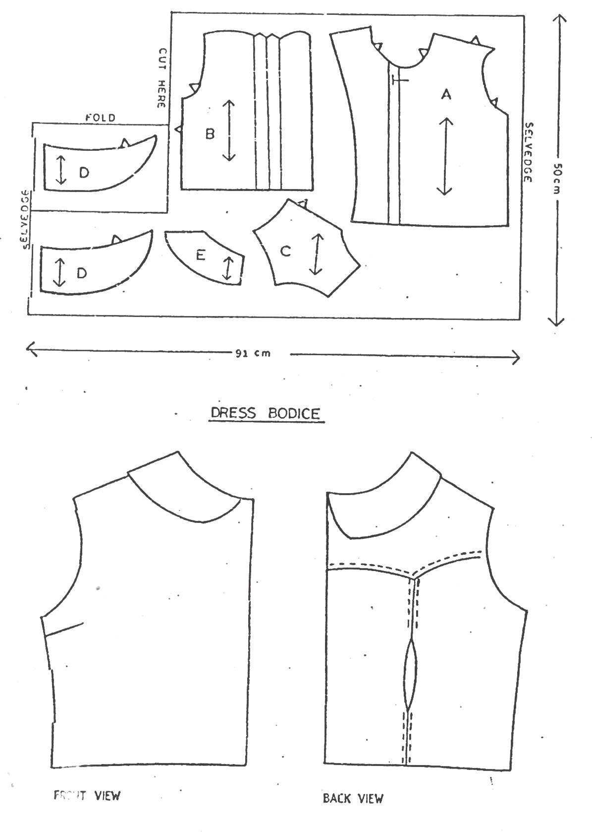
SELVEDGE
SELVEDGE
Fold

50 cm
C
D
A
B
D
91 cm
DRESS BODICE
BACK VIEW
FRONT VIEW

