**NAME ……………………………………..……………….. DATE …………………………………**

**INDEX NO. …………….……….……..…..… CANDIDATE’S SIGNATURE …………..…..………..**

443/1

AGRICULTURE

PAPER 1 (THEORY)

TIME: 2 HOURS

**MBOONI EAST SUB – COUNTY FORM FOUR JOINT EVALUATION TEST, 2014**

***Kenya Certificate of Secondary Education***

443/1

AGRICULTURE

PAPER 1 (THEORY)

JULY/AUGUST 2014

TIME: 2 HOURS

**INSTRUCTIONS TO CANDIDATES**

1. Write your name and index number in the spaces provided above.
2. This paper has **THREE** sections: A , B and C
3. Answer **ALL** the questions in section A and B and any **TWO** questions in section C
4. ALL answers **MUST** be written in the spaces provided.
5. Do not remove any pages from this booklet.
6. This paper consists of 10 printed pages. Candidates should check to ensure that all pages are printed as indicated and no questions are missing

**FOR EXAMINER’S USE ONLY**

|  |  |  |  |
| --- | --- | --- | --- |
|  | **Questions** | **Maximum score** | **Candidate’s score** |
| A | **01 - 16** | **30 marks** |  |
| B | **16 - 20** | **20 marks** |  |
| C | **21 - 23** | **40 marks** |  |
| **Total score** | | **90** |  |

© 2014, Mbooni East sub - County Form Four Joint Evaluation test

443/1

Agriculture

Paper 1 (theory)

**SECTION A**

**Answer all questions in the space provided**

1. State four importance of drainage as a land reclamation method? (2marks)

………………………………………………………………………………………………………………………………………………………………………………………………………………………………………………………………………………………………………………………………………………………………………………………………………………………………………………………………

2. State four a ways in which minimum tillage can be achieved? (2marks

………………………………………………………………………………………………………………………………………………………………………………………………………………………………………………………………………………………………………………………………………………………………………………………………………………………………………………………………

3. Give the element whose its deficiency in the is characterized by the following;

a) Inter venial chlorosis of leaves (½ mark)

………………………………………………………………………………………………………………

b) Blossom end rot in tomato fruit. (½ mark)

………………………………………………………………………………………………………………

c) Scorched edges of a leaf. (½ mark)

………………………………………………………………………………………………………………

4. State four reasons that determines the depth of planting? (2marks)

………………………………………………………………………………………………………………………………………………………………………………………………………………………………………………………………………………………………………………………………………………………………………………………………………………………………………………………………

5. State four disadvantages of communal land tenure system? (2marks)

………………………………………………………………………………………………………………………………………………………………………………………………………………………………………………………………………………………………………………………………………………………………………………………………………………………………………………………………

6. Give the meaning of the following terms:

a) Pomology. (1mark)

………………………………………………………………………………………………………………………………………………………………………………………………………………………………

b) Apiculture. (1mark)

………………………………………………………………………………………………………………………………………………………………………………………………………………………………

c) Plantation farming. (1mark)

………………………………………………………………………………………………………………………………………………………………………………………………………………………………

7. State four characteristics of intensive farming? (2marks)

………………………………………………………………………………………………………………………………………………………………………………………………………………………………………………………………………………………………………………………………………………………………………………………………………………………………………………………………

8. State four ways in which labour productivity in the farm can be improved? (2marks)

………………………………………………………………………………………………………………………………………………………………………………………………………………………………………………………………………………………………………………………………………………………………………………………………………………………………………………………………

9. Give four advantages of increased level of education and technology in farming? (2marks)

………………………………………………………………………………………………………………………………………………………………………………………………………………………………………………………………………………………………………………………………………………………………………………………………………………………………………………………………

10. State three areas that should be avoided when soil sampling? (1½ marks)

………………………………………………………………………………………………………………………………………………………………………………………………………………………………………………………………………………………………………………………………………………………………………………………………………………………………………………………………

11. Give two reasons for processing agricultural produce? (1mark)

………………………………………………………………………………………………………………………………………………………………………………………………………………………………

12. Give how the following structures or practices control the soil erosion?

a) Contour farming (1mark)

………………………………………………………………………………………………………………………………………………………………………………………………………………………………………………………………………………………………………………………………………………

b) Grass strips / filters strips (1mark)

………………………………………………………………………………………………………………………………………………………………………………………………………………………………………………………………………………………………………………………………………………

13. State four ways in which herbicides work to kill weeds? (2marks)

………………………………………………………………………………………………………………………………………………………………………………………………………………………………………………………………………………………………………………………………………………………………………………………………………………………………………………………………

14. State four factors considered when drawing a farm plan? (2marks)

………………………………………………………………………………………………………………………………………………………………………………………………………………………………………………………………………………………………………………………………………………………………………………………………………………………………………………………………

15. State two varieties of beans grown for green pod production? (1mark)

………………………………………………………………………………………………………………………………………………………………………………………………………………………………………………………………………………………………………………………………………………………………………………………………………………………………………………………………

16. Give four advantages of using seeds as planting materials? (2marks)

………………………………………………………………………………………………………………………………………………………………………………………………………………………………………………………………………………………………………………………………………………………………………………………………………………………………………………………………

**SECTION B (20MARKS)**

**Answer all the questions in the space provided**

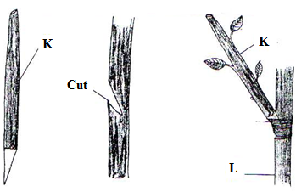17. Below is a method in crop improvement in crop production. Study it carefully and answer questions that follow;

a) Identify the practice? (1mark)

………………………………………………………………………………………………………………………………………………………………………………………………………………………………………………………………………………………………………………………………………………

b) Identify the parts labeled k and l

K

………………………………………………………………………………………………………………

L

………………………………………………………………………………………………………………

c) Explain three advantages of the above practice in crop production? (3marks)

………………………………………………………………………………………………………………………………………………………………………………………………………………………………………………………………………………………………………………………………………………

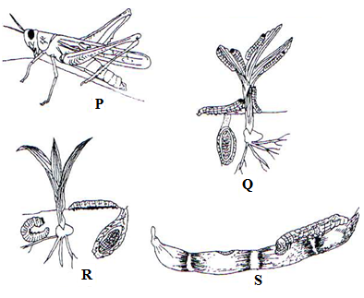18. Below are the pests that commonly attack the crops. Study them carefully and answer questions that follow:

a) Identify the pest labeled P, Q, R and S (2marks)

P

………………………………………………………………………………………………………………

Q

………………………………………………………………………………………………………………

R

………………………………………………………………………………………………………………

S

………………………………………………………………………………………………………………

b) What kind of mouth parts do they possess? (1mark)

………………………………………………………………………………………………………………………………………………………………………………………………………………………………

c) Give two ways in which pest can be categorized depending on their habitat (2marks)

………………………………………………………………………………………………………………………………………………………………………………………………………………………………

19. Below is a method of irrigation. Study it carefully and answer questions that follow;

a) Identify the method (1mark)

………………………………………………………………………………………………………………………………………………………………………………………………………………………………

b) Other than the above method, give any other two types of surface irrigation? (2marks)

………………………………………………………………………………………………………………………………………………………………………………………………………………………………

c) Give two ways in which the above method of irrigation can be maintained? (2marks)

………………………………………………………………………………………………………………………………………………………………………………………………………………………………

20. Below are weeds. Study them carefully and answer question that follow?

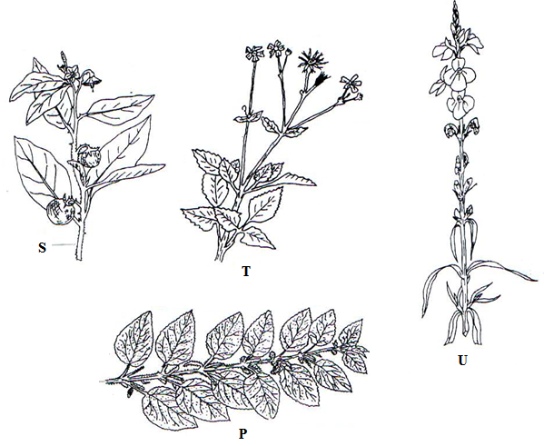

a) Identify weeds labeled S, T, U and P (2marks)

S

………………………………………………………………………………………………………………

T

………………………………………………………………………………………………………………

U

………………………………………………………………………………………………………………

P

………………………………………………………………………………………………………………

b) Explain three factors which contribute to the competitive ability of weeds? (3marks)

………………………………………………………………………………………………………………………………………………………………………………………………………………………………………………………………………………………………………………………………………………

SECTION C (40MARKS)

**Answer only two questions in this section**

**21** a) Describe harvesting of sugarcane? (4marks)

b) Explain four precautions when harvesting pyrethrum? (4marks)

c) Explain six importance of organic matter in the soil (6marks)

d) Identify and explain three forms of water that exist in the soil? (6marks)

22. a) Describe the production of carrot under the following sub-headings

(i) Land preparation (2marks)

(ii) Harvesting (3marks)

b) Explain five advantages of mulching? (5marks)

c) Identify and explain five factors determining spacing of a particular crop? (10marks)

23 (a) Explain five problems associated with credits? (5marks)

b) Explain eight uses of farm records? (8marks)

c) Explain seven effects of strong winds in agriculture (7marks)

………………………………………………………………………………………………………………………………………………………………………………………………………………………………………………………………………………………………………………………………………………………………………………………………………………………………………………………………………………………………………………………………………………………………………………………………………………………………………………………………………………………………………………………………………………………………………………………………………………………………………………………………………………………………………………………………………………………………………………………………………………………………………………………………………………………………………………………………………………………………………………………………………………………………………………………………………………………………………………………………………………………………………………………………………………………………………………………………………………………………………………………………………………………………………………………………………………………………………………………………………………………………………………………………………………………………………………………………………………………………………………………………………………………………………………………………………………………………………………………………………………………………………………………………………………………………………………………………………………………………………………………………………………………………………………………………………………………………………………………………………………………………………………………………………………………………………………………………………………………………………………………………………………………………………………………………………………………………………………………………………………………………………………………………………………………………………………………………………………………………………………………………………………………………………………………………………………………………………………………………………………………………………………………………………………………………………………………………………………………………………………………………………………………………………………………………………………………………………………………………………………………………………………………………………………………………………………………………………………………………………………………………………………………………………………………………………………………………………………………………………………………………………………………………………………………………………………………………………………………………………………………………………………………………………………………………………………………………………………………………………………………………………………………………………………………………………………………………………………………………………………………………………………………………………………………………………………………………………………………………………………………………………………………………………………………………………………………………………………………………………………………………………………………………………………………………………………………………………………………………………………………………………………………………………………………………………………………………………………………………………………………………………………………………………………………………………………………………………………………………………………………………………………………………………………………………………………………………………………………………………………………………………………………………………………………………………………………………………………………………………………………………………………………………………………………………………………………………………………………………………………………………………………………………………………………………………………………………………………………………………………………………………………………………………………………………………………………………………………………………………………………………………………………………………………………………………………………………………………………………………………………………………………………………………………………………………………………………………………………………………………………………………………………………………………………………………………………………………………………………………………………………………………………………………………………………………………………………………………………………………………………………………………………………………………………………………………………………………………………………………………………………………………………………………………………………………………………………………………………………………………………………………………………………………………………………………………………………………………………………………………………………………………………………………………………………………………………………………………………………………………………………………………………………………………………………………………………………………………………………………………………………………………………………………………………………………………………………………………………………………………………………………………………………………………………………………………………………………………………………………………………………………………………………………………………………………………………………………………………………………………………………………………………………………………………………………………………………………………………………………………………………………………………………………………………………………………………………………………………………