NAME…………………………..……………….. DATE …………………………

INDEX NO. ……….……….…………………...…..… SIGNATURE ……………..…………..

231/1
BIOLOGY
PAPER 1
(THEORY)
TIME: 2 HOURS

MBOONI EAST SUB - COUNTY FORM FOUR JOINT EVALUATION TEST, 2014
Kenya Certificate of Secondary Education

231/1
BIOLOGY
PAPER 1
(THEORY)
JULY /AUGUST 2014
TIME: 2 HOURS

INSTRUCTIONS TO CANDIDATES.
- Write your name and index number in spaces provided above.
- Sign and write the date.
- Answer ALL the questions in the spaces provided.
- Answers must be written in the spaces provided in the question paper. Additional pages must not be inserted.
- This paper consists of 8 printed pages. Candidates should check to ensure that all pages are printed as indicated and no questions are missing

FOR EXAMINER’S USE ONLY.
Questions | Maximum score | Candidate’s score
1 - 27 | 80

© 2014, Mbooni East Sub- County Form Four Joint Evaluation Test
231/1
Biology Paper 1

- Insects’ blood is noted to lack a respiratory pigment. Explain (1 mark)
………………………………………………………………………………………………………………………………………………………………………………………………………………………………………………
- State the function of the following parts of a nephron.
- Loop of Henle (1 mark)
………………………………………………………………………………………………………………………………………………………………………………………………………………………………………………
- Distal convoluted tubule. (1 mark)
………………………………………………………………………………………………………………………………………………………………………………………………………………………………………………
- Most terrestrial plants do not grow well in water logged soils. Give a reason for this (1mark)
………………………………………………………………………………………………………………………………………………………………………………………………………………………………………………
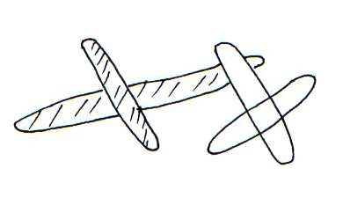
- The diagrams below show a pair of homologous chromosomes. Study them and answer the questions that follow.

- State the phenomenon shown above (1mark)
………………………………………………………………………………………………………………………………………………………………………………………………………………………………………………
(ii) What is the genetic significance of the phenomenon above? (2 marks)
………………………………………………………………………………………………………………………………………………………………………………………….………………………..………………………….
- Give two destinations of food translocated from the leaves of plants. (2 marks)
………………………………………………………………………………………………………………………………………………………………………………………………………………………………………………
- Name the organelle that is likely to be found in abundance in:
- An enzyme secreting cell.
………………………………………………………………………………………………………………………
- Cells producing lipid related secretions.
………………………………………………………………………………………………………………………
- Areas where the cells have raptured
………………………………………………………………………………………………………………………

- A small boy remarked that his dog looks larger on cold days than on hot days. Give a biological explanation for this. (2 marks)
………………………………………………………………………………………………………………………………………………………………………………………….………………………..………………………….
- The table below shows the percentage composition of carbon (IV) oxide and oxygen in inhaled and exhaled air.
Gases | Inhaled air | Exhaled air
Oxygen | 20 % | 17%
Carbon (IV) oxide | 0.04% | 4.0%
Explain the differences in percentage of the two gases in inhaled and exhaled air.
- Oxygen (2 marks)
………………………………………………………………………………………………………………………………………………………………………………………….………………………..………………………….
- Carbon (IV) oxide (2 marks)
………………………………………………………………………………………………………………………………………………………………………………………….………………………..………………………….
- The diagram below represents a pyramid of biomass derived from a certain ecosystem.
Consumer
Producer

- Suggest the type of ecosystem from which the pyramid was derived (1 mark)
………………………………………………………………………………………………………………………………………………………………………………………….………………………..………………………….
- State the significance of short food chains in an ecosystem. (1 mark)
………………………………………………………………………………………………………………………………………………………………………………………….………………………..………………………….
- State two features of neurones that increase the rate of impulse transmission (2 marks)
………………………………………………………………………………………………………………………………………………………………………………………….………………………..………………………….
- Distinguish precisely between diabetes mellitus and diabetes insipidus ( 2 marks)
………………………………………………………………………………………………………………………………………………………………………………………….………………………..………………………….

- The set up below shows apparatus to demonstrate a certain biological process
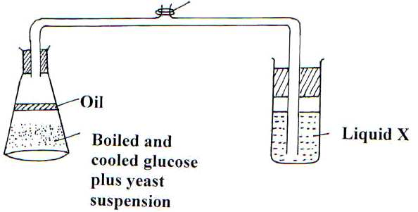

- What biological process was being investigated in the experiment (1 mark)
……………………………………………………………………………………………………………………………………………………………………………………….…………………………..………………………….
- Write down a word equation that represents the reaction above. (1 mark)
……………………………………………………………………………………………………………………………………………………………………………………….…………………………..………………………….
- In the above set up, why was it important to boil and cool glucose before adding yeast? (1 mark)
……………………………………………………………………………………………………………………………………………………………………………………….…………………………..………………………….
- Explain how the following occur during gene mutation.
- Substitution ( 2marks)
……………………………………………………………………………………………………………………………………………………………………………………….…………………………..………………………….
- Insertion (2marks)
……………………………………………………………………………………………………………………………………………………………………………………….…………………………..………………………….
- (a) What are meristems? ( 1mark)
……………………………………………………………………………………………………………………………………………………………………………………….…………………………..………………………….
(b) (i) what is the role of cork – cambium in secondary growth? (1mark)
……………………………………………………………………………………………………………………………………………………………………………………….…………………………..………………………….
ii) Name the meristem that is responsible for increase in length of stems (1mark)
……………………………………………………………………………………………………………………………………………………………………………………….…………………………..………………………….
- State two functions of the spleen (2 marks)
……………………………………………………………………………………………………………………………………………………………………………………….…………………………..………………………….

- Name the excretory products eliminated by the following animals.
- Tilapia. (1 mark)
………………………………………………………………………………………………………………………………………………………………………………………………………………………………………………
- Chicken. (1mark)
………………………………………………………………………………………………………………………………………………………………………………………………………………………………………………
- State the functions of the following parts of the human ear. (1mark)
- Ossicles (1mark)
………………………………………………………………………………………………………………………………………………………………………………………………………………………………………………
- Pinna (1mark)
………………………………………………………………………………………………………………………………………………………………………………………………………………………………………………
- Name the causative organism of the following diseases.
- Malaria (1mark)
………………………………………………………………………………………………………………………………………………………………………………………………………………………………………………
- Bilharzia (1mark)
………………………………………………………………………………………………………………………………………………………………………………………………………………………………………………
- Identify the part of light microscope which serve each of the functions described below
- Making rough focus ( 1mark)
………………………………………………………………………………………………………………………………………………………………………………………………………………………………………………
- Reflecting light from the source (1 mark)
………………………………………………………………………………………………………………………………………………………………………………………………………………………………………………
- State two characteristics of aerenchyma tissue. (2marks)
………………………………………………………………………………………………………………………………………………………………………………………………………………………………………………
- What is the significance of transpiration in plants? (3marks)
………………………………………………………………………………………………………………………………………………………………………………………………………………………………………………………………………………………………………………………………………………………………………………………………………………………………………………………………………………………………
- State two ways in which xylem vessels are adapted to their functions. ( 2marks)
………………………………………………………………………………………………………………………………………………………………………………………………………………………………………………………………………………………………………………………………………………………………………………………………………………………………………………………………………………………………
- Distinguish between convergent and divergent evolution (1mark)
………………………………………………………………………………………………………………………………………………………………………………………………………………………………………………
- State the characteristics that distinguish the following organisms into their respective classes (3 marks)
Millipedes,spider and tsetse fly.
………………………………………………………………………………………………………………………………………………………………………………………………………………………………………………………………………………………………………………………………………………………………………………………………………………………………………………………………………………………………
- How do identical twins and fraternal twins arise?
- Identical twins (2 marks)
………………………………………………………………………………………………………………………………………………………………………………………………………………………………………………
- Fraternal twins. (2 marks)
………………………………………………………………………………………………………………………………………………………………………………………………………………………………………………
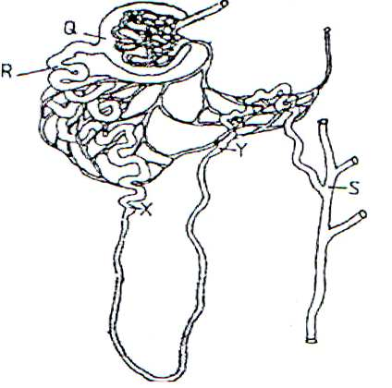
- The diagram below illustrates part of a nephron from a mammalian kidney.

- Name the fluid found in the part labeled Q. (1 mark)
………………………………………………………………………………………………………………………………………………………………………………………………………………………………………………
- Identify the process responsible for the formation of the fluid named in (a) above (1mark)
………………………………………………………………………………………………………………………………………………………………………………………………………………………………………………
- Which two hormones exert their effect in the nephron? (2 marks)
………………………………………………………………………………………………………………………………………………………………………………………………………………………………………………

- The diagram below shows a tip of a plant coleoptiles with light coming towards it from one side.
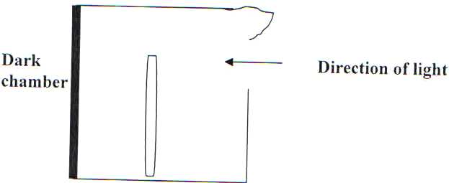

- How would the plant respond to light? (1 mark)
………………………………………………………………………………………………………………………………………………………………………………………………………………………………………………
- Give the name of such a response (1 mark)
………………………………………………………………………………………………………………………………………………………………………………………………………………………………………………
- What is the advantage of plants responding in this way? (2marks)
………………………………………………………………………………………………………………………………………………………………………………………………………………………………………………
- The experiment illustrated below was set up to investigate a certain physiological process using a raw tuber.
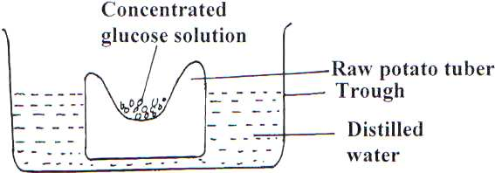

- Suggest a possible physiological process that was being investigated. (1 mark)
………………………………………………………………………………………………………………………………………………………………………………………………………………………………………………
- Explain the results obtained in the above experiment after a few hours (2 marks)
………………………………………………………………………………………………………………………………………………………………………………………………………………………………………………
- State the observations that would have been made if the experiment was repeated using boiled potato.
………………………………………………………………………………………………………………………………………………………………………………………………………………………………………………
- (a) Give two functions of blood as a tissue. (2 marks)
………………………………………………………………………………………………………………………………………………………………………………………………………………………………………………

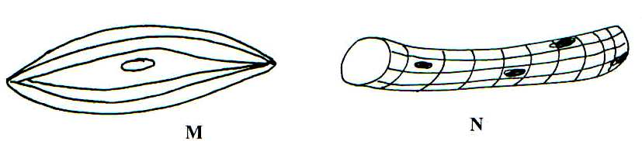
- The figures below illustrate specialized cells in an animal body.

- Identify the cells M and N (2 marks)
M
………………………………………………………………………………………………………..…….
N
………………………………………………………………………………………………………………
- State the structural differences between M and N (2marks)
………………………………………………………………………………………………………………………………………………………………………………………………………………………………………………
- Which of the above specialized cells is found in the gut? (1mark)
………………………………………………………………………………………………………………………………………………………………………………………………………………………………………………

