NAME …………………………..……………….. DATE …………………………

INDEX NO. ……….……….…………………...…..… SIGNATURE ……………..…………..

312/1
GEOGRAPHY
PAPER 1
JULY/AUGUST 2014
TIME: 2 ¾ HRS

MBOONI EAST SUB - COUNTY FORM FOUR JOINT EVALUATION TEST 2014

Kenya Certificate of Secondary Education

INSTRUCTIONS TO CANDIDATES
- Write your name and index number in the spaces provided above.
- This paper has TWO sections: A and B.
- Answer ALL the questions in section A. In section B answer QUESTION 6 and any other TWO questions from the section.
- ALL answers MUST be written in the Answer Booklet provided.
- Do not remove any pages from this booklet.
- This paper consists of 4 printed pages. Candidates should check to ensure that all pages are printed as indicated and no questions are missing

© 2014, Mbooni East Sub - County Form Four Joint Evaluation Test
312/1
Geography
Paper 1
SECTION A
Answer all the questions in this section.
1. (a) What is desertification? (2 marks)
(b) State three human activities that lead to desertification. (3 marks)

2. (a) Give three examples of mechanically formed sedimentary rocks. (3 marks)
(b) State two changes that occur in sedimentary rocks when they are subjected to intense heat and pressure
(2 marks)

3. (a) Why is ocean salinity higher in the tropical regions than at the equator . (2 marks)
(b) Name three types of ocean tides. (3 marks)

4. (a) When local time is 2.00 p.m. at longitude 60⁰E.What is the longitude of a place whose local time is 5.00 p.m.
(3 marks)
(b) Give two effects of the oval shape of the orbit of the earth. (2 marks)

5. (a) Apart from river and wave deposition state three ways in which lakes may be formed. (3 marks)
(b) Name two lakes in Kenya where formed through river deposition. (2 marks)

SECTION B
Answer question 6 and any other two questions

- Study the map of Karatina 1:50000 sheet 121/3 provided and answer the questions that follow.
- (i) Give the latitudinal and longitudinal extend of the area covered by the map. (2 marks)
(ii) Name two methods used to represent relief on the map. (2 marks)
(iii) Calculate the area enclosed by the forest boundary east of easting 97 and west of easting 05. (2 marks)
- (i) Draw a rectangle measuring 9 cm by 8 cm to represent the area enclosed by the following grid references
9653, 0553, 9645 and 0545 (1 mark)
(ii) On the rectangle mark and name the following.
- District boundary (1 mark)
- Kamurdwana hill. (1 mark)
- River Gakombaki (1 mark)
- All weather bound surface road from Kianga to Kariko (1 mark)
(c) Explain three factors influencing the distribution of population in the area covered by the map. (6 marks)
(d) Students of Kianga Secondary School carried out a field study of the area around their school.
(i) Identify two ways in which they prepared for the study (2 marks)
(ii) Using evidence from the map give three economic activities which they were able to identify (6 marks)

7. (a) (i) Give three sources of underground water. (3 marks)
(ii) Identify three ways in which springs occur. (3 marks)
(b) With the aid of a well labelled diagram show the three zones of underground water. (6 marks)
(c) Explain how the following factors influence the existence of underground water.
(i) Precipitation (2 marks)
(ii) Vegetation cover (2 marks)
(d) (i) Name any three surface features of limestone areas. (3 marks)
(ii) Describe how stalagmites are formed (3 marks)
(e) State three significance of underground water to human activities (3 marks)

8. (a) (i) What is an ice sheet? (2 marks)
(ii) Give two reasons why there are no ice sheets in Kenya. (2 marks)
(iii) State three factors that influence the movement of ice from the place where it has accumulated.
(3 marks)
(b) Describe the formation of the following features
(i) An Arete (4 marks)
(ii) Hanging valley (5 marks)
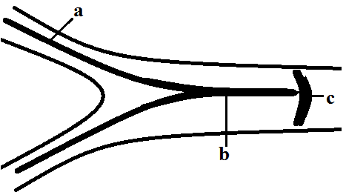
- The diagram below shows types of moraines in a valley glacier.

Name the types of moraine marked a,b and c. (3 marks)
(d) You have been asked to carry out a field study on land use on a glaciated lowland.
(i) State three preparations you would make for your field study. (3 marks)
(ii) State three possible land uses you are likely to identify during the field study. (3 marks)

9.
(a) (i) Define faulting . (1 mark)
(ii) Identify three types of faults. (3 marks)
(b) Apart from compressional forces, explain two other processes that may cause faulting. (4 marks)
(c) With the aid of diagrams describe how compressional forces may have led to the formation of the Great Rift Valley. (8 marks)
(d) Apart from the rift valley name three other relief features that were formed by compressional forces (3 marks)
(e) Explain three significance of faulting to the physical and human environment. (6 marks)

10. Below is a map of Africa representing climatic regions .Use it to answer the questions that follow.
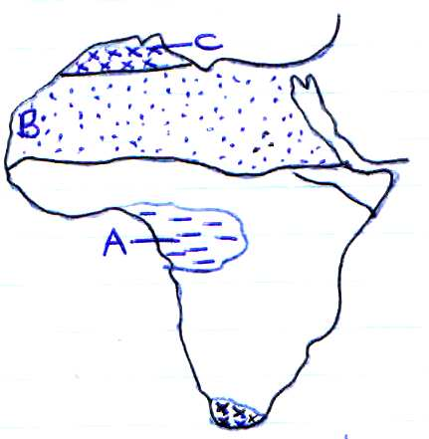

(a) Identify the climatic regions marked a, b and c. (3 marks)
(b) Outline the climatic characteristics of the regions marked:
- A (4 marks)
- C (4 marks)
(c) Explain how the following factors influence climate
(i) Altitude (4 marks)
(ii) Distance from the sea (4 marks)
(d)
(i) Describe a suitable site where you would locate a weather station. (2 marks)
(ii) Give reasons why a Stevenson’s screen is:
- Painted white (2 marks)
- Has louvers (2 marks)

