NAME …………………………..……………….. DATE …………………………

INDEX NO. ……….……….…………………...…..… SIGNATURE ……………..…………..

312/2
GEOGRAPHY
PAPER 2
JULY/AUGUST 2014
TIME: 2 ¾ HRS

MBOONI EAST SUB - COUNTY FORM FOUR JOINT EVALUATION TEST 2014

Kenya Certificate of Secondary Education

INSTRUCTIONS TO CANDIDATES
- Write your name and index number in the spaces provided above.
- This paper has TWO sections: A and B.
- Answer ALL the questions in section A. In section B answer QUESTION 6 and any other TWO questions from the section.
- ALL answers MUST be written on the answer booklet provided.
- Do not remove any pages from this booklet
- This paper consists of 3 printed pages. Candidates should check to ensure that all pages are printed as indicated and no questions are missing

© 2014, Mbooni East Sub - County Form Four Joint Evaluation Test
312/2
Geography
Paper 2

SECTION A
Answer all the questions in this section.
1. (a) Define the term “forestry”. (2 marks)
(b) Give three reasons why agro forestry is being encouraged in Kenya. (3 marks)

2. (a) Name three modes of transport used in Kenya . (3 marks)
(b) Give two ways in which Cellphone contribute to Kenya’s economic development. (2 marks)

3. (a) List down three ways in which the society benefits from urbanization. (3 marks)
(b) In what ways are the functions of Nairobi and New York similar? (2 marks)

4. (a) Define the term “mining” (2 marks.)
(b) List three challenges Kenya faces in exploitation of her minerals. (3 marks)

5. (a) State two advantages of using solar energy. (2 marks)
(b) Identify three non-renewable sources of energy used in Kenya. (3 marks)

SECTION B
Answer question 6 and any other two questions from this section.

6. The data below represents sugarcane production in five major factories in Kenya.
Use it to answer the following questions.
FACTORY PRODUCTION IN 000’TONNES
SONY 50
NZOIA 100
CHEMELIL 200
MUHORONI 250
MUMIAS 400

(a) (i) Using the data above, draw a divided rectangle measuring 15CM length (7 marks)
(ii) Give the difference in tonnage produced by Muhoroni and Nzoia companies. (1 mark)
(iii) List two advantages of representing data using a divided rectangle. (2 marks)

(b) Explain four physical conditions required for the growing of sugarcane successfully in Kenya. (8 marks)

(c) (i) State three uses of sugar . (3 marks)
(ii) State four benefits of sugarcane growing to the Kenyan economy. (4 marks)

7. (a) (i) Define the term trade. (2 marks)
(ii) State three reasons why Kenya experiences an unfavourable balance of trade. (3 marks)
(b) Explain four factors that influence internal trade in Kenya. (8 marks)
(c) (i) List three major imports to Kenya from Japan. (3 marks)
(ii) List three aids to trade available in Kenya (3 marks)
(d) Explain three benefits which member states of COMESA derive from the formation of the trading block
(6 marks)

8. Use the map of North America to answer the questions below.
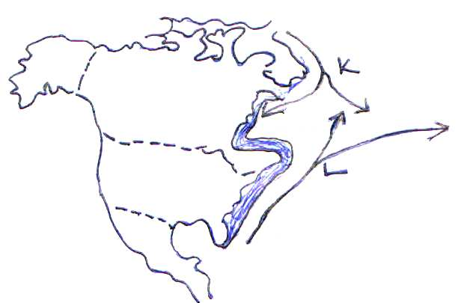

- (i) Name the ocean currents named K and L (2 marks)
(ii) Name two methods of fishing used in the shaded area. (2 marks)
(b) Explain how the following factors favour fishing in the shaded area.
(i) Indented coastline (2 marks)
(ii) Ocean currents (2 marks)
(c) Explain four ways in which marine fisheries in Kenya can be conserved (8 marks)
(d) (i) Give three methods used to preserve fish in Kenya (3 marks)
(ii) Explain three problems experienced by fishermen in Lake Victoria (6 marks)

9 (a) (i) Differentiate between land reclamation and land rehabilitation. (2 marks)
(ii) Name three methods of irrigation used in Kenya. (3 marks)
(b) (i) State three objectives that led to the establishment of Mwea irrigation scheme in Kenya (3 marks)
(ii) Explain four problem facing irrigation farming in Kenya. (8 marks)
(c) (i) What is a polder? (2 marks)
(ii) Name two crops grown in polders (2marks)
(d) Give five benefits of the Zulder Zee project to the Dutch. (5Marks)

10 (a) (i) Define the term Environmental conservation (2marks)
(ii) Apart from floods and environmental pollution name any other three environmental hazards (3 marks)
(iii) How do floods occur? (2 marks)
(b) Explain four measures used to combate floods in Kenya. (8 marks)
(c) (i) State three ways in which farming contributes to water pollution. (3 marks)
(ii) State four effects of air pollution on the environment (4 marks)
(d) Give three ways in which air pollution can be controlled. (3 marks)

