NAME………………………………………………INDEX NO………………CLASS …….....
Date……………………Sign …………….
231/2
BIOLOGY
PAPER 2 (THEORY)
MAY 2014
2 HOURS
KASSU JOINT EXAMINATION TEST - 2014
Kenya Certificate of Secondary Education (K.C.S.E)
INSTRUCTIONS
- This paper consists of two sections A and B. Answer All the questions in section A in the spaces provided.
- In section B answer questions 6 (Compulsory) and either Questions 7 or 8 in the spaces provided.
FOR EXAMINER’S USE ONLY
SECTION | QUESTION | MAXIMUM SCORE |  | CANDIDIATE’S  SCORE
A | 1 | 8
A | 2 | 8
A | 3 | 8
A | 4 | 8
A | 5 | 8
B | 6 | 20
B | 7 | 20
B | 8 | 20
TOTAL SCORE |  | 80

This paper consists of 11 printed pages. Candidates should check carefully
to ascertain that all the pages are printed as indicated and no questions are missing

SECTION A (40 MARKS)
Answer all the questions in this section in the spaces provided after each question.
- The diagrams below represent two plant cells A and B placed in two different solutions. Study the diagrams and answer questions that follow:
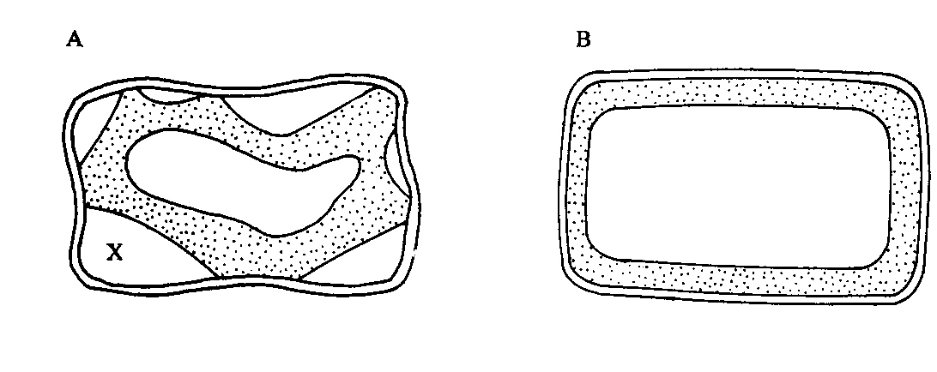
- Identify the nature of solution into which each cell was placed. (2mk)
A …………………………………………………………………………………........
B ………………………………………………………………………………………
- Name the physiological process responsible for the observed results. (1mk)
………………………………………………………………………………………..
c) Give the correct biological term used to describe cell A. (1mk)
………………………………………………………………………………………...
- Describe what would happen if a red blood cell was placed in the solution in which cell B was placed. (2mk)
………………………………………………………………………………………………………………………………………………………………………………………………………………………………………………………………………………
- Explain why freshwater amoeba do not burst when placed in distilled water. (2mk)
………………………………………………………………………………………………………………………………………………………………………………………………………………………………………………………………………………

- a) What is meant by the term linked genes? (1mk)
………………………………………………………………………………………………………………………………………………………………………………………………………………………………………………………………………………………………
b). Haemophilia is a genetic condition transmitted through a recessive gene linked to X
chromosome. The normal gene may be represented by X^{H}.
- What is the genotype of a haemophilic female? (1mk)
………………………………………………………………………………………………………………………………………………………………………………
- A woman who is a carrier for the haemophilia gene marries a normal man. Work out the phenotypic ratio for their offspring. (4mk)
………………………………………………………………………………………………………………………………………………………………………………………………………………………………………………………………………………………………………………………………………………………………………………………………………………………………………………………………………………………………………………………………………………………………………………………………………………………………………………………………………………………………………………………………………………………………………………………………………………………………………………………………………………………………………………
- Haemophilia is more common in males than in females. Explain this phenomenon. (2mk)
………………………………………………………………………………………………………………………………………………………………………………………………………………………………………………………………………………………………………………………………………………………………………………………………………………………………………………………

- Study the diagram below and answer questions that follow.
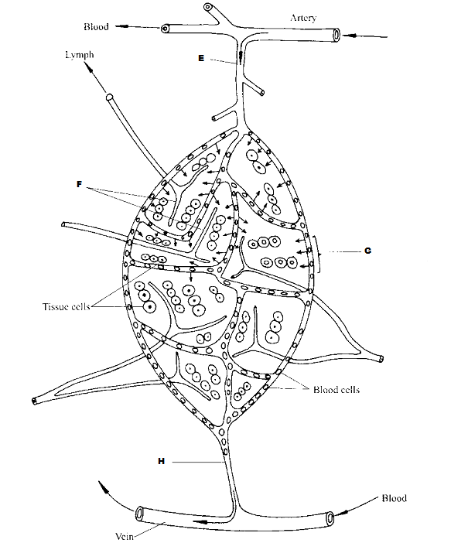

- Identify the parts labeled E, F and H. (3mk)
E………………………………………………………………………………………
F………………………………………………………………………………………
H………………………………………………………………………………………
- State the importance of the process represented by G in bodies of living organisms.
(2mk)
………………………………………………………………………………………………………………………………………………………………………………………………………………………………………………………………………………
- Compare the composition of blood in vessel E and H. (3mk)
…………………………………………………………………………………………………………………………………………………………………………………………………………………………………………………………………………………………………………………………………………………………………………………………………………………………………………………………………………………………………………………………………………………………………………………………………………………………………………………………

- Use the figure below to answer questions that follow:
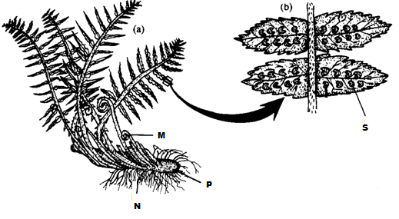
- Identify the division to which the specimen belongs. (1mk)
…………………………………………………………………………………………..
- Name the parts labeled M, N and P. (3mk)
M………………………………………………………………………………………N………………………………………………………………………………………
P ……………………………………………………………………………………..
- Name the spore producing structures that constitute the part labeled S. (1mk)
………………………………………………………………………………………..

- Identify three features that distinguish the specimen above from higher plants. (3mk)
……………………………………………………………………………………………………………………………………………………………………………………………………………………………………………………………………………………………………………………………………………………………………………………………………………………………………………………………………
- a) Name the plant organs in which meiosis take place. (2mk)
……………………………………………………………………………………………………………………………………………………………………………………………..
- Identify the figure below. (1mk)

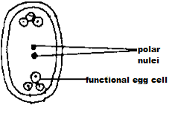
…………………………………………………………………………………………
- Using the diagram, explain the meaning of double fertilization in flowering plants.
(1mk)
………………………………………………………………………………………………………………………………………………………………………………………………………………………………………………………………………………………………………………………………………………………………………….
- What happens to the structure above after fertilization? (1mk)
……………………………………………………………………………………………………………………………………………………………………………………
- State three adaptations of fruits to animal dispersal. (3mk)
………………………………………………………………………………………………………………………………………………………………………………………………………………………………………………………………………………………………………………………………………………………………………………………………………………………………………………………………………………………………………………………………………………………………
SECTION B (40 MARKS)
Answer questions 6 (compulsory) and either question 7 or 8 in the spaces provided.
- A study was carried out to investigate the distribution of certain mammals in a game reserve with three distinct habitats. The results were as presented in the graph below.

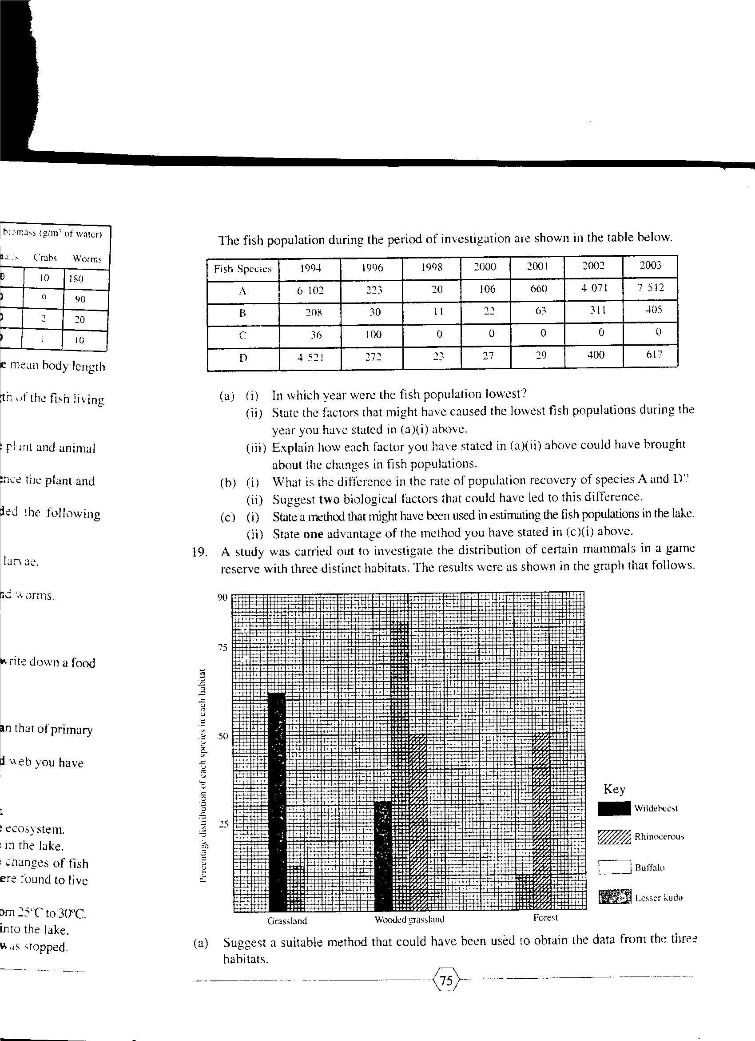

- Suggest a suitable method that could have been used to obtain the data from the three habitats. (1mk)
…………………………………………………………………………………………..
- Suggest three reasons why all mammalian species were found in the wooded grassland. (3mk)
………………………………………………………………………………………………………………………………………………………………………………………………………………………………………………………………………………………………………………………………………………………………………………………………………………………………………………………………………………………………………………………………………………………………………………………………………………………………………………………………………………………………………………………………………………………………………………………………………………………………………………
- From the data, suggest the feeding habits of:
- Wildebeest. (3mk)
……………………………………………………………………………………………………………………………………………………………………………………………………………………………………………………………………………………………………………………………………………………………………………………………………………………………
- Lesser kudu. (3mk)
……………………………………………………………………………………………………………………………………………………………………………………………………………………………………………………………………………………………………………………………………………………………………………………………………………………………………………………………………………………………………………………………………………………………………………………………………………………………………………………………………………………

- The vegetation in this game reserve was destroyed by fire. Two weeks after the onset of rains, most of the animals were found in the grassland. Explain. (4mk)
………………………………………………………………………………………………………………………………………………………………………………………………………………………………………………………………………………………………………………………………………………………………………………………………………………………………………………………………………………………………………………………………………………………………………………………………………………………………………………………………………………………………………………………………………………………………………………………………………………………………………………
- Name three environmental factors that are necessary for growth of vegetation other than rain. (3mk)
…………………………………………………………………………………………………………………………………………………………………………………………………………………………………………………………………………………………………………………………………………………………………………
- For each of the factors, briefly explain its importance. (3mk)
……………………………………………………………………………………………………………………………………………………………………………………………………………………………………………………………………………………………………………………………………………………………………………………………………………………………………………………………………………………………………………………………………………………………………………………………………………………………………………………………………………………………………………………………………………………
- a) Describe how water molecules are absorbed from the soil and moves to the leaves in a tree. (10mk)
b) Describe the mechanism of inhalation in human beings. (10mk)
- a) Describe adaptations of the reproductive system of a male mammal to its function. (10mk)
b) Explain how the following vertebrae are adapted to their function. (10mk)
(i) Cervical vertebra.
(ii) Thoracic vertebra.
………………………………………………………………………………………………………………………………………………………………………………………………………………………………………………………………………………………………………………………………………………………………………………………………………………………………………………………………………………………………………………………………………………………………………………………………………………………………………………………………………………………………………………………………………………………………………………………………………………………………………………………………………………………………………………………………………………………………………………………………………………………………………………………………………………………………………………………………………………………………………………………………………………………………………………………………………………………………………………………………………………………………………………………………………………………………………………………………………………………………
………………………………………………………………………………………………………………………………………………………………………………………………………………………………………………………………………………………………………………………………………………………………………………………………………………………………………………………………………………………………………………………………………………………………………………………………………………………………………………………………………………………………………………………………………………………………………………………………………………………………………………………………………………………………………………………………………………………………………………………………………………………………………………………………………………………………………………………………………………………………………………………………………………………………………………………………………………………………………………………………………………………………………………………………………………………………………………………………………………………………
………………………………………………………………………………………………………………………………………………………………………………………………………………………………………………………………………………………………………………………………………………………………………………………………………………………………………………………………………………………………………………………………………………………………………………………………………………………………………………………………………………………………………………………………………………………………………………………………………………………………………………………………………………………………………………………………………………………………………………………………………………………………………………………………………………………………………………………………………………………………………………………………………………………………………………………………………………………………………………………………………………………………………………………………………………………………………………………………………………………………
………………………………………………………………………………………………………………………………………………………………………………………………………………………………………………………………………………………………………………………………………………………………………………………………………………………………………………………………………………………………………………………………………………………………………………………………………………………………………………………………………………………………………………………………………………………………………………………………………………………………………………………………………………………………………………………………………………………………………………………………………………………………………………………………………………………………………………………………………………………………………………………………………………………………………………………………………………………………………………………………………………………………………………………………

