NAME:…………………………………………………………… ADM. NO…………………………..…..…..
SCHOOL:……………………………………………………SIGNATURE……………………………… DATE…………….……………………………….
443
AGRICULTURE
(Theory)
TIME: 2 HOURS

SET 4
FORM TWO

INSTRUCTIONS TO CANDIDATES
- Write your name and Adm. number in the spaces provided.
- Answer ALL the questions in the spaces provided,

FOR EXAMINERS USE ONLY
Question | Maximum score | Candidates score
1-29 | 100

This paper consists of 10 printed pages. Candidates should check the question paper to ensure that all the pages are printed as indicated and no questions are missing.

1. What are essential nutrients ? (1 mark)
……………………………………………………………………………………………………………………………………………………………………………………………………………………………………
2. Name two examples of liming elements (1mark)
……………………………………………………………………………………………………………………………………………………………………………………………………………………………………
3. State three roles of Nitrogen in vegetable production (3 marks)
………………………………………………………………………………………………………………………………………………………………………………………………………………………………………………………………………………………………………………………………………………………………………………………………………………………………………………………………………..
4. A farmer was advised to apply 40kg of P205 per hectare of maize at planting time. The phosphatic fertilizer available was single superphosphate containing 20 % P2O5.
i) Calculate the amount of Single superphosphate fertilizer the farmer would apply in two hactares (2 marks)
………………………………………………………………………………………………………………………………………………………………………………………………………………………………………………………………………………………………………………………………………………………………………………………………………………………………………………………………………....
5. State two ways in which a farmer can raise the PH of the soil. (2 marks)
……………………………………………………………………………………………………………………………………………………………………………………………………………………………………
6. State two things that would happen to the element nitrogen when ammonium sulphate fertilizer is applied to the field of maize. (2 marks)
…………………………………………………………………………………………………………………………………………………………………………………………………………………………………………………………………………………………………………………………………………………………………………………………………………………………………………………………………………

7. a) Give three benefits of vegetative propagation in oranges (3 marks)
…………………………………………………………………………………………………………………………………………………………………………………………………………………………………………………………………………………………………………………………………………………………………………………………………………………………………………………………………………
b) Differentiate the terms bulb and bulbils (2 marks)
…………………………………………………………………………………………………………………………………………………………………………………………………………………………………………………………………………………………………………………………………………………………………………………………………………………………………………………………………………
c) State one environmental condition necessary for the successful chitting in Irish potatoes (1 mark)
……………………………………………………………………………………………………………………………………………………………………………………………………………………………
8. Give four factors that determine the depth of planting in crops (2marks)
……………………………………………………………………………………………………………………………………………………………………………………………………………………………………………………………………………………………………………………………………………………………………………………………………………………………………………………………………………………………………………………………………………………………………………………………
9. Give three benefits of crop rotation (4 marks)
………………………………………………………………………………………………………………………………………………………………………………………………………………………………………………………………………………………………………………………………………………………………………………………………………………………………………………………………………………………………………………………………………………………………………………………………………………………………………………………………………………………………………………

10. State two disadvantages of Monocropping (2 marks)
………………………………………………………………………………………………………………………………………………………………………………………………………………………………………………………………………………………………………………………………………………………………………………………………………………………………………………………………………
11. Give four benefits of using organic mulch for mulching (2 marks)
………………………………………………………………………………………………………………………………………………………………………………………………………………………………………………………………………………………………………………………………………………………………………………………………………………………………………………………………………
12. State four reasons for pruning fruit coffee (4 marks)
……………………………………………………………………………………………………………………………………………………………………………………………………………………………………………………………………………………………………………………………………………………………………………………………………………………………………………………………………………………………………………………………………………………………………………………………………………………………………………………………………………………………………………
13. State two practices which help to achieve optimum plant population (2 marks)
………………………………………………………………………………………………………………………………………………………………………………………………………………………………………………………………………………………………………………………………………………………………………………………………………………………………………………………………………
14. a) What is earthing up in crop production? (1 mark)
…………………………………………………………………………………………………………………………………………………………………………………………………………………………………… b) Give a reason for earthing up in each of the following crops (4 marks)
i) Irish potatoes………………………………………………………
ii) Groundnuts……………………………………………………………
iii) Tobacco………………………………………………………………
iv) Maize………………………………………………………………….
15. a) State two factors that determine the method of harvesting to be used by a farmer (1 mark)
……………………………………………………………………………………………………………………………………………………………………………………………………………………………………
…………………………………………………………………………………………………………………………………………………………………………………………………………………………………… b) The stem cuttings should be obtained from the middle part of the shoot. Give a reason why the top and bottom parts are not suitable for stem cutting. (2 marks)
…………………………………………………………………………………………………………………………………………………………………………………………………………………………………………………………………………………………………………………………………………………………………………………………………………………………………………………………………………
16. The diagrams labeled A_{1,} A₂, A_{3,} and B below illustrate materials and methods of vegetative propagation. Study them and answer the questions that follow.

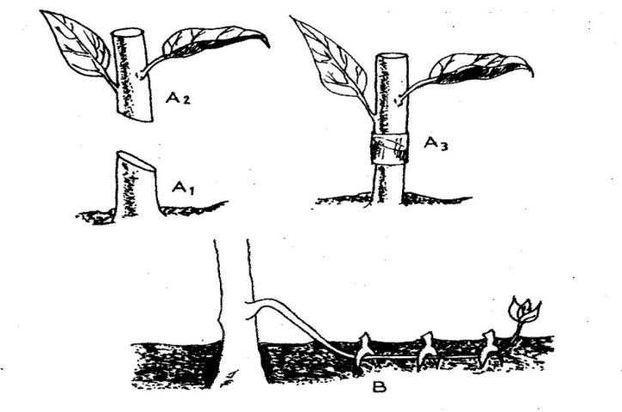

(a) Name the parts labeled A₁, and A₂ (1 mark)
A_{1……………………………………………………………………}
A_{2…………………………………………………………………..}
(b) Name the methods of propagation illustrated in diagrams A₃ and B (2 marks)
A_{3……………………………………………………………………….}
B…………………………………………………

17. a) Name two notifiable diseases in cattle. (1 mark)
…………………………………………………………………………………………………………………………………………………………………………………………………………………………………… b) Name two vector borne diseases in livestock (1 mark). ……………………………………………………………………………………………………………………………………………………………………………………………………………………………………
18. Name one intermediate host for each of the following livestock parasites (1 mark)
(a) Liver fluke (Fasciola spp)
……………………………………………………………………………………………………………..
(b) Taenia solium
……………………………………………………………………………………………………………..
19. State two ways by which proper feeding contribute to disease control in livestock. (2 marks)
……………………………………………………………………………………………………………………………………………………………………………………………………………………………………
…………………………………………………………………………………………………………………………………………………………………………………………………………………………………
20. Give FOUR causes of blossom end rot in tomatoes (4 marks)
…………………………………………………………………………………………………………………………………………………………………………………………………………………………………………………………………………………………………………………………………………………………………………………………………………………………………………………………………………
……………………………………………………………………………………………………………………………………………………………………………………………………………………………………

21. The diagrams are illustrations of a livestock parasite. Study and answer the question that follow.
M N
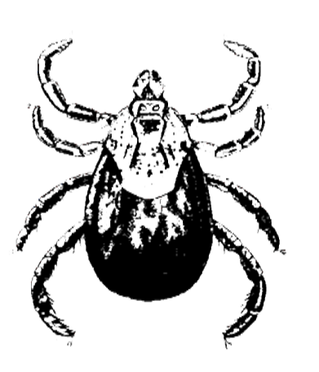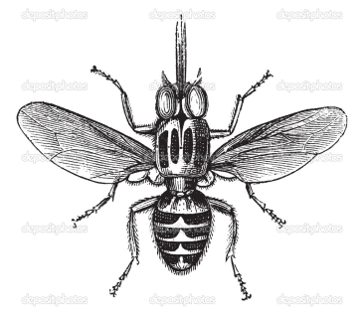
a) Identify the parasites labeled as M and N above. (1 mark)
b) State two harmful effects of M parasite (2 marks)
…………………………………………………………………………………………………………………
……………………………………………………………………………………………………………………………………………………………………………………………………………………………………
c) Name a class chemical used to control the parasite M (1 mark)
………………………………………………………………………………………………………………… d) Name a disease transmitted by the parasite N; (1 mark)
To Man………………………………………………..
To Livestock………………………………………..
22. The illustration below shows a life cycle of an internal parasite. Study it anser the questions that follow.
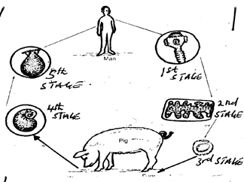
a) i) Identify the parasite above. 1 mark
……………………………………………………………
ii) How is the parasite passed from livestock to man. (1 mark)
…………………………………………………………………………………………………………………………………………………………………………………………………………………………
- Give two forms in which the parasite is found in livestock. (1 mark)
………………………………………………………………………………………………………………………………………………………………………………………………………………………………………………………………………………………………………………………………………………………………………………………
23. Give four reasons why water is important to animals ( 4 marks)
……………………………………………………………………………………………………………………………………………………………………………………………………………………………………………………………………………………………………………………………………………………………………………………………………………………………
24. State four sources of carbohydrates for livestock (4 marks)
…………………………………………………………………………………………………………………………………………………………………………………………………………………………………………………………………………………………………………………………………………………………………………………………………………………………………………………………………………
25. a) Name the following Nutrients ; (2 marks)
i) A vitamin whose deficiency leads to redarded growth ,poor eye sight, and reduced resistance to
diseases………………………………………………….
ii) A vitamin which is found in whole grains and can be synthesized by micro-organisms in the
rumen………………………………………………………………………………….
iii) Mineral which is required for reproduction in livestock………………………………..
iv) A mineral required by piglet immediately after birth to control piglet anaemia…………………

26. State four factors affecting digestibility (4 marks)
………………………………………………………………………………………………………………………………………………………………………………………………………………………………………………………………………………………………………………………………………………………………………………………………………………………………………………………………………..
27. A farmer is required to prepare 100 kg of ration of 30% digestible crude protein ( DCP) from simsim seed cake containing 50% DCP and maize meal 10% DCP. Using Pearson’s square method calculate the amount of simsimand maize the farmer requires.(4marks )

28. The photographs below illustrate the parts of a ruminant stomach. Study them and answer the questions that follow.
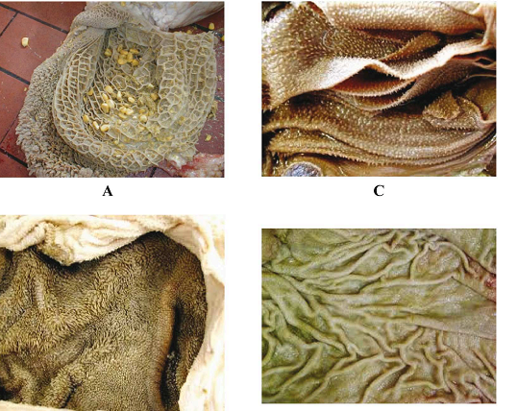

i. Identify parts A and C (1 mark)
A ……………………
C…………………….
ii. Give the functions of the part labeled as B and D (2 marks)
B……………………………………………
D…………………………………………..
29. a) Explain three field practices in carrot production. (6 marks)
………………………………………………………………………………………………………………………………………………………………………………………………………………………………………………………………………………………………………………………………………………………………………………………………………………………………………………………………………..
- Describe harvesting in onions. (4 marks)
………………………………………………………………………………………………………………………………………………………………………………………………………………………………………………………………………………………………………………………………………………………………………………………………………………………………………………………………………..

