FORM TWO AGRICULTURE
END TERM EXAMINATIONS
MARCH/APRIL 2016
TIME:2HOURS
NAME……………………………………………………...........ADM.NO:………………………….
SCHOOL………………………….

INSTRUCTIONS TO STUDENTS
1. Answer all questions in this question paper.
2. All your answers must be written in the spaces provided in this question paper.

Answer All the Question

1. List four characteristics of plantation farming (4mks)

2. Give four benefits of Agro forestry (4mks)

3. Differntaiate between soil structure and soil texture (2mks)

4. State four reasons for treating water in the farm (4mks)

5. State four disadvantages of using organic manure (4mks)

6. Name two species of camel (2mks)

7. State four control measures of tsetse flies (4mks)

8. What is meant by BosInducus? (1mk)

9. Name four dairy breeds of goat (4mks)

10. Why do we keep farm record (1mk)

SECTION B(2MKS)

11. The diagram below illustrates some types of soil structure. Study and answer the question that follow

- Identify the type of soil structure illustrated by (2mks)
A

B

- Name parts labeled (i) and (ii) (2mks)

- State two effects of soil structure A in crop production (2mks)

12. Below are farm tools

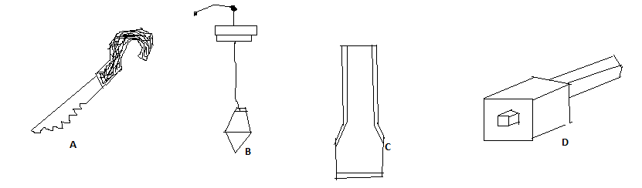

- Name the tool above (4mks)

A

B

C

D

b) State use of each tool above (4mks)

A

B

C

D

(c) State two maintenance that can be carried to tool D (2mk)

(d) Classify the following tools at their appropriate categories (4mks)

Categories
A
B
C
D

SECTION C (40 MKS)

13. (a) State the importance of livestock in the farm (4mks)
(b) Explain differences between BosIndicus and Bos Taurus breeds (10mks)
(c) List six breeds of rabbit (6mks)

14. (a) Describe the importance of livestock husbandly (15mks)
(b) State four breeds of dairy cattles (4mks)
(c) Which dairy breeds produce high butter fat content

15 (a) Discuss seven method by which soil is able to loss its fertility (14mks)
(b) State six characteristic of a fertile soil (6mks)

