NAME:………………………………………..…………….. ADM. NO………………
SCHOOL:……………………………………………………SIGNATURE……………… DATE…………….………………

231
BIOLOGY
(Theory)
TIME: 2 HOURS
SET 1
FORM 2

INSTRUCTIONS TO CANDIDATES
- Write your name and Adm. number in the spaces provided.
- Answer ALL the questions in section A and B in the spaces provided,

FOR EXAMINERS USE ONLY
Question | Maximum score | Candidates score
1-17 | 70

1.The diagram below represents a plant cell organelle
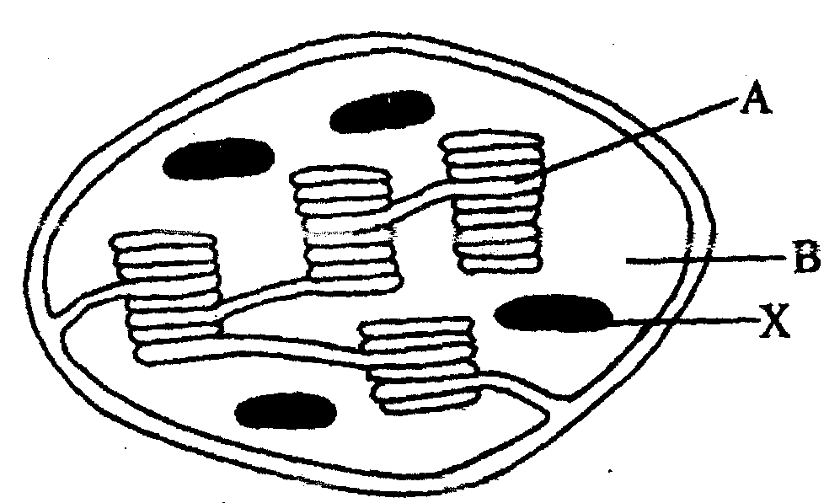
a) Name the organelle. (1mk)

b) In which of the labelled parts does carbon (IV) Oxide fixation occur? (1mk)

c) Name the parts labelled A and B and state how each is adapted to its functions. (4mks)

A.....................................................................................................................................................................................................................................................................
B.....................................................................................................................................................................................................................................................................
d) Explain what would have happened to the structures labelled X had the plant been kept in darkness for 48 hours. (2mks)

2. The diagram below shows some components of a light microscope.
- Name the parts labeled (2mrks)
K ………………………………………………………………………………………………
M ………………………………………………………………………………………………
- State the functions of (2mrks)
P ………………………………………………………………………………………………
Q ………………………………………………………………………………………………
- A student was viewing a prepared slide of a plant cell under high power microscope. The features of the cell were blurred. Which one of the labelled parts of the microscope would the student use to obtain:-
- a sharper outline of the features. (1mrk)
………………………………………………………………………………………………
- Give the formula used to calculate magnification in a light microscope. (1mrk)
………………………………………………………………………………………………
- A student was preparing a section of a plant cell to be viewed on a light microscope. Give a reason for each of the following steps:-
(i)Cutting a very thin section (1mrk)

(ii)Staining the section (1mrk)

(iii)Putting the section in water (1mrk)

3.The diagram below shows part of a longitudinal section of a root: -
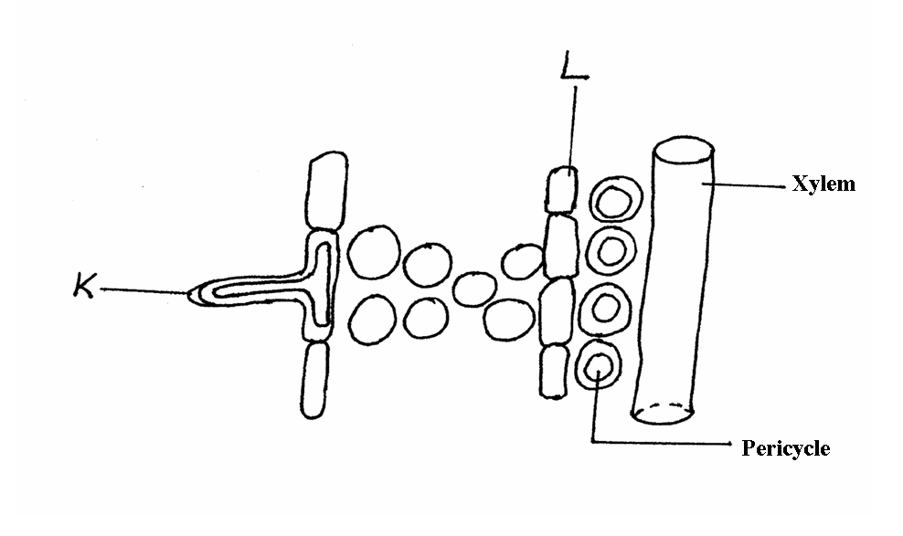
(a) Identify cells K and L :- (2 mks)
K
……………………………………………………………………………………………………….……………………………………………………………………
L
……………………………………………………………………………………………………….……………………………………………………………………
(b) State two adaptations of Cell K to its functions :- (2 mks)
……………………………………………………………………………………………………….……………………………………………………………………………………
……………………………………………………………………………………………………….……………………………………………………………………………………

4.State three main functions of the stomach in human beings:- (3 mks)

5.Name the cell organelles responsible for :
i) Protein synthesis

ii) Destroying worn – out organells and cells

6.a) Lietego school biology student used a microscope with x40 objective lens and x5 eye piece lens which had 2mm radius. Calculate the area of the field of view in micrometers. (2mks)

b) What is the average size of the cell in micrometers (2mks)

7.(a) Identify the organelle shown below:- (1mk)
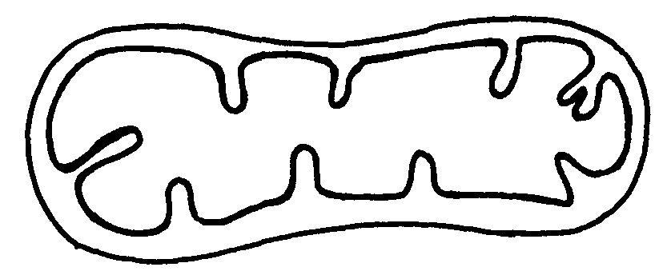
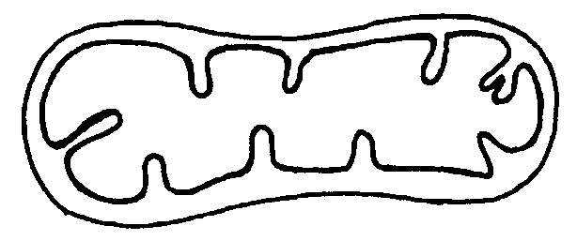

(b) How is the organelle you have identified in (a) above suited to its function(2mks)

8.State three properties of the cell membrane (3mks)

9.a) What is the formula for calculating linear magnification of a specimen when using a
hand lens (1mk)

10.Distinguish between the following terms :-(4mks)
- Magnification and resolution of a microscope

Mounting and staining of a specimen

11.Name the organelle that performs each of the following functions in a cell. (3mks)
- Transport of packaged glycoproteins

- Destruction of worn out cell organelles

(c) Synthesis of proteins

12.Why are the following procedures done when preparing sections to be observed under a light
microscope? (3mks)
- Making of thin sections
- Using a sharp blade to make the sections

c)Staining

13.Statethree physiological processes that are involved in movement of substances a cross the cell membrane (3mks)

14Name the diseases caused by deficiency of : (2mks) (a) Iodine

(b) Vitamin C

15.What are the two functions of bile salts during the process of digestion?(2mks)

16.State two adaptations of herbivores which enable them to digest cellulose(2mks)

17.State three factors that affect the rate of osmosis(3mks)

18.State three roles of light in photosynthesis(3mks)

19.Explain how saliva is important in digestion (2mks)

20.Briefly explain the fate of the following products from the light stage of the process of
Photosynthesis (3mks)
(a) Oxygen

b)Hydrogen

- ATP

21.State three ways by which plants compensate for lack of the ability to move from one place
to another(3mks)

21.State four difference between monosaccharide and polysaccharides(4mks)

23.Describe how mammalian small intestine is adapted to its function (7mks)

