Name : ………………………………………………………… Index No : .................................................................
School:………………………………………………………… Candidate’s Name : …………………………..............
Date: ...........................................................................
443/1
AGRICULTURE
Paper 1
July/August 2014
Time: 2 Hours

Kenya Certificate of Secondary Education
AGRICULTURE
Paper 1
July/August 2014
Time: 2 Hours
INSTRUCTIONS TO CANDIDATES:
- Write your name and index number in the spaces provided above.
- Sign and write the date of examination in the spaces provided above.
- This paper consists of three section A,B and C
- Answer all the questions in section A and B any two questions from section C.
- Cndidate should check the question paper to ascertain that all the pages are printed as indicated and that no questions are missing.

SECTION | QUESTIONS | MAXIMUM SCORE | CANDIDATE’S SCORE
A | 1-18 | 30
B | 19 - 23 | 20
C |  | 20
C |  | 20
TOTAL SCORE |  | 90
Instructions to candidates

This paper consists of 10 printed pages. Candidates should check to ascertain that all pages are printed as indicated and that no questions are missing.

SECTION A (30MARKS)
1. State four factors that determine the choice of water pipes used in the farm. (2mks)
..........................................................................................................................................................
...........................................................................................................................................................
..........................................................................................................................................................
2. (a) State three causes of blossom end- rot diseases in tomatoes. (1 ½mks)
.....................................................................................................................................................
....................................................................................................................................................
.....................................................................................................................................................
.....................................................................................................................................................
(b) Give two factors that induce forking in carrots. (1mk)
.....................................................................................................................................................
....................................................................................................................................................
....................................................................................................................................................
3. Give three effects of diseases on crop production. (1 ½ mks)
..................................................................................................................................................................
..................................................................................................................................................................
..................................................................................................................................................................
.................................................................................................................................................................
4. Name four classes of pesticides according to the mode of action. (2mks)
.................................................................................................................................................................. ..................................................................................................................................................................
..................................................................................................................................................................
..................................................................................................................................................................
5. State two factors that determining the quality of compost manure. (1mk)
.................................................................................................................................................................
..................................................................................................................................................................6. Give two properties of the soil that are influenced by the soil texture. (1mk)
..................................................................................................................................................................
..................................................................................................................................................................
..................................................................................................................................................................
7. State four ways of improving farm labour productivity. (2mks)
....................................................................................................................................................................................................................................................................................................................................

...................................................................................................................................................................................................................................................................................................................................
8. Name four types of financial books. (2mks)
..................................................................................................................................................................
..................................................................................................................................................................
..................................................................................................................................................................
..................................................................................................................................................................
9. Distinguish between over sowing and under sowing as used in pasture establishment. (1mk)
..................................................................................................................................................................
..................................................................................................................................................................
..................................................................................................................................................................
10. (a) State two disadvantages of shifting cultivation. (1mk)
.....................................................................................................................................................
.....................................................................................................................................................
(b) List three activities carried out in secondary cultivation. (1mk)
...................................................................................................................................................... ..................................................................................................................................................... .....................................................................................................................................................
......................................................................................................................................................
11. Name four methods of treating the seeds before planting. (2mks)
..................................................................................................................................................................
.................................................................................................................................................................
.................................................................................................................................................................. ..................................................................................................................................................................12. State four roles of trees in soil and water conservation. (2mks)
..................................................................................................................................................................
..................................................................................................................................................................
..................................................................................................................................................................
..................................................................................................................................................................
13. Give four government policies that influence agricultural production in Kenya. (2mks)
..................................................................................................................................................................
.................................................................................................................................................................. ..................................................................................................................................................................
..................................................................................................................................................................

14. Sate two advantages of tenancy system in farming. (1mk)
..................................................................................................................................................................
..................................................................................................................................................................
.................................................................................................................................................................
15. List four sites for agro forestry trees and shrubs in the farm. (2mks)
..................................................................................................................................................................
..................................................................................................................................................................
..................................................................................................................................................................
..................................................................................................................................................................
16. Give three factors that determine the competitive ability of weeds. (1 ½ mks)
..................................................................................................................................................................
..................................................................................................................................................................
.................................................................................................................................................................. .................................................................................................................................................................
17. State two field practices that could be carried out to maximize the use of nitrogenous fertilizer in
maize field. (1 mk)
..................................................................................................................................................................
..................................................................................................................................................................
18. State two cultural measures of controlling maize streak diseases. (1mk)
..................................................................................................................................................................
..................................................................................................................................................................
SECTION B (20MARKS)
- Answer all the questions on this section in the spaces provided.
19 The diagram below shows a banana tissue culture. Study it and answer the questions that follow.
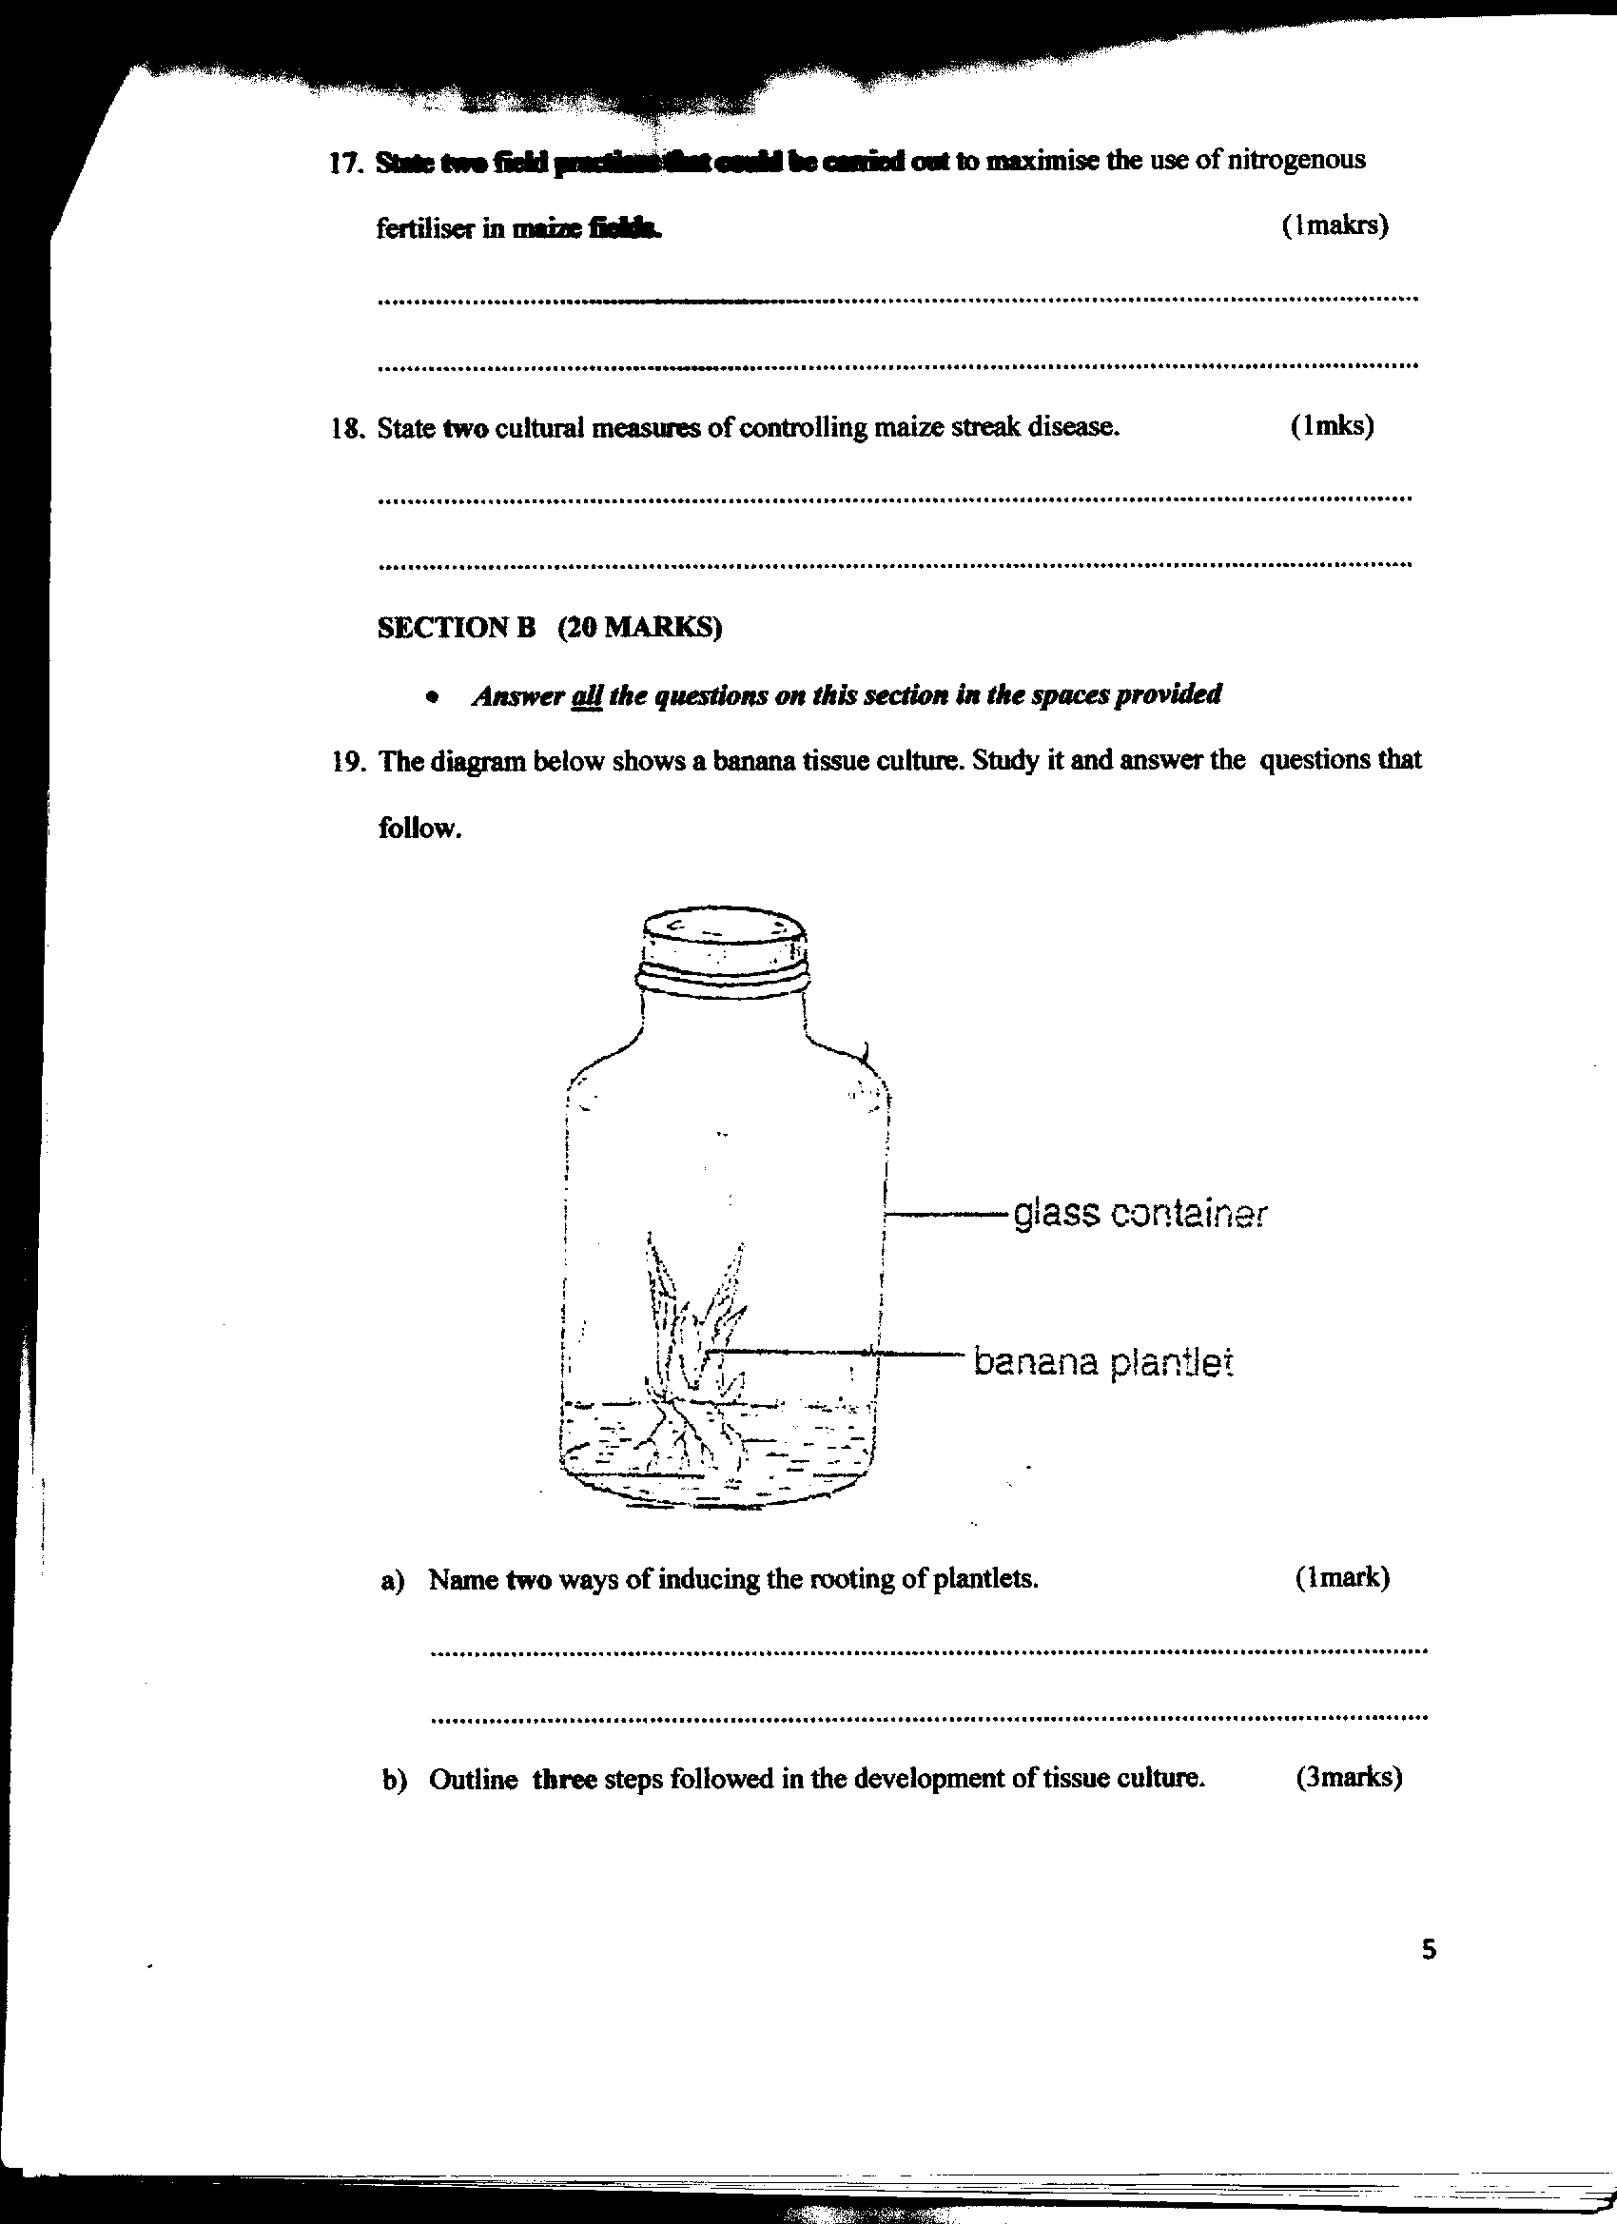

Glass container

Banana planlet

(a) Name two ways of inducing the rooting of plantlets. (1mk)
..................................................................................................................................................
.................................................................................................................................................

(b) Outline three steps followed in the development of tissue culture. (3mks) ............................................................................................................................................... .. ..................................................................................................................................................
..................................................................................................................................................
..................................................................................................................................................
(c) State two advantages of propagating crops by tissue culture technique. (1mk)
..................................................................................................................................................................
..................................................................................................................................................................
20. A farmer has 16 hectares of land .6 ha under permanent pasture. He plans to grow 6 hectares of
beans . In the previous seasons, the hired casual workers at the rate of 80 man days per hectares.
The cost was kshs. 30 per man – day. This seasons he intends to hire a tractor to open the land at a
cost of ksh.600 per hectares . He thinks that using a tractor will increase bean production from 800
to 1200kg/ha . Harvesting will cost kshs. 6 per kg of beans seeds and the price of beans will be kshs. 60/kg. Draw up a partial budget to show whether the change would be worthwhile. (5mks)

21. The diagram D and E below illustrate some methods of draining waterlogged soils . Study them and
answer the questions that follow.

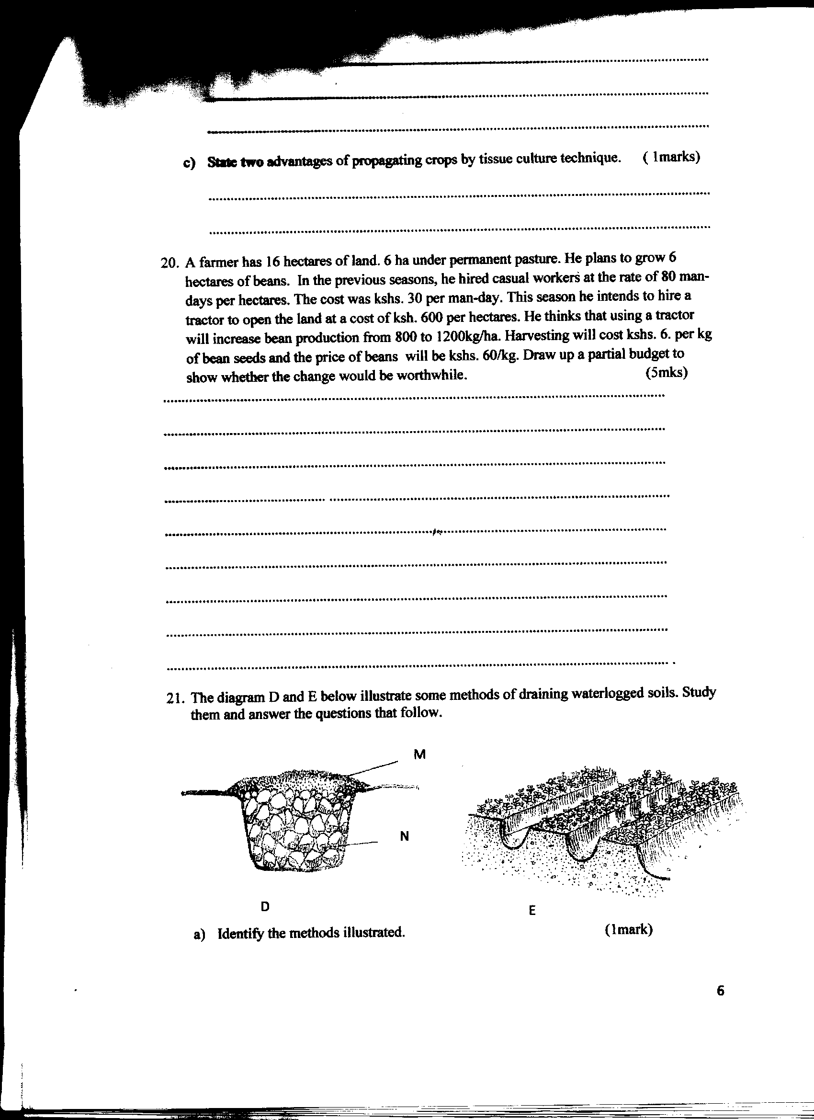

(a) Identify the methods illustrated. (1mk)
....................................................................................................................................................
.....................................................................................................................................................
(b) Name the material used in D labeled M and N. (2mks)
M ................................................................................................................................................
N ...............................................................................................................................................
(c) A part from the methods illustrated above, name any other two ways of draining a waterlogged soil. (1mk)
............................................................................................................................................................................................................................................................................................................
22. The diagram below shows a pest and the damaged crop. Study it and answer the questions that follow.
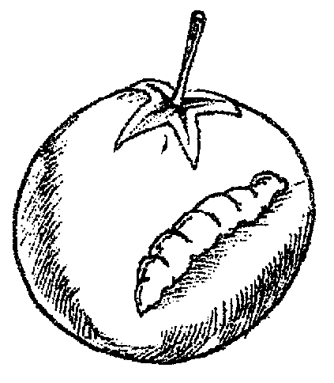

(a) Identify the crop pest illustrated above. ( ½ mk)
.....................................................................................................................................................
......................................................................................................................................................
(b) What damage does the pest cause to the crop. ( ½ mk)
....................................................................................................................................................
...................................................................................................................................................
(c) State two ways of controlling the pest. (1mk)
......................................................................................................................................................
.....................................................................................................................................................

23. The diagram below illustrate some soil structures. Study them and answer the questions that follow.
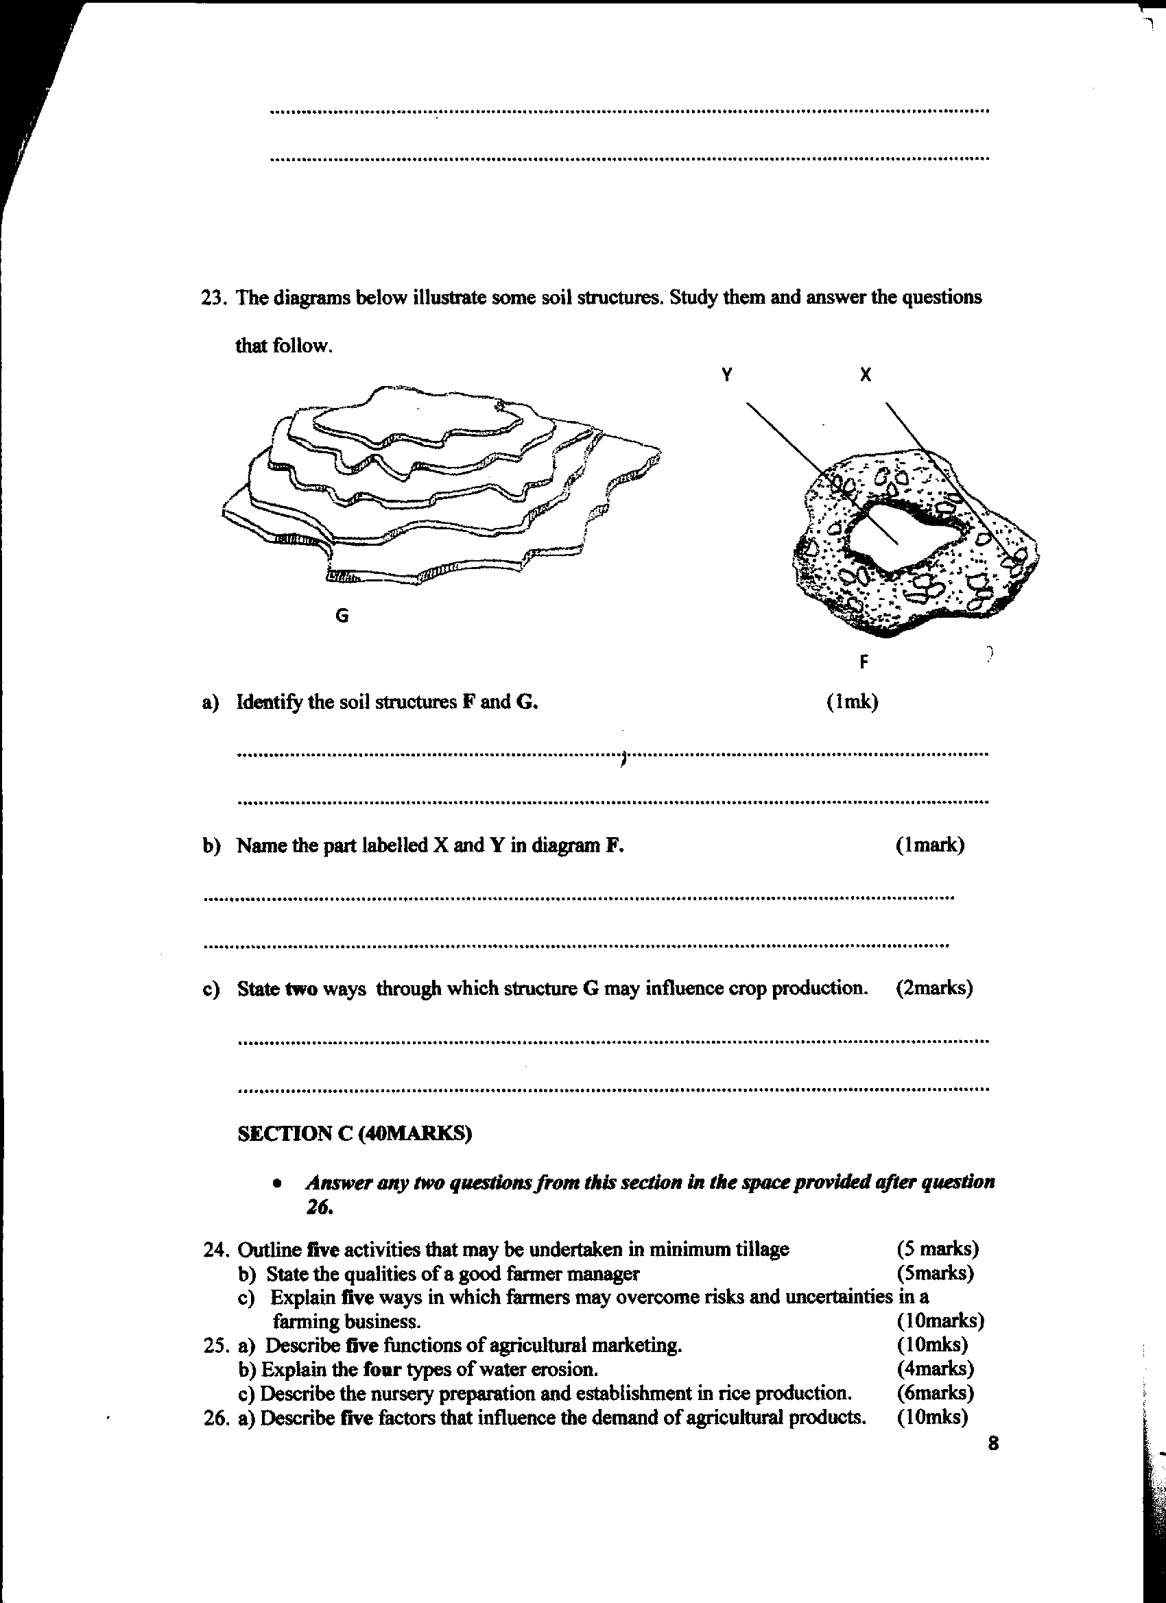
X
Y

(a) Identify the soil structures F and G. (1mk)
.....................................................................................................................................................
......................................................................................................................................................
(b) Name the part labelled X and Y in diagram F. (1mk)
......................................................................................................................................................
......................................................................................................................................................
(c) State two ways through which structure G influence crop production. (2mks)
......................................................................................................................................................
......................................................................................................................................................
SECTION C (40MARKS)
- Answer any two questions from this section in the spaces provided after question 26.

24. (a) Outline five activities that may be undertaken in minimum tillage. (5mks)
(b) State the qualities of a good farmer manager. (5mks)
(c) Explain five ways in which farmers may overcome risks and uncertainties in a farming business. (10mks)
25. (a) Describe five functions of agricultural marketing. (10mks)
(b) Explain the four types of water erosion. (4mks)
(c) Describe the nursery preparation and establishment in rice production. (6mks)
26. (a) Describe five factors that influence the demand of agricultural products. (10mks)
(b) Outline the different methods of pasture conservation and utilization. (5mks)
(c) Give reasons for raising vegetable seedlings through a nursery. (5mks)
...............................................................................................................................................................................................................................................................................................................................................................................................................................................................................................................................................................................................................................................................................................................................................................................................................................................................................................................................................................................................................................................................................................................................................................................................................................................................................................................................................................................................................................................................................................................................................................................................................................................................................................................................................................................................................................................................................................................................................................................................................................................................................................................................................................................................................................................................................................................................................................................................................................................................................................................................................................................................................................................................................................................................................................................................................................................................................................................................................................................................................................................................................................................................................................................................................................................................................................................................................................................................................................................................................................................................................................................................................................................................................................................................................................................................................................................................................................................................................................................................................................................................................................................................................................................................................................................................................................................................................................................................................................................................................................................................................................................................................................................................................................................................................................................................................................................................................................................................................................................................................................................................................................................................................................................................................................................................................................................................................................................................................................................................................................................................................................................................................................................................................................................................................................................................................................................................................................................................................................................................................................................................................................................................................................................................................................................................................................................................................................................................................................................................................................................................................................................................................................................................................................................................................

