Name: …………………………………………………… Index No: ………………………………
School: ………………………………………………….. Candidate’s name ……………………………..
Date: ……………………………………

231/1
BIOLOGY
Paper 1
July/August, 2014
Time: 2 Hours

Kenya Certificate of Secondary Education

BIOLOGY
Paper 1
July August, 2014
Time: 2 Hours

INSTRUCTIONS TO CANDIDATES:
- Write your name and Index Number and School in the spaces provided above.
- Answer all the questions in this question paper.
- Answers must be written in the spaces provided in this booklet.

EXAMINER’S USE ONLY
Question | Maximum score | Candidate’s score
1 | 20
2 | 25
3 | 20
4 | 15

This paper consists of 7 printed pages. Candidates should check to ascertain that all papers are printed as indicated and that no questions are missing
Answer all the questions in the spaces provided.
1 State the role of light in photosynthesis (1mk)
…………………………………………………………………………………………………………..
…………………………………………………………………………………………………………..
2. Name two functions of sodium in human body (2mks)
…………………………………………………………………………………………………………..
…………………………………………………………………………………………………………..
………………………………………………………………………………………………………….
3. List down the processes responsible for ; (2mks)
- The formation of glomerular filtrate
……………………………………………………………………………………………………………………………………………………………………………………………………………………
(ii) Absence of glucose and amino acids in urine.
…………………………………………………………………………………………………………
…………………………………………………………………………………………………………
4. (a) State the functions of the following parts in a cell (2mks)
- Nucleolus
...........................................................................................................................................................................................................................................................................................................................
- Smooth endoplasmic reticulum
……………………………………………………………………………………………………………………………………………………………………………………………………………………
(b) Name an organelle that would be found in large numbers in cells of secretory glands (1mk)
………………………………………………………………………………………………………….
…………………………………………………………………………………………………………..
5. Identify the use of the following apparatus (3mks)
- Bait trap
…………………………………………………………………………………………………………..
…………………………………………………………………………………………………………..
…………………………………………………………………………………………………………..
- Specimen bottle
…………………………………………………………………………………………………………………………………………………………………………………………………………………..
- Pitfall trap
……………………………………………………………………………………………………….
……………………………………………………………………………………………………….
6. (a) Why is osmosis regarded as a special case of diffusion (1mk)
…………………………………………………………………………………………………
…………………………………………………………………………………………………
(b) List down two importance of active transport in animals (2mks)
………………………………………………………………………………………………….
………………………………………………………………………………………………….
…………………………………………………………………………………………………..
7. (a). Define the term allele 1mk)
………………………………………………………………………………………………….
………………………………………………………………………………………………….
(b) Differentiate between a dominant gene and a recessive gene (2mks)
…………………………………………………………………………………………………
………………………………………………………………………………………………….
………………………………………………………………………………………………….
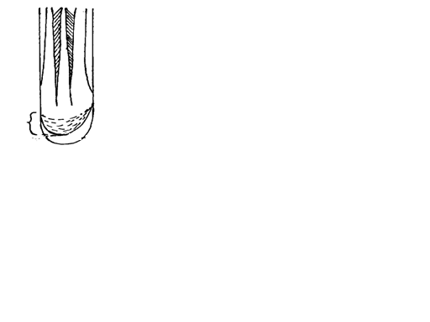
8 Study the diagram below and answer the following questions.

X
Z

- (i) Identify the part labelled X (1mk)
…………………………………………………………………………………………………………………………………………………………………………………………………………………….
- State the function of part X above (1mk)
…………………………………………………………………………………………………………..
…………………………………………………………………………………………………………...
- List down two characteristics of cells in the region labelled Z (2mks)
………………………………………………………………………………………………………………………………………………………………………………………………………………………………………………………………………………………………………………………………

9(a) What is meant by the following terms; (2mks)
- Ecosystem
………………………………………………………………………………………………………………………………………………………………………………………………………………………………………………………………………………………………………………………………
(ii) Carrying capacity
………………………………………………………………………………………………………..
………………………………………………………………………………………………………..
(b) Give two ways on how hydrophytes are adapted to the process of gaseous exchange (2mks)
…………………………………………………………………………………………………………
…………………………………………………………………………………………………………
10. The scheme below illustrates the blood clotting process;

Vitamin K + prothrombin damaged blood vessels/tissue

Ions Z platelets exposed

Protein X

Enzyme Y

Fibrinogen fibrin clot

- Identify the following; (2mks)
(i) Protein X
…………………………………………………………………………………………………………………..
(ii) Enzyme Y
…………………………………………………………………………………………………………………..
(b) State down the role of ions Z in the scheme above (1mk)
…………………………………………………………………………………………………………………..

(iii) Name a trait in humans determined by multiple alleles (1mk)
…………………………………………………………………………………………………………………..

11. Oat coleoptiles were used in the experiment set ups shown below. Study the set-ups and answer
The following questions.
Glass rod with IAA brushed on the
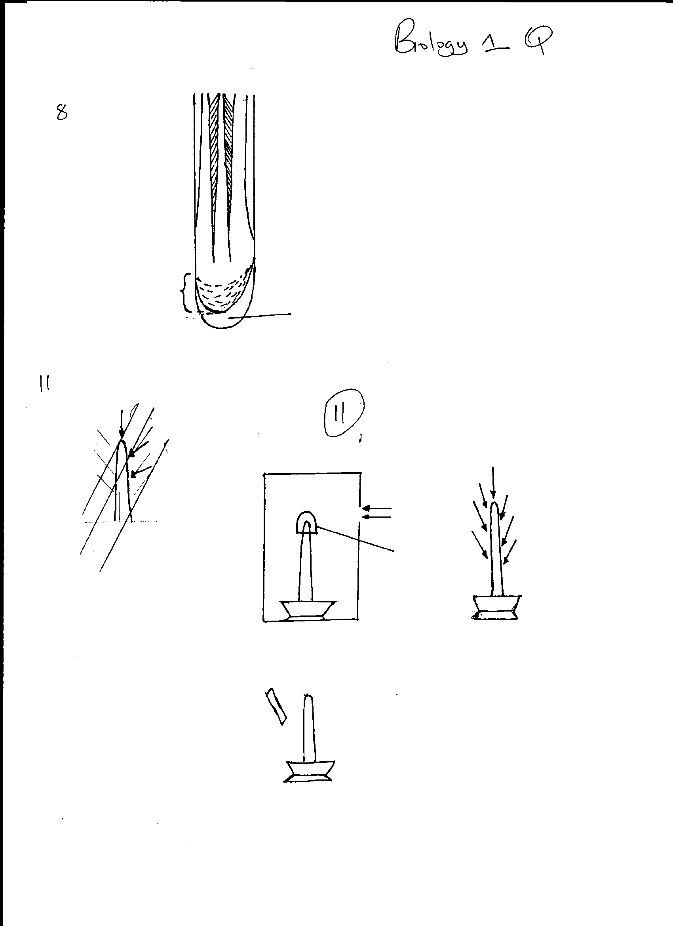
Left side of coleoptile
Sun light
Sunlight
Aluminium foil
Set up A
Set up C
Set up B

- What type of response was being investigated above? (1mk)
………………………………………………………………………………………………………
- Which of the set up above would act as a control experiment? (1mk)
………………………………………………………………………………………………………
- Explain what happened in set up B after 24 hours (2mks)
………………………………………………………………………………………………………………………………………………………………………………………………………………………………………………………………………………………………………………………
12. The equation below represents a process in a mammalian liver
Amino acid Organic compound+ Urea
- Name the process shown by the equation above (1mk)
………………………………………………………………………………………………………….
- List down a carbohydrate that is;-
- Stored in the mammalian liver (1mk)
………………………………………………………………………………………………………….
(ii) Found in abundance in mammalian blood (1mk)
………………………………………………………………………………………………………….
13. a) Distinguish between homologous structures and analogous structures (2mks)
…………………………………………………………………………………………………………
…………………………………………………………………………………………………………
b) State a major shortcoming in Jean Baptiste de Lamarck’s theory of evolution (1mk)
…………………………………………………………………………………………………………
14. a) List down two differences between closed and open circulatory systems (2mks)
…………………………………………………………………………………………………………
………………………………………………………………………………………………………..

b) Name two ways in which heart muscles are special (2mks)
…………………………………………………………………………………………………………..
………………………………………………………………………………………………………….15. a) State two physiological mechanisms of controlling the human body temperatures during a hot day (2mks)
…………………………………………………………………………………………………………..
…………………………………………………………………………………………………………..
b) Name two ways in which loop of henle is adapted to its function (2mks)
…………………………………………………………………………………………………………..
………………………………………………………………………………………………………….
16. a) State the function of Juvenile hormone in insect metamorphosis (1mk)
………………………………………………………………………………………………………….
b) Give a reason why most insects are serious crop pests at the larval stage (1mk)
…………………………………………………………………………………………………………
(ii) What happens at growth phase in insects growth curve (1mk)
……………………………………………………………………………………………………….
17. What are the effects of releasing excess nutrients into lake Naivasha by the nearby flowers
farms? (3mks)
…………………………………………………………………………………………………………
…………………………………………………………………………………………………………
…………………………………………………………………………………………………………
…………………………………………………………………………………………………………
18. State three ways how HIV and AIDS is transmitted in human population (3mks)
……………………………………………………………………………………………………………
……………………………………………………………………………………………………………
……………………………………………………………………………………………………………
19. List three characteristics that distinguish arthropods from organisms in kingdom Monera (3mks)
…………………………………………………………………………………………………………….
…………………………………………………………………………………………………………….
………………………………………………………………………......................................................
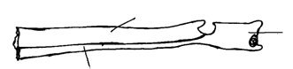
20. Study the bones below and answer the questions that follow;
Radius
Q2
Ulna
Radius
Q
Ulna

(a) Identify the function of the part labeled Q (1mk)
………………………………………………………………………………………………………
………………………………………………………………………………………………………
(b) Name the bone that circulates with the bone above at the proximal end (1mk)
……………………………………………………………………………………………………….
………………………………………………………………………………………………………
(c) List down two types of support tissue in plants (2mks)
…………………………………………………………………………………………………..
…………………………………………………………………………………………………..
21.Form two students set up an experiment as shown in the diagram below;
Yeast + Glucose
solution
(Boiled and cooled)
Cork
Delivery tube
Test Tube
Liquid Paraffin
Boiling Tube
Lime water
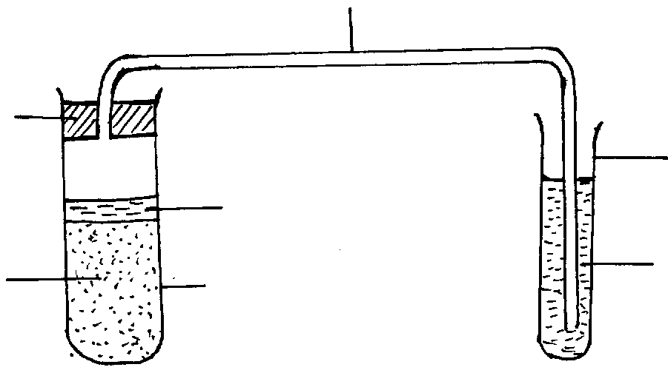

- Which process was being investigated? (1mk)
…………………………………………………………………………………………………………..………………………………………………………………………………………………………….
- Why was it necessary to boil the glucose solution? (1mk)
…………………………………………………………………………………………………………..
………………………………………………………………………………………………………….
- Write a word equation representing the chemical reaction taking place above in the boiling tube (1mk)
…………………………………………………………………………………………………………..
…………………………………………………………………………………………………………
22. Name two types of active immunity (2mks)
…………………………………………………………………………………………………………
…………………………………………………………………………………………………………
23. State how the following parts of the mammalian ear are adapted to their functions. (3mks)
(i) Pinna……………………………………………………………………………………………
(ii) Eardrum………………………………………………………………………………………..
- Cochlea………………………………………………………………………………………..
24. (a) A passager was involved in a road accident. He couldn’t move his limbs and neck. Which part of
the brain was affected? (1mk)
…………………………………………………………………………………………………………..
…………………………………………………………………………………………………………..
(b) (i)State two functions of cerebrospinal fluid. (2mks)
…………………………………………………………………………………………………………
………………………………………………………………………………………………………….
…………………………………………………………………………………………………………..
………………………………………………………………………………………………………….
25. State the importance of breathing through the nose than through the mouth . (2mks)
………………………………………………………………………………………………………….
…………………………………………………………………………………………………………..
………………………………………………………………………………………………………….

26. a) Identify the type of asexual reproduction exhibited by yeast cells (1mk)
…………………………………………………………………………………………………………
b) List down the functions of the following parts; (3mks)
i) Testis…………………………………………………………………………………………………
ii) Fallopian tube………………………………………………………………………………………
iv)Urethra……………………………………………………………………………………………….

