Name: ……………………………………………………… Index No: ……………………..……
School: …………………………………………………….. Candidate’s Signature……………………
Date: ……………….………………..

233/1
CHEMISTRY
Paper 1 (Theory)
July/August 2014
Time: 2 Hours

Kenya Certificate of Secondary Education (K.C.S.E)

CHEMISTRY
Paper 1
July/August 2014
Time: 2 Hours

INSTRUCTIONS TO CANDIDATES:

- Answer all the questions in the spaces provided.
- Write your name and index number in the spaces provided above.
- Mathematical tables and electronic calculators may be used for calculations.
- All workings must be clearly shown where necessary

For Examiner’s Use only:

QUESTION | MAXIMUM SCORE | CANDIDATE’S SCORE
1 – 30 | 80

This paper consists of 11 printed pages. Candidates should check to ascertain that all pages are printed as indicated and that no questions are missing.

1. a) What is meant by allotropy? (1 mark)
………………………………………………………………………………………………………......
……………………………………………………………………………………………………..........

b) The diagram below shows the structure of one of the allotropes of carbon

  - Identify the allotrope (¹/₂ mark)
…………………………………………………………………………………………………….
  - State one property of the above allotrope and explain how it is related to its structure. (1½marks)
……………………………………………………………………………………………………….
…………………………………………………………………………………………………….
2. Pentane and ethanol are miscible. Describe how water can be used to separate a mixture of pentane and ethanol. (3 marks)

……………………………………………………………………………………………………..........
…………………………………………………………………………………………………….........
…………………………………………………………………………………………………….........
……………………………………………………………………………………………………..........
……………………………………………………………………………………………………..........
3. a) Using dots and cross diagram, show how a hydro-axonium ion, H₃O⁺ is formed

Hint: H₂O +H⁺ H₃O⁺ Atomic numbers (H= 1, O = 8) (2 marks)

b) What name is given to the bonding in (a) above. (1 mark)

…………………………………………………………………………………………………….........
…………………………………………………………………………………………………….......
4. In the redox reaction below:

2H⁺_{(aq)} + Cr₂0₇²⁻_{(aq)} + 3SO_{2 (aq)} Cr³⁺_{(aq)} + 3SO²⁻₄ +H₂0_{(l)}

Identify the reducing agent, explain your answer. (2 marks)

……………………………………………………………………………………………………….........
……………………………………………………………………………………………………….......
………………………………………………………………………………………………………........
5. 60cm³ of oxygen gas diffused through a porous hole in 50 seconds. How long will it take 80cm³ of sulphur (iv) oxide to diffuse through the same hole under the same conditions. (3 marks)
(S= 32.0. O=16.0)
…………………………………………………………………………………………………………........
…………………………………………………………………………………………………………........
………………………………………………………………………………………………………….......
………………………………………………………………………………………………………….......
………………………………………………………………………………………………………….......
6. Calculate the heat of formation of carbon (II) oxide from the following data. (2 marks)
C_{(s)} + 0_{2(g)} CO_{(g)} ∆H = -394.8kj/mol

CO_{(g)} + 1/2O_{2(g)} CO₂ ∆H = -285.6kj/mol

……………………………………………………………………………………………………..........
…………………………………………………………………………………………………….........
……………………………………………………………………………………………………..........
……………………………………………………………………………………………………...........
7. a) Draw and name the structure of the compound formed when one mole of ethyne reacts with one mole of hydrogen bromide. (1 mark)
…………………………………………………………………………………………………….........
……………………………………………………………………………………………………........
b) Draw and name the structural isomers of C₄H₈ (2 marks)
………………………………………………………………………………………………….............
………………………………………………………………………………………………….............
………………………………………………………………………………………………….............
…………………………………………………………………………………………………............

8. The table below gives the atomic numbers of element w, x, y and z. The letters do not represent the actual symbols of the elements.

Element | w | x | y | Z
Atomic number | 9 | 10 | 11 | 12

- Which one of the elements is least reactive? Explain (1 mark)
……………………………………………………………………………………………………............
……………………………………………………………………………………………………............

- (i) Which two elements would react most vigorously with each other? (1 mark)

……………………………………………………………………………………………………...........
…………………………………………………………………………………………………..............
(ii) Give the formula of the compound formed when elements in (i) above react. (1 mark)
……………………………………………………………………………………………………...........
……………………………………………………………………………………………………...........

9. The solubility of potassium nitrate is 85g/100g of water at 50ºc and 32g/100g of water at 25ºc.

- Define the term solubility. (1 mark)
………………………………………………………………………………………………………………………………………………………………………………………………………………........
- Calculate the mass of the crystals formed if a saturated solution of potassium nitrate in 50g of water at 50ºc is cooled to 25ºc. (2 marks)
……………………………………………………………………………………………………..
……………………………………………………………………………………………………..
…………………………………………………………………………………………………….

10. The following are observations made from two solid substances x and y.

Solid | Electrical conductivity in solid state | Solubility in water | Boiling point
X | Poor | Insoluble | Sublimes
y | poor | soluble | high

- State the most likely type of bonding in
  - Solid x ……………………………………………………. (1 mark)
(ii) Solid y……………………………………………………. (1 mark)

11. What is the oxidation number of Nitrogen in
a) HNO₂ ………………………………………………………………… (1 mark)

b) NH₄⁺ …………………………………………………………………… (1 mark)

12. When air is bubbled through pure water (PH=7) the PH drops to 6.0. Explain. (2 marks)

……………………………………………………………………………………………………..........
…………………………………………………………………………………………………………...………………………………………………………………………………………………….............

13. Temporary water hardness can be removed by boiling
  - What is hard water. (1 mark)
……………………………………………………………………………………………………........
…………………………………………………………………………………………………….......
  - Write a chemical equation to show how temporary hardness is removed by boiling.
(1 mark)
……………………………………………………………………………………………………........
…………………………………………………………………………………………………...........

  - State one advantage of hard water. (1 mark)
……………………………………………………………………………………………………........
……………………………………………………………………………………………………….....

14. Calculate the mass of sulphur which on complete combustion would yield 7dm³ of sulphur (iv) oxide measured at 182ºc and 722 mm Hg pressure.
(0=16, S=32, molar gas volume = 24dm³ at r.t.p) (3 marks) ……………………………………………………………………………………………………………………………………………………………………………………………………………………………………………………………………………………………………………………………………………………………………………………………………………………………....................................................

15. The set-up below represents electrolysis of acidified water.

Gas M Gas N
=- - =-=
=- - =-=
=- - - - - - - -= -

Dilute sulphuric acid

a) Write the ionic equation for production of gas
(i) M (1 mark)

  - N (1 mark)

- Why is the above set-up referred to as electrolysis of water? (1 mark)
…………………………………………………………………………………………………….........
…………………………………………………………………………………………………….........

16. a) Differentiate between thermo softening and thermosetting plastics. (1 mark)

………………………………………………………………………………………………………………..…………………………………………………………………………………………………..
b) In the test for the chloride ions in solution, a little nitric acid is added followed by silver nitrate solution, why is nitric acid added. (1 mark)

……………………………………………………………………………………………………………………………………………………………………………………………………………………

17 . The set-up below shows laboratory preparation of hydrogen gas, use it to answer the questions that follow.

Dilute
Sulphuric
Acid

Zinc granules Conc. H₂SO₄

- Identify two mistakes in the set-up (2 marks)

………………………………………………………………………………………………………………………………………………………………………………………………………………………………………………………………………………………………………………………………
b) Why is dilute nitric acid not used in preparation of hydrogen gas. (1 mark)
………………………………………………………………………………………………………………………………………………………………………………………………………………........
18. Starting with copper (II) oxide, describe how you can prepare copper (II) sulphate crystals (3 marks)
……………………………………………………………………………………………………………………………………………………………………………………………………………………………………………………………………………………………………………………………………………………………………………………………………………………………………………………………………………………………………………………………………………………
19. The set-up below shows the products formed when solid lead (ii) nitrate is heated.

Heat gas y

Lead II Nitrate
Crystals-

liquid x ice cold mixture

a) Identify:
(i) Liquid x …………………………………………………………… (1 mark)

(ii) Gas y……………………………………………………………… ( 1 mark)
b) When lead (ii) Nitrate crystals are heated, they descrepitate and decompose, what is meant by the term decrepitating? (1 mark)
……………………………………………………………………………………………………………………………………………………………………………………………………………………
20. Study the set-up below and answer the questions that follow.

Gas x

- -
- -
- -
- - - - - - - - - - - - - - - Chlorine water
- - - - - -- - - - - - - - -

a) Name gas x………………………………………………………………………… ( 1 mark)

b) State the condition which is not indicated on the diagram for gas x to be formed. (1 mark)
……………………………………………………………………………………………………………………………………………………………………………………………………………………
21. a) Aluminium chloride sublimes. Explain why this is possible. (2 marks)
………………………………………………………………………………………………………………………………………………………………………………………………………………………………………………………………………………………………………………………………

b) Aluminium is reactive metal yet utensils made of aluminium do not corrode easily.
Explain. (1 mark)
……………………………………………………………………………………………………………………………………………………………………………………………………………………
22. State how burning can be used to differentiate between but-1-yne and butane. (2 marks)
……………………………………………………………………………………………………………………………………………………………………………………………………………………………………………………………………………………………………………………………
23. The diagram below represents an incomplete paper chromatogram of pure dyes x, y, z and
mixture w.

w x y z

Mixture w contains dyes y and z only. Complete the chromatogram to show how mixture w separates (2 marks)

24. a) State and explain the observations made when fluorine gas is bubbled through sodium bromide solution. (2 marks)
………………………………………………………………………………………………………………………………………………………………………………………………………………………………………………………………………………………………………………………………

b) When excess ammonia solution is added to a solution of copper (ii) ions, a deep blue solution forms. Write the formula of the complex ions formed. (1 mark)
……………………………………………………………………………………………………………………………………………………………………………………………………………………
25. 22.2cm³ of sodium hydroxide solution containing 4.0g per litre sodium hydroxide were required for complete neutralisation of 0.1g of a dibasic acid. Calculate the relative formula mass of the dibasic acid. (Na = 23, O=16, H=1) (3 marks)

……………………………………………………………………………………………………………………………………………………………………………………………………………………………………………………………………………………………………………………………………………………………………………………………………………………………………………………………………………………………………………………………………………………

26. The following reaction is in equilibrium in a closed container

2SO_{2(g)} + O_{2(g)} ⇌ 2 SO_{3 (g)} ∆H= -Ve

State giving reasons how an increase in temperature would affect the amount of sulphur
(VI) oxide gas. (2mks)
…………………………………………………………………………………………………..………
……………………………………………………………………………………………………....….
…………………………………………………………………………………………………..………
……………………………………………………………………………………………………....…..

27. The diagram below is a sketch of the graph of the catalysed decomposition of hydrogen peroxide.
Z
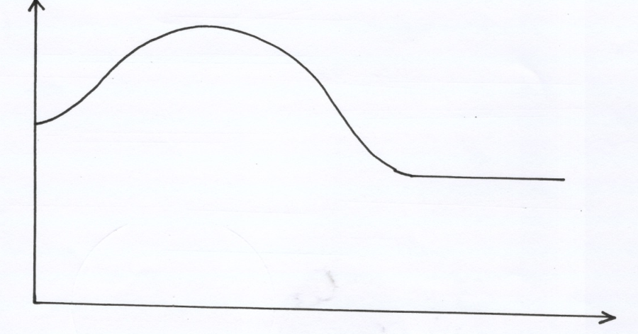
2 H₂O₂
_{(aq)}
Catalysed

2H₂O_{(l)} +O_{2(g)}

Reaction path

a) What does point Z represent. (1mk)
………………………………………………………………………………………………
………………………………………………………………………………………
b) Name one suitable catalyst that can be used. (1mk)
Energy
………………………………………………………………………………………………
……………………………………………………………………………

28. The following are half cell reactions and their reduction potentials. The letters are not the actual
symbols of the elements)
E^{θ}(volts)
(i) Z²⁺ _{(aq)} + 2e⁻ Z _{(s)} - 0.76
(ii) M²⁺ + 2e ⁻ M _{(s)} - 0.13
(iii) S⁺ + e⁻ S _{(s)} +0.80
(iv) T²⁺ + 2e⁻ T _{(s)} + 0.30

a) Write the cell representation for the electrochemical cell that would give the highest E^{θ} (1mk)

b) Calculate the E^{θ} value for the cell represented in 5(a) above. (2mks)

29. The diagram below shows the set-up that was used to prepare and collect sulphur (iv) oxide gas.
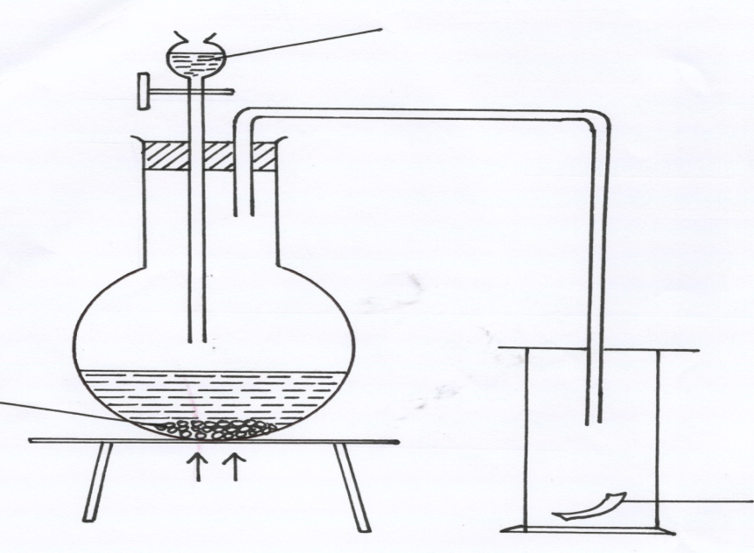
Hydrochloric acid
Heat
Solid P
Moist red flower

(a) Identify solid P (1mk)
…………………………………………………………………………………………………..…......
……………………………………………………………………………………………….…….......
(b) (i) Why is it possible to collect sulphur (IV) Oxide as shown? (1mk)
…………………………………………………………………………………………………..…......
……………………………………………………………………………………………………….....
(ii) What happened to the red flower? (1mk)
…………………………………………………………………………………………………..…
……………………………………………………………………………………………………….
30. The set-up show how small pieces of red phosphorous are heated in Nitrogen (I) Oxide.
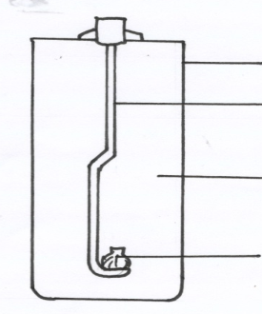
Gas jar
Deflagrating spoon

Nitrogen (I) oxide

Burning Phosphorous

a) Write an equation for the reactions which occur in the gas jar. (2mks)
…………………………………………………………………………………………………..…
……………………………………………………………………………………………………….
b) Give two uses of Nitrogen (I) oxide. (2mk)
…………………………………………………………………………………………………..…
……………………………………………………………………………………………………….

