

SCHOOL OF ENGINEERING
DEPARTMENT OF ELECTRICAL/ELECTRONICS
ARTISAN CERTIFICATE IN ELECTRICAL INSTALLATION
YEAR I
END OF SERIES EXAMINATIONS
AUGUST/SEPTEMBER 2017
ELECTRICAL INSTALLATION (TRADE THEORY)
KNEC 0202/213

TIME: 2 HOURS

INSTRUCTIONS TO CANDIDATES:
- Answer ALL questions
- Any examination IRREGULARITY will lead to DISQUALIFICATION.
- Indicate your FULL ADMISSION NUMBER in each Answer Sheet used.
- Cell phones are NOT allowed in the examination room
- Ensure you have both SCHOOL ID and EXAM CARDS in the examination room
- Scientific calculators and mathematical tables may be used where appropriate.
- Do not write your name anywhere on the answer booklet

Answer ALL questions
QUESTION 1
- Name the instruments used for measuring each of the following electrical quantities:
- resistance
- Power (2marks)
- Outline FOUR safety gears (wears) to be used in a workshop. (4marks)
- Distinguish between a conductor and insulator (4marks)
- The figure below shows series-parralel connection of resistors.

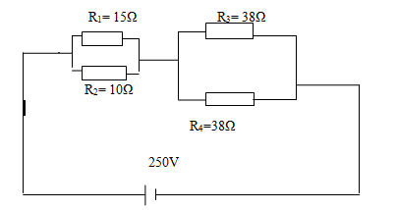
Calculate;
- Total resistance of the circuit
- Current drawn from the power source
- Current through R₂
- Power dissipated by R₃ (10marks)

QUESTION 2
- Define the following quantities and give their SI units: (4marks)
- voltage
- power
- Outline FOUR components in an electric circuit (4marks)
- State Ohms law. (2marks)
- Define the term capacitance as used in electrostatics and give its SI units (3marks)
- State FOUR factors which affect resistance of a conductor (4marks)
- Sketch the symbols of the following electrical and electronic components
- Voltmeter
- Fuse
- Variable resistor (3marks)

QUESTION 3
- Define the following terms as used in primary cells:
- Local action
- Polarization (4marks)
- The following is a diagram showing resistors connected in a series. (6marks)
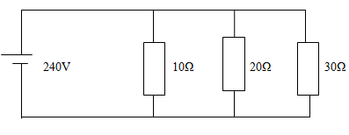
- Determine the total resistance of the circuit
- Calculate the current withdrawn from the power source
- Determine the current through
- 20Ω resistor.
- 30Ω resistor
- State FIVE safety precautions to be observed while in an electrical workshop. (5marks)
- with an aid of a diagram, draw wiring diagram of one lamp controlled from two positions using one gang two way switch. (5marks)
QUESTION 4
- Outline any FOUR types of capacitors (4marks)
- A 100W electric light bulb is connected to a 250V supply. Determine;
- The current flowing in the bulb
- The resistance of the bulb (4marks)
- Define the following terms as used in circuit protection:
- Current rating
- Fusing current
- Fusing factor (6marks)
- List any THREE types of fuses (3marks)
- A cartridge fuse is rated 18A. If the fusing factor is 2.2, determine the fusing current that will blow the fuse. (3marks)
QUESTION 5
- State any TWO components of an electric cable (2marks)
- Name any THREE examples of materials which are insulators. (3marks)
- State THREE factors which determine capacitance of a capacitor (3marks)
- State any THREE electric circuit conditions (3marks)
- The figure below shows connection of capacitors.

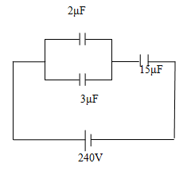
- Determine total capacitance of the circuit
- Calculate total charge
- Determine the voltage across 15μF capacitor
- Find charge through 3μF (9marks)

******END******

