

SCHOOL OF ENGINEERING
DEPARTMENT OF ELECTRICAL/ELECTRONICS
ARTISAN CERTIFICATE IN ELECTRICAL INSTALLATION
YEAR I

END OF SERIES EXAMINATIONS
NOVEMBER/DECEMBER 2017
APPLIED GEOMETRY
KNEC 0202/214

TIME: 3 HOURS

INSTRUCTIONS TO CANDIDATES:
- Answer ALL questions.
- Any examination IRREGULARITY will lead to DISQUALIFICATION.
- Cell phones are NOT allowed in the examination room
- Ensure you have both SCHOOL ID and EXAM CARDS in the examination room
- Use A3 drawing paper and the relevant grades of pencils.
- Keep your drawing paper clean and neat
- Use the relevant drawing instruments in each question

Answer ALL questions
QUESTION 1
- Sketch the conventional symbols for each of the following:
- First angle projection
- Third angle projection (4marks)
- Construct a triangle PQR with a base PR of 55mm and an altitude of 40mm. Angle PQR = 45⁰. Measure the (9marks)
      - Length of QR and PR
      - Size of angle QRP
- Construct a rhombus if the diagonal is 70mm long and one side 45mm long. (7marks)
QUESTION 2
- Construct an inscribed circle in a triangle ABC given AB=50mm, BC=60mm, CA=70mm. (9marks)
- Construct a triangle ABC where AB=25mm, BC=40mm, and CA=30mm. Draw a similar triangle with a perimeter of 110mm. (11marks)
QUESTION 3
Figure below shows a pictorial drawing of an object. Draw full size in third angle projection taking front elevation in the direction of the arrow. Insert six major dimensions and include the hidden details. (20marks)

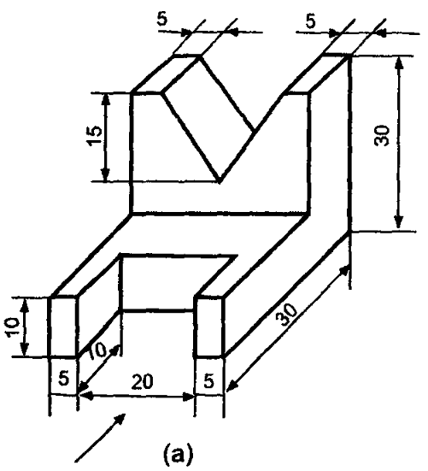
QUESTION 4
- Construct the following angles (10marks)
- 60 ⁰
- 105⁰
- Line AB is 80mm long. Point ‘K’ is 50mm above line AB and 70mm from point A, Drop a perpendicular to line AB from K. (4marks)
- Construct a regular hexagon of side 30mm. (6marks)

QUESTION 5.
Figure below shows a pictorial drawing of an object. Draw full size in first angle projection taking front elevation in the direction of the arrow. Insert six major dimensions and include the hidden details. (20Marks)
