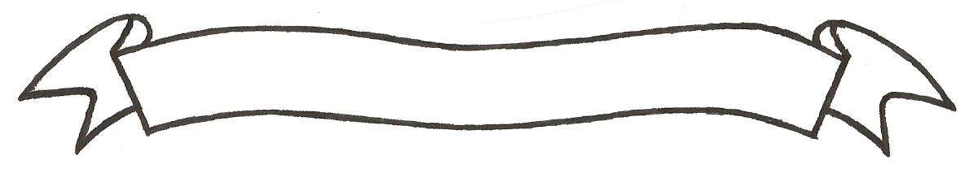
MERU UNIVERSITY OF SCIENCE AND TECHNOLOGY
P.O. Box 972-60200 – Meru-Kenya.
Tel: 020-2069349, 061-2309217. 064-30320 Cell phone: +254 712524293, +254 789151411
Fax: 064-30321
Website: www.must.ac.ke Email: info@must.ac.ke

University Examinations 2015/2016
SECOND YEAR SECOND SEMESTER EXAMINATION
FOR DIPLOMA IN
CIVIL ENGINEERING

EMC 2250: INTRODUCTION TO THERMODYNAMICS
DATE: APRIL 2016 TIME: 1 ½ HOURS
INSTRUCTIONS: Answer question one and any other two questions

QUESTION ONE (30 MARKS)
- ..
- Name any four thermodynamic properties (2 marks)
- Describe the first law of Thermodynamics (3 marks)
- Differentiate between a closed and open system. (4 marks)
- ..
- Give the prefix and symbol for the following sub-multiples of basic units
- One million million
- One thousand million
- One millionth
- One thousand millionth. (2 marks)
- Define a reversible process and give three criteria for the Thermodynamic process to be reversible (5 marks)
- Define a Thermodynamic cycle (2 marks)

- What is specific Enthalpy and why is it considered to be a thermodynamic property. (3 marks)
- Define the following Themodynamic processes.
- Adiabatic process (2 marks)
- Isochoric process (1 marks)
- Isothermal process (1 mark)
- Polytrophic process (2 marks)
- Isobaric process (1 mark)
- Isotropic process (2 marks)

QUESTION TWO (15 MARKS)
- State the second law of Thermodynamics (2 marks)
- Describe Throtthing (5 marks)
- Using the steady flow energy equation show shate for a throtthing process, the initial Enthalpy h₁ is equal to the final enthalpy h₂ (8 marks)

QUESTION THREE (15 MARKS)
- Unit mass of a certain fluid is contained in a cylinder at a initial pressure of 20 bar. The fluid is allowed to expand reversibly behind a piston according to the law PV² = Constant until the volume is doubled. The fluid is then cooled reversibly at a constant pressure until the piston regains its original position; heat is then supplied reversibly with the piston locked in position until the pressure rises to the original value of 20 bar.
Show this process on a Pv diagram. (5 marks)
- In a certain steam plant the turbine develops 1000 Kw. The heat supplied to th steam in the boiler is 2800Kj/Kg, the heat rejected by the steam to the cooling water in the condenser Is 2100Kj/Kg and the feed pump work required to pump the condensate back into the boiler is 5Kw.
- Show a diagrammatic representation of the cycle (4 marks)
- Calculate the steam flow rate. (6 marks)

QUESTION FOUR (15 MARKS)
- Represent the following Thermodynamic process on Pv diagrams.
- Adiabatic process (4 marks)
- Polytropic process (4 marks)
- Using a diagrammatic illustration, derive the steady flow energy equation.
(7 marks)

