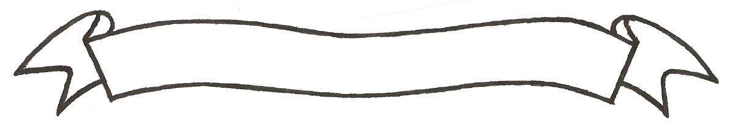
MERU UNIVERSITY OF SCIENCE AND TECHNOLOGY
P.O. Box 972-60200 – Meru-Kenya.
Tel: 020-2069349, 061-2309217. 064-30320 Cell phone: +254 712524293, +254 789151411
Fax: 064-30321
Website: www.must.ac.ke Email: info@must.ac.ke

University Examinations 2015/2016
SECOND YEAR SECOND SEMESTER EXAMINATION
FOR DIPLOMA IN
CIVIL ENGINEERING

ECV 2251: ENGINEERING SURVEYING III
DATE: APRIL 2016 TIME: 1 ½ HOURS
INSTRUCTIONS: Answer question one and any other two questions

QUESTION ONE (30 MARKS)
- State and explain any four types of horizontal curves. (4 marks)
- Explain any three types of errors that a regular GPS receiver may experience (6 marks)
- Define the following surveying concepts
- Triangulation
- Trizateration (4 marks)
- Define the following elements of a single circular curve.
- Point of intersection
- The long chord
- Angle of deflection (3 marks)
- A circular curve has a radius of 400m and a deflection angle of 60⁰. Find the degree of the curve by:
- Arc definition
- Chord definition
Also calculate the following elements
- Length of the curve
- Tangent length
- Length of the long chord
- Apex distance
- Mid-ordinate (5 marks)
- Explain the two methods of setting out of circular curves. (4 marks)

QUESTION TWO (15 MARKS)
- State any five sources of errors in curve computations and settings out. (5 marks)
- The deflection angle between two straights is measured and found to be . The straights are to be joined by a composite horizontal curve consisting of a central circular arc and two transition curves of equal lengths. The design speed of the road is 60km/hr and the radius of the circular curve is 480m. If the through chainage of the intersection point is 720. 42m, Draw up the setting out table for the three curves at 20m intervals of through chainage using the tangential angle method. (10 marks)

QUESTION THREE (15 MARKS)
- State the function of the following road elements in a road construction
- Transition curves (2 marks)
- Super-elevation (2 marks)
- Two straights AB and BC intersect at a chainage of 4242.0m. The angle of intersection is 140⁰. It is required to set out a simple circular curve to connect the straights. Calculate all the data necessary to set out the curve, using an interval of 30m. (10 marks)
- Define GPS and GDPS systems as applied in surveying. (1 mark)

QUESTION FOUR (15 MARKS)
- Explain the three GPS component segments (6 marks)
- Explain an two methods of setting out of circular curves. (4 marks)
- Two straight roads meeting at a deflection angle of are to be connected by a 80⁰ circular curve. Draw a well labled diagram representing the data above. (5 marks)

