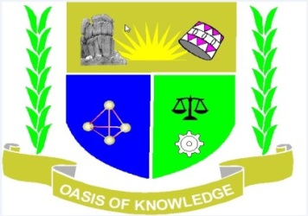

JARAMOGI OGINGA ODINGA UNIVERSITY OF SCIENCE AND TECHNOLOGY
SCHOOL OF HUMANITIES AND SOCIAL SCIENCES
UNIVERSITY EXAMINATION FOR THE DEGREE OF BACHELOR OF
EDUCATION ARTS WITH IT
4TH YEAR 2ND SEMESTER 2015/2016 ACADEMIC YEAR
BUSIA SCHOOL BASED
______________________________________________________________________________
COURSE CODE: DPS 415
COURSE TITLE: POLITICS AND GOVERNMENT IN KENYA
EXAM VENUE: STREAM:
DATE: EXAM SESSION:
TIME:
Instructions
1. Answer question 1 (COMPULSORY) and any other 2 questions
2. Candidates are advised not to write on the question paper
3. Candidates must hand in their answer booklet to the invigilator while in the examination
Room

1a) Define the terms politics and government 5mks
b) Discuss the decentralized political system as was practiced by the Agikuyu during the pre-
colonial period 10mks
c) Explain the application of indirect rule in Kenya by the British colonial government 15mks
2. Discuss the colonial policies introduced by the British in Kenya 20mks
3. Discuss the nationalist movements and the decolonization process in Kenya 20mks
4. Was the Mau Mau movement a nationalist or a tribal Movement? Discuss 20mks
5. Discuss the contributions of Multiparty System to Democracy in Kenya 20mks

