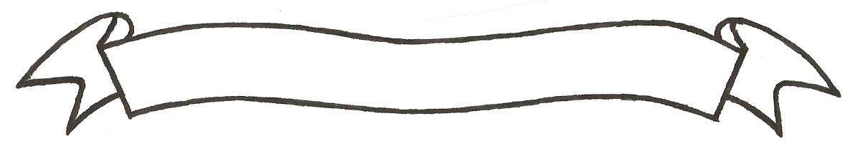

MERU UNIVERSITY OF SCIENCE AND TECHNOLOGY
P.O. Box 972-60200 – Meru-Kenya.
Tel: 020-2069349, 061-2309217. 064-30320 Cell phone: +254 712524293, +254 789151411
Fax: 064-30321
Website: www.must.ac.ke Email: info@must.ac.ke

University Examinations 2016/2017

THIRD YEAR, FIRST SEMESTER EXAMINATION FOR THE DEGREE OF BACHELOR OF TECHNOLOGY IN CIVIL ENGINEERING

ECT 3302: GEOSPATIAL TECHNOLOGIES

DATE: DECEMBER, 2016 TIME: 2 HOURS

INSTRUCTIONS: - Answer question one and any other two questions

QUESTION ONE (30 MARKS)
- State three advantages and disadvantages of aerial photograph over a line map (6 marks)
- State five uses of data collected using satellite remote sensing (5 marks)
- Define the following with examples;
- Spatial resolution (2 marks)
- Spectral resolution (2 marks)
- Radiometric resolution (2 marks)
- Temporal resolution (2 marks)
- State three advantages and two disadvantages of vector data model (5 marks)
- State six advantages of web based GIS (6 marks)
QUESTION TWO (20 MARKS)
- Explain five properties of the topological data structure (10 marks)
- Explain five benefits and advantages of GIS (10 marks)

QUESTION THREE (20 MARKS)
- Explain five uses of GPS technology (10 marks)
- Explain the trends and technology of GPS (10 marks)
QUESTION FOUR (20 MARKS)
- Explain how Geospatial technology helps in following area;
- Watershed management (2 marks)
- Flood hazard maping (2 marks)
- Security and defence (2 marks)
- Urban and infrastructure development (2 marks)
- Health management (2 marks)
- Explain five advantages of mobile GIS (10 marks)

