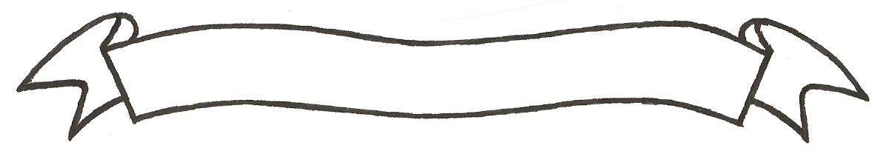

MERU UNIVERSITY OF SCIENCE AND TECHNOLOGY
P.O. Box 972-60200 – Meru-Kenya.
Tel: 020-2069349, 061-2309217. 064-30320 Cell phone: +254 712524293, +254 789151411
Fax: 064-30321
Website: www.must.ac.ke Email: info@must.ac.ke

University Examinations 2016/2017

FOURTH YEAR, FIRST SEMESTER EXAMINATION FOR THE DEGREE OF BACHELOR OF FOOD SCIENCE AND TECHNOLOGY

AFT 3427: DAIRY TECHNOLOGY I

DATE: DECEMBER, 2016 TIME: 2 HOURS

INSTRUCTIONS: - Answer question one and any other two questions

QUESTION ONE (30 MARKS)
- Define the following terms as commonly used in dairy technology. (5 marks)
- Adulteration
- Card
- Homogenization
- Fouling
- Fat spread
- (i) Briefly explain the principle behind cheese making. (2 marks)
(ii) State six characteristics of starter culture (3 marks)
- (i) Milk is a complete food. Explain. (2 marks)
(ii) Explain different ways in which milk can be contaminated (3 marks)
(iii) State six factors that influence the rate of fouling in milk during pasteurization.(3 marks)
(iv) Explain four factors that affect quality of yoghurt. (2 marks)
- (i) Briefly explain how cream/butter fat is processes in a dairy industry. (3 marks)
(ii) Explain the major difference between ‘mala’ and natural yoghurt. (2 marks)
(iii) Explain the precautions that should be put in consideration when processing milk powder. (2 marks)
(iv) State the main heat induced reaction in milk. (2 marks)
- State the difference between condensed and evaporated milk. (1 mark)
QUESTION TWO (20 MARKS)
- Discuss how cheddar cheese is processed from raw milk. (15 marks)
- Explain the common ingredients used in manufacture of chocolate ice cream and their roles. (5 marks)
QUESTION THREE (20 MARKS)
Write short notes on the following
- Condensed milk (5 marks)
- Whey protein concentrate processing (5 marks)
- Butter (5 marks)
- Dairy effluents (5 marks)
QUESTION FOUR (20 MARKS)
- Explain the following in relation to anhydrous milk fat;
- Characteristics. (3 marks)
- Principle of production. (4 marks)
- The flow of AMF production from raw milk. (8 marks)
- Using flow diagram outline the process vanilla yoghurt production in a dairy industry. (5 marks)

