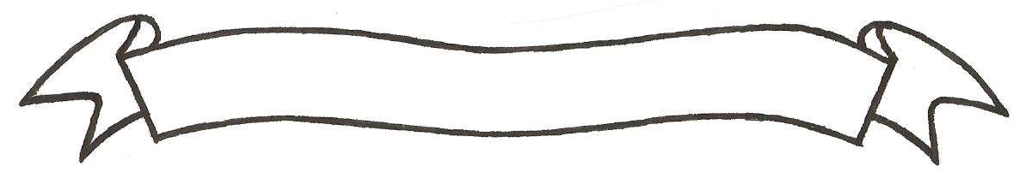

MERU UNIVERSITY OF SCIENCE AND TECHNOLOGY
P.O. Box 972-60200 – Meru-Kenya.
Tel: 020-2069349, 061-2309217. 064-30320 Cell phone: +254 712524293, +254 789151411
Fax: 064-30321
Website: www.must.ac.ke Email: info@must.ac.ke

University Examinations 2016/2017

SECOND YEAR, FIRST SEMESTER EXAMINATION FOR THE DEGREE OF BACHELOR OF SCIENCE IN FOOD SCIENCE IN FOOD SCIENCE AND TECHNOLOGY.

AFT 3200: FOOD ENGINEERING 1

DATE: DECEMBER, 2016 TIME: 2 HOURS

INSTRUCTIONS: - Answer question one and any other two questions

QUESTION ONE (30 MARKS)
- Define the following terms as used in food engineering. (5 marks)
- Unit operation
- Closed system
- Viscosity
- Fourier’s law of conduction of heat
- D-value
- A student was carrying out a food freezing and thawing practical using a food sample. He noticed the sample took longer period of time to thaw than to freeze. Explain (3 marks)
- A supervisor in a food industry wanted to know how thermal conductivity and specific heat capacity of milk change if he increased temperature from 20⁰ to 80⁰C. Explain (2 marks)
- Determine the moisture content in wet and dry basis of a food sample weighing 3g that lost 2g of weight during drying in an oven at 105⁰C. (3 marks)
- List three advantages of using steam in food processing rather than hot water systems. (3 marks)
- A steel pipe is 10m in length with an inside radius of 2.50 cm and an outside radius of 2.8 cm. The inside temperature is 80⁰C and the outside temperature is 25⁰C. The thermal conductivity of steel is 45W/mK. Find the heat transfer through the pipe due to the temperature difference between the inside and the outside pipe walls. (5 marks)
- Briefly highlight the principles of the following methods of drying. (4 marks)
- Freeze drying
- Spray drying
- A butcher is producing minced meat containing 20% of fat. He uses two types of meat. Type A which contains 28% fat and type B which contains 10% fat. Determine the proportions in which he should mix the two. (5 marks)
QUESTION TWO (20 MARKS)
- Discuss two types of pumps used in food industries highlighting one application of each. (5 marks)
- Food powder (1000kg) was dried from 40 to 4% moisture content in a batch drier with constant air conditions. The drying rate remained constant at 0.006 kg H₂0 m⁻²s⁻¹ up to a critical moisture content of 15%. The equilibrium moisture content is 2%; calculate the total drying time if the exposed surface is 2m². All moisture contents are given on a wet basis. (10 marks)
- During a practical lesson, contaminated milk with bacteria load of 200000 cfu per ml was heated at 72⁰C. The survivors were determined after every 10 minutes. After 20 minutes the survivors were 2000 cfu per ml. Determine the decimal reduction time assuming first order kinetics. (5 marks)

QUESTION THREE (20 MARKS)
- Milk with 3.7% fat content is centrifuged to produce skim milk and two types of cream, a full fat cream with 35% and a light cream with 20% fat content, in equal quantities. The light cream is produced by mixing a portion of the milk feed. Assuming that 6% of the milk stream that enters the centrifuge is separated to full fat cream, determine the mass quantities and fat composition in every stream of the process. (10 marks)
- Differentiate between co current and counter current heat exchangers. Showing their temperature profiles and list advantages and disadvantages of each. (10 marks)
QUESTION FOUR (20 MARKS)
Discuss use of ultraviolet light in food processing and preservation highlighting mode of operation, advantages and disadvantages and applications. (20 marks)

