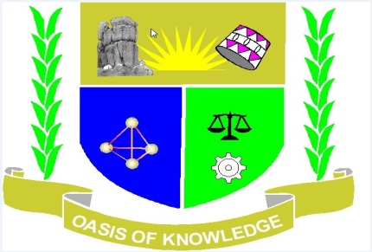

JARAMOGI OGINGA ODINGA UNIVERSITY OF SCIENCE AND
TECHNOLOGY
SCHOOL OF HUMANITIES AND SOCIAL SCIENCES
UNIVERSITY EXAMINATION FOR THE DEGREE OF BACHELOR OF
EDUCATION ARTS WITH IT
4TH YEAR 2ND SEMESTER 2015/2016 ACADEMIC YEAR
REGULAR -MAIN CAMPUS
___________________________________________________________________________
COURSE CODE: AHI 407
COURSE TITLE: HISTORY OF SOUTHERN AFRICA
VENUE: STREAM:
DATE: EXAM SESSION:
TIME:
Instructions
1. Answer question 1 (COMPULSORY) and any other 2 questions
2. Candidates are advised not to write on the question paper
3. Candidates must hand in their answer booklet to the invigilator while in
the examination Room

1. Discuss the causes, course and consequences of Mfecane (30 marks)
2. Explain the causes, events and results of the Great Trek in South Africa (20 marks)
3. Examine the European occupation and African reaction in Lesotho
(20 marks)
4. Explain how Khama of Bamagwato collaborated with the British (20 marks)
5. Discuss the following racial conflicts in South Africa (20 marks)
(a) Afrikaner-English Conflict
(b) Afrikaner-Indian Conflict

