JARAMOGI OGINGA ODINGA UNIVERSITY OF SCIENCE AND TECHNOLOGY SCHOOL OF ENGINEERING
UNIVERSITY EXAMINATION FOR THE DIPLOMA IN BUILDING AND CIVIL ENGINEERING

1ST YEAR 1ST SEMESTER ACADEMIC YEAR
MAIN CAMPUS
COURSE CODE: SPH 2111
COURSE TITLE: PHYSICS I
EXAM VENUE: STREAM: REGULAR
DATE: EXAM SESSION:
TIME:
________________________________________________________________________
Instructions:
- Answer Question 1 (compulsory) and ANY other 2 questions
- Question one carries 30 marks while all the other questions 20 marks each
- Candidates must hand in their answer booklets to the invigilator while in the examination room.

QUESTION 1

- A heavy iron ball is attached by a spring to a rotating platform as shown below. Two observes, one in the rotating frame and one on the ground at rest, observes its motion. State with reason which observer sees the ball being pulled outward, stretching the spring? And which observer sees the spring pulling the ball in a circle? (2marks)
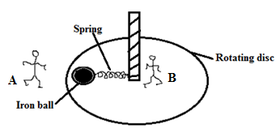

- A pump raises water from a well of depth 20 m at a rate of 10 kg/s and discharges it at 6 m/s. What is the power of the motor? (3marks)
- When a footballer kicks the ball, the ball and the man experience forces of the same magnitude but in opposite directions according to newton’s third law of motion. Give a reason why the ball moves but the man does not move. (2 marks)

- A bullet of mass m₁ travelling horizontally at a speed v₁ embeds itself into a ballistic pendulum of mass m₂
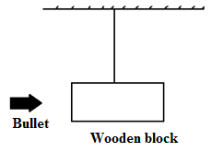
Show that:
- $v_{f}=(\frac{m_{1}}{m_{1}+m_{2}})v_{1}^{2}$ (2marks)

- $h=\frac{v_{1}^{2}}{2g}{\left(\frac{m_{1}}{m_{1}+m_{2}}\right)}^{2}$ (3marks)
Where $v_{f}$= the final velocity after the impact and h = the maximum height reached by the system after the impact
- Define the following terms: Period, Frequency and amplitude of an oscillating particle. (3marks)
- A mass m attached to a spring is vibrating with time period of 2.0s. When this mass is increased by 2kg, the periodic time becomes 3.0s. Determine the value of m. (3marks)
- The figure below shows a thin uniform rod of mass M and Length 2a. What is its rotational inertia about an axis through one of its end and perpendicular to its length? (3marks)
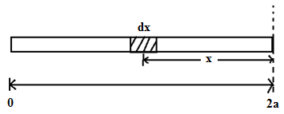
- Differentiate between the following terms: Balanced and unbalanced forces; couples and torque (3marks)
- The angular position of a reference line on a spinning wheel is given by θ = t³ - 27t + 4. where t is in seconds and θ in radians; find angular velocity (ω) and angular acceleration (α) (3marks)

- State 3 factors affecting moment of inertia of a rotating rigid body with respect to the rotating axis (3marks)

QUESTION 2
- Forces can be classified as conservative and non-conservative. Using example, explain when a force would be classified as conservative force. (3marks)
- State energy work theorem (2marks)
- The spring of a spring gun is compressed a distance d of 3.2 cm from its relaxed state, and a ball of mass m= 12g is put in the barrel. With what speed will the ball leave the barrel once the gun is fired. The spring constant is 7.5 N/m. Assume no friction and a horizontal gun barrel. (4marks)
- A 61kg bungee cord jumper is on a bridge 45 m above a river. In its relaxed state, the elastic bungee cord has length L= 25 m. Assume that the cord obeys Hooke’s law, with a spring constant of 160 N/m.
- If the jumper stops before reaching the water, what is the height h of her feet above the water at her lowest point? (5marks)
- What is the net force on her at the lowest point? (3marks)
- A 20 kg bucket is held above a well by a massless rope wound about a windlass as shown below.
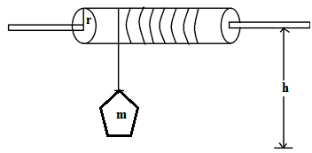
The windlass is a cylinder with a radius of 0.2 m and a momentum of inertia of 0.2 kgm². If the bucket is released from rest, what is its speed just before it hits the water 10 m below (assume there is no friction or air resistance.) (3marks)

QUESTION 3
- State the law of conservation of linear momentum (2marks)
- Differentiate between elastic and inelastic collisions (2marks)
- A minibus of mass 1500kg travelling at a constant velocity of 72 km/h collides with another stationary car of mass 900kg. The impact takes 2 seconds before the two moved together at a constant velocity for 20 seconds. Calculate:
- The velocity after the impact (3marks)
- The impulsive force developed during the impact (3marks)
- The energy lost during the impact (3marks
- The driver if a train moving at 97 km/h suddenly observes another train 60m a head, running on the same track in the same direction but with a slower speed of 48 km/h . The driver instantly applies his brakes. How much constant deceleration is required to avoid collision? (5marks)
- State the principle of transmission of pressure in fluids (2marks)
QUESTION 4
- Identify and explain 3 types of friction. (3marks)
- A t=0, the displacement x(0) of the block in a linear oscillation is – 8.5cm. Its velocity V(0) then is – 0.92 m/s and acceleration a(0) is +47m/s². Taking, $x\left(t\right)=x_{m}\cos\left(wt+∅\right),$
$v\left(t\right)=-wx_{m}\sin\left(wt+∅\right),$ and $a\left(t\right)=-w^{2}x_{m}\cos\left(wt+∅\right),$
Find:
- The angular frequency (ω) and the frequency (f) of this system. (4marks)
- The phase constant (φ) (3marks)
- The amplitude of the motion (3marks)
- State newton’s second law of motion (2marks)
- A picture frame of weight 20 N is suspended by two ropes as shown below. Find the tension on the ropes given that $θ_{1}={30}^{0} and θ_{2}={45}^{0}$ (5marks)
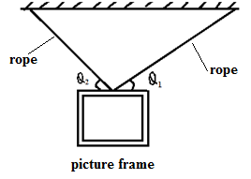
QUESTION 5
- Define terms velocity and acceleration (2marks)
- The velocity of a particle moving along positive x-axis varies as V=$∝\sqrt{x}$ where $∝$ is a constant. If the particle is at x = 0 at time t = 0.
- How do the velocity and acceleration of the particle change with time. (5marks)
- What is the average velocity of the particle during the time it moves a distance S. (3marks)

- A uniform log of wood AB is 9m long and weighs 320N. It’s supported horizontally at two points P and Q. P is 3m from end A while Q is 2cm from end B. Calculate the weights supported at each of the points P and Q. (5marks)
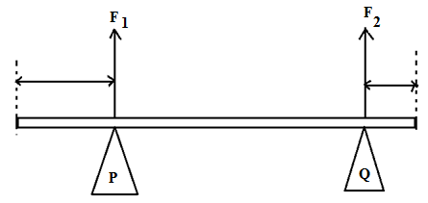

- The figure below shows two blocks of mass m₁ and m₂ are connected by a massless cord that hangs over a frictionless pulley.
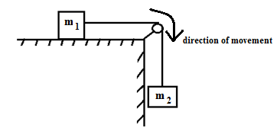
If the surface is frictionless, show that; $T=( \frac{M_{1}M_{2}}{M_{1}+M_{2}})g$ (5marks)

---- THE END ---

