SPORTS MEDICINE 2
- Which of the following does not explain the importance of on-the-field injury assessment?
  - It is a universal protocol in sports medicine.
  - It helps determine the nature of injury.
  - It provides information regarding direction of treatment.
  - Without it appropriate acute care cannot be provided.

- Which of the following statements is incorrect regarding the initial handling of unconsciousness resulting from sports injury?
  - The physiotherapist should assume neck and spine injury until proved otherwise.
  - If athlete is unconscious and breathing, nothing should be done until consciousness resumes.
  - If lying prone and breathing, the athlete should be carefully log-rolled into supine and then observed until consciousness resumes.
  - If lying prone and not breathing, the athlete should be log-rolled carefully into supine position then CPR begun immediately.

- When instituting an off-the-field evaluation of injury which question among these listed should the athlete be asked last?
  - What is the matter?
  - How and when did it occur?
  - Did you hear or feel something?
  - In which direction did the movement occur?

- Which of the following correctly explains the difference between therapeutic and conditioning exercises?
  - Therapeutic exercises apply in the course of treatment whereas conditioning exercises are used in prevention of or recovery from injury.
  - Conditioning exercises apply in the course of treatment whereas therapeutic exercises are used to minimize risk of injury.
  - Therapeutic exercises have a higher demand on stroke volume and maximum oxygen uptake as compared to conditioning exercises.
  - Conditioning exercises have a lower demand on stroke volume and maximum oxygen uptake as compared to therapeutic exercises.

- Among the observations required in management of foot injuries is whether the athlete ‘favours a foot’. What does ‘favouring a foot’ imply?
  - Being so mindful of his foot.
  - Relieving one foot from weight-bearing roles.
  - Pampering one foot in preference to the other.
  - Taking extreme care about how much weight to transfer to his feet.

- If physical examination of an athlete revealed a positive Morton’s test, which of the following would be a differential diagnosis?
  - Metatarsalgia.
  - Morton’s toe.
  - Apophysitis of the calcaneum.
  - Retrocalcaneal bursitis.

- The Kleiger’s test is appropriate as a special test for the clinical diagnosis of
  - Damage to the deltoid ligament.
  - Tear of the anterior cruciate ligament.
  - Damage to the anterior talofibular ligament.
  - Tear of the posterior talofibular ligament.

- The Tinel’s sign is a special test which when performed in the foot assesses the integrity of:
  - Dorsalis pedis artery.
  - Posterior tibial nerve.
  - Posterior tibial artery.
  - Tarsal tunnel syndrome.

- Which of the following statements is not true regarding sports-related foot injuries?
  - The weight-bearing role of the foot makes it so prone to injury.
  - The weight-bearing role of the foot contributes to delayed healing of its injury.
  - The relatively poor venous drainage contributes to delay healing of foot injury.
  - The bones of the foot fracture easily under stress because they are not long bones.

- Refer to the following slides:

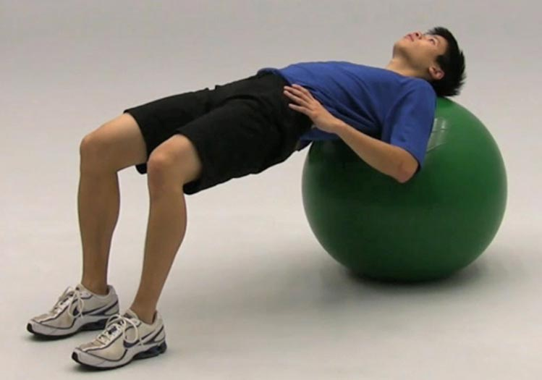

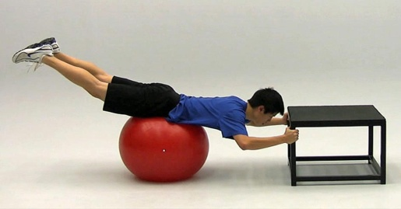
What is the objective of the activity highlighted in the slides?
  - Strength training.
  - Core stabilization.
  - Flexibility training.
  - Endurance training.

