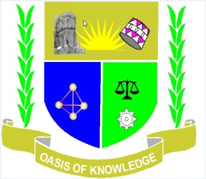

JARAMOGI OGINGA ODINGA UNIVERSITY OF SCIENCE AND TECHNOLOGY

SCHOOL OF HEALTH SCIENCES

UNIVERSITY EXAMINATION FOR THE BACHELOR OF SCIENCE
DEGREE

1ST YEAR 1ST SEMESTER
(APRIL 2016)

MAIN CAMPUS

COURSE CODE : HCD 3112 / SBI 3114 / PH 111

COURSE TITLE : HIV AND AIDS

EXAM VENUE :

STREAM : BED ARTS/ BSc/ BA.ECO AND
BA.SUPPLIES

TIME : 2.00 HOURS

DATE :

INSTRUCTION
- Answer ALL questions in section A carrying 30 marks and ANY other 2 questions in section B carrying 20 marks each.
- Candidates are advised not to write on the question paper.
- Candidates must hand in their answer booklets to the invigilator while in the examination room.

SECTION A (30 MARKS)

- State three evidences that show that HIV is the causative agent of AIDS. (3 marks)
- State three theories that attempt to explain the origin of HIV and AIDS . (3 marks)
- Distinguish between adaptive immunity and passive immunity. (3mks)
- State three ways in which HIV – 1 differ from HIV – 2. (3 marks)
- Explain the contribution of nutrition to the spread of HIV/AIDS. (3mks)
- Five (5) ARV action points and drug at each stage. (5 marks)
- Explain any three strategies used for ensuring safety in blood transfusion
to prevent HIV as envisaged by WHO program. (3 marks)
- a) State the goals of ART. (1 marks)
b) State two roles of HIV enzymes. (2marks)
- Name and state the roles of four enzymes in the HIV virus. (4 marks)
SECTION B (40 MARKS)
- a) Discuss five reasons for conducting counseling to HIV infected clients (10mrks)
b) Two factors that make women to be more vulnerable in unprotective sex. (10mks)

- Explain the Replication of HIV virus. (20 marks)

- Discuss five methods which may be employed by Kenyans to be AIDS free Nation. (20 marks)

- a) Explain any five factors that contribute to the spread of HIV and AIDS in Kenya.(10mks)
- Discuss 10 roles of nutrition in the management of HIV/AIDS (10 marks)

