INTRODUCTION TO FINANCE
JOUST BUSIA LEARNING CENTRE
2nd Year 1st Semester 2015/2016
ACADEMIC YEAR
COURSE CODE: ABA 202
ANSWER QUESTON ONE AND ANY OTHER TWO QUESTIONS
TIME: 2 HRS

Q1.
- People often refer to a business as having a ‘strong balance sheet’. What do they mean by this? And when people say ‘cash is the King’ what do they mean by this statement? (5mks)
- Barley Ltd is assessing an investment project. The estimated cash flows are as follows:
Year £million
0 10 Out flow
1 5 Inflow
2 4 Inflow
3 3 Inflow
4 2 Inflow

The business’s cost of finance is 15 per cent p.a and it seeks projects with a three – year maximum payback period. Should the project be undertaken on the basis of NPV and PBP? (10mks)
- What does the matching convention of accounting say? (3mks)
- Many businesses issue loans notes, which carry the right for holders to convert them into ordinary shares in the same business at a later date. Why might a business choose to issue convertible loan notes rather than make an issue of equity in the first place? (5mks)
- Discuss three forms of capital markets efficiency (7mks)

Q2. The following are the highly simplified financial statements of Sukari Ltd for last year:
Income statement for the year ended 31st December
£’000’
Turnover 80
Cost of sales (60)
Gross profit 20
Operating expenses (10)
Operating profit 10
Balance sheet as at 31st December
£’000’
Non – current assets 70
Current assets 20
Total assets 90
Equity (share and reserves) 78
Current liabilities 12
Total equity and liabilities 90

Calculate as many accounting ratios as the information provided will allow. (20mks)

Q3.
- What is the difference between capital market line (CML) and security market line (SML)? (4mks)
- What are the assumptions of capital assets pricing model (CAPM)? (4mks)
- From the following data calculate the beta of security i.
σ_{i}= 12%; σ_{m} = 9% and correlation, i_{m} = 0.72 (5mks)
- What is a risk free asset? Give examples (3mks)
- Define systematic risk and give two examples (4mks)

Q4.
- According to Irving Fisher (1930s) and Hirshleifer (1958) explain the meaning of separation theorem. (4mks)
- List four assumptions of separation theorem. (4mks)
- Any financial decision making involve six steps. Explain briefly (6mks)
- “Preference shares and loan notes are much the same” is this statement correct? Explain? (6mks)

Q5.
- The first entry in the standard – layout cash flow statement is “cash flows from operating activities”. How is this figure different from the operating profit for the same period? (6mks)
- What are the main reasons for the existence of creative accounting? (10mks)
- Explain four ways of checking creative accounting. (4mks)

Present value table of Kshs.1
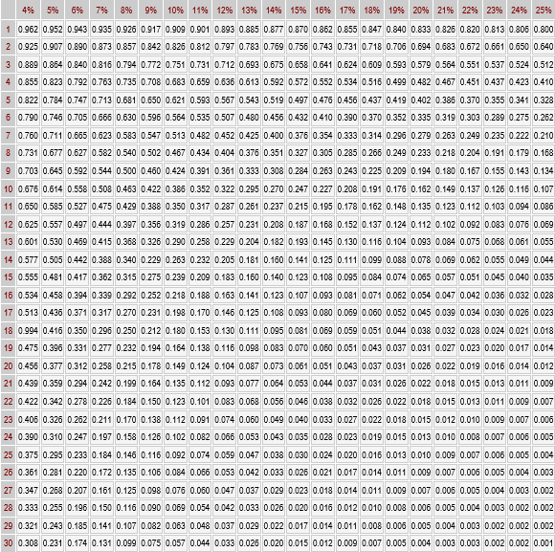

FINANCIAL MANAGEMENT
JOUST BUSIA LEARNING CENTRE
4th Year 2nd Semester 2015/2016
ACADEMIC YEAR
COURSE CODE: ABA 303

ANSWER QUESTION ONE AND ANY OTHER TWO QUESTIONS
TIME: 2 HRS

Q1.
- Evidence shows that many businesses use more than one of the four methods of investments appraisal found in practice. What could be the reason for this? (6mks)
- CAPM is a model that provides a framework to determine the required rate of return on an asset and indicates relationship between return and risk of the asset.
- List assumptions of CAPM (5mks)
- Briefly explain the difference between CAPM and APT (Arbitrage Pricing Theory) (3mks)
- The following is the data regarding six securities
U V W X Y z
Return (%) 10 10 15 5 11 10
Risk (σ) 5 6 13 5 6 7
Which security will be selected? Illustrate? (6mks)
- What is security market line? Illustrate? (3mks)
- What are the consequences of too tight credit policy (4mks)
- Define the term ‘monetary policy stance’ that is often referred to by Central Bank of Kenya. (3mks)

Q2.
- Bunyala Ltd is considering the purchase of a new machine that is expected to save labour on an existing project. The estimated data for the two machines available on the market are as follows:
Machine A Machine B
£’000’ £’000’
Initial cost (year 0) 120 120
Residual value of machines (Year 5) 20 30
Annual labor cost savings:
Year 1 40 20
2 40 30
3 40 50
4 20 70
5 40 50

Which machined will be selected under the following criteria?
- NPV, assuming a cost of finance of 10 per cent p.a
- IRR
- ARR
Ignore taxation throughout, and treat the savings as if they will occur at the end of the relevant year. (10mks)
- Discuss the agency problem in a public limited company (10mks)

Q3.
- What is the CAPM approach for calculating the cost of equity? (6mks)
- “Debt is the cheapest source of funds”. Explain? (5mks)
- Illustrate the computation of the expected rate of return of an asset. (5mks)
- Differentiate between transaction motive and precautionary motive of holding cash. (4mks)

Q4.
- Busia Company uses white paint at the rate of Kshs. 10,000.00 litres per year the holding cost of the paint is Kshs. 0.2 per litre per annum and the buying cost is Kshs. 50 per order. Determine the EOQ. What is the annual total stock cost at the level of 2,000 litres. (10mks)
- Explain the elements of stock control. (10mks)

Q5.
- Discuss the Central Bank of Kenya challenges related to controllability of monetary policy (10mks)
- What are the channels through which changes in the monetary policy stance influence aggregate demand and inflation in Kenya? (10mks)

Present value table of Kshs.1

