

**JARAMOGI OGINGA ODINGA UNIVERSITY OF SCIENCE AND TECHNOLOGY SCHOOL OF SPATIAL PLANNING AND NATURAL RESOURCE MANAGEMENT**

**UNIVERSITY EXAMINATION FOR DEGREE OF BACHELOR OF SCIENCE IN WATER RESOURCES AND ENVIRONMENTAL MANAGEMENT**

**YEAR 1 SEMESTER 2 2016/2017 ACADEMIC YEAR**

**REGULAR**

**COURSE CODE: PMQ 1217**

**COURSE TITLE: FLUID MECHANICS**

**EXAM VENUE: LR 6 STREAM: Water Sciences)**

**DATE: EXAM SESSION: 2.00 – 4.00 PM**

**TIME: 2.00 HOURS**

**__________________________________________________________________**

**Instructions:**

1. **Answer Section A (Compulsory) and ANY other 2 questions in section B**
2. **Candidates are advised not to write on the question paper.**
3. **Candidates must hand in their answer booklets to the invigilator while in the examination room.**

**SECTION ONE: Answer Question One (30 MARKS)**

**QUESTION ONE:**

1. Fluids are categorized depending on their properties, explain any THREE of such properties. (6 Marks)
2. Define the term moment and obtain the moment arm of fluid pressure force on an inclined surface defined by angle θ with respect to x-axis. (9 Marks)
3. Outline some of the merits of manometers as instruments used to measure pressure gauge. (6 Marks)
4. State the law of conservation of mass hence show that for a steady flow, the continuity equation is given by

(11 Marks)

$ρ\int{u_{1}{∂A}_{1}}+ρ\int{u_{2}{∂A}_{2}}=0$

**SECTION TWO: Answer any TWO Questions (40 Marks)**

**QUESTION TWO:**

1. State the limitations of manometers as instruments used to measure pressure gauge.

(4 Marks)

1. Density varies with temperature and pressure throughout in a compressible ﬂuid domain. Using the equation of state for a perfect gas, derive the expression for pressure diﬀerence between two arbitrary points in a compressible fluid. (8 Marks)
2. Water flows from point A to points D and E as shown. Some of the flow parameters are known, as shown in the table. Determine the unknown parameters.

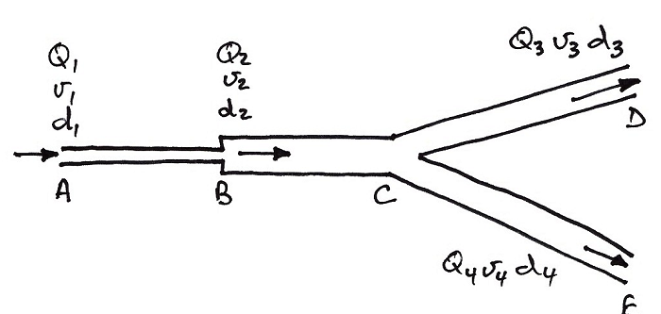

|  |  |  |  |
| --- | --- | --- | --- |
| **Section** | **Diameter (mm)** | **Flow Rate (m3s-1)** | **Velocity (ms-1)** |
| AB | 300 | ? | ? |
| BC | 600 | ? | 1.2 |
| CD | ? | Q3=2Q4 | 1.4 |
| CE | 150 | Q4=0.5 Q3 | ? |

(8 Marks)

**QUESTION THREE:**

1. Distinguish the following terms as used in fluid mechanics; Newtonian Fluids and Non-Newtonian Fluids, hence or otherwise discuss the further classification under Non Newtonian fluids. (7 Marks)
2. State the FOUR assumptions considered in deriving Bernoulli´s equation

(4 Marks)

1. Cross sectional area of pipe is **A** Mean velocity is **um**. In time **t**, a cylinder of fluid will pass point **X** with a volume **A**\***um**\***t**. If $A= 1.4*{10}^{-3}m^{2}$ and discharge, Q is 24 l/s, calculate the mean velocity. (7 Marks)

**QUESTION FOUR:**

1. Differentiate the two approaches to analyzing the velocity field in fluid mechanics.

(4 Marks)

1. Define a streamline and state TWO properties associated with streamlines in fluid flows (6 Marks)
2. Considering momentum conservation in ﬂuid particles, Show that Euler´s equation is given by $\frac{D}{Dt}\left(ρu\right)=\left(ρg\right)-∇p$ in x-dimension of the coordinate system. (10 Marks)

**QUESTION FIVE:**

1. Explain the following terms as applied in flows in an open channel as opposed to the closed pipe: Depth, Wetted Perimeter, Surface Width, and Hydraulic Radius.

(8 Marks)

1. Viscosity as one of the properties of fluids varies with temperature change. Explain.

(4 Marks)

1. Discuss the FOUR forms of fluid flows as characterized by time and length of flow.

(8 Marks)