
JARAMOGI OGINGA ODINGA UNIVERSITY OF SCIENCE AND TECHNOLOGY
SCHOOL OF BIOLOGICAL AND PHYSICAL SCIENCES
UNIVERSITY EXAMINATION FOR THE DEGREE OF BACHELOR OF BIOLOGICAL SCIENCES
2ND YEAR 1ST SEMESTER 2017/2018 ACADEMIC YEAR
MAIN REGULAR

COURSE CODE: SCH 3211
COURSE TITLE: INORGANIC CHEMISTRY
EXAM VENUE: STREAM:
DATE:
TIME: 2 HRS EXAM SESSION:

INSTRUCTIONS:
- Answer question 1 (Compulsory) in section A and ANY other 2 questions in Section B.
- Candidates are advised not to write on the question paper.
- Candidates must hand in their answer booklets to the invigilator while in the examination room.
- Some important information, formulas and the periodic table are found on the last page of this question paper

SECTION A
Question 1
- Discuss the four quantum numbers that fully describes the electronic configuration of an atom. (4 marks)
- Describe the electronic configurations (spdf) of the following atoms. (4 marks)
- Sodium atom
- Magnesium atom
- Fluoride atom
- Iron atom
- Describe the energy level diagram for the sodium and iron atoms. (6 marks)
- Discuss the shapes of atomic orbitals in an s orbital, p orbital and d orbital (6 marks)
- The formation of ammonium phosphate fertilizers involves the following reactions.
- 2Ca₃(PO₄)₂ + 6SiO₂ + 10C → P₄ + 10CO + 6CaSiO₃
- P₄ + 5O₂ + 6H₂O → 4H₃PO₄
- H₃PO₄ + NH₃ → (NH₄)₃PO₄
Write complete redox reactions with oxidation numbers for each element shown and the reduced/oxidized species indicated. (6 marks)
- The following reactions involve Brønsted-Lowry Acid and Brønsted-Lowry Base forward reactions. In each reaction, discuss why the chemical species can be identified as a Brønsted-Lowry Base or Brønsted-Lowry Acid (4 marks)
- HClO₂(aq) + NaIO(aq) → HIO(aq) + NaClO₂(aq)
- HS⁻(aq) + HF(aq) → H₂S(aq) + F⁻(aq)

SECTION B
Question 2
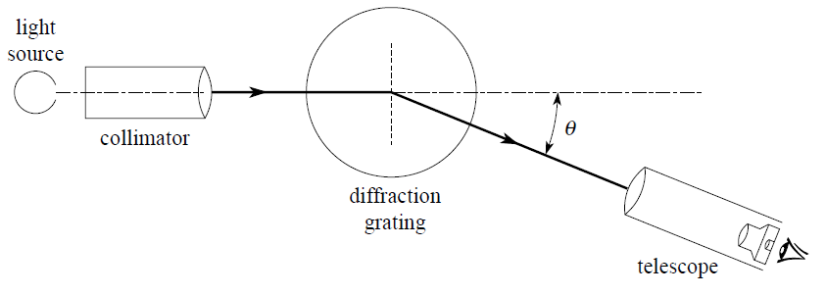
- The above spectrometer has a diffraction grating as the light dispersion device. Given that the light is diffracted at an angle of 32º determine the wavelength of the diffracted light. (5 marks)
- Use the electron box and arrow configurations in combination with Pauli exclusion principle and Hund's rule to demonstrate the electronic configuration of V⁺, V²⁺, V³⁺, V⁴⁺, and V⁵⁺ (5 marks)
- Given the Bohr equation below, determine the Bohr radius of H atom at n = 1. (5 marks)
- An increase in the principal quantum number from n = 1 to n = ∞ corresponds to the ionization of the atom and the ionization energy can be determined from the equation below. Given that one mole of a substance contains 6.022 x 10²³ mol⁻¹ particles, determine the first ionization energy for H. (5 marks)

Question 3
- Given that the principal quantum number, n, is 2, and using the rules that govern quantum numbers n and l, write down the allowed values of l and m_{l}, and determine the number of atomic orbitals possible for n = 3. (5 marks)
- Discuss the possible sets of quantum numbers that describe an electron in a 2s atomic orbital. What is the significance of the physical significance of these unique sets? (5 marks)
- Confirm that the experimentally observed electronic configuration of K, 1s², 2s², 2p⁶, 3s², 3p⁶, 4s¹, is energetically more stable than the configuration 1s², 2s², 2p⁶, 3s², 3p⁶, 3d¹. (5 marks)
- Briefly discuss the following principles: The aufbau principle, The Pauli exclusion principle, and The hands rule. (5 marks)

Question 4
- Briefly discuss electron transitions that make up the Lyman and Balmer series in the emission spectrum of atomic hydrogen (use of a diagram is prefered). (10 marks)
- Using the first 30 elements in the periodic table to demonstrate why they are labelled as s block, d block, p block elements. (10 marks)

Question 5
- Using the diagram shown below, discuss the Rutherfords model of an atom and the Bohr’s model of an atom. Include in your discussion the Bohrs’ postulates. (20 marks)
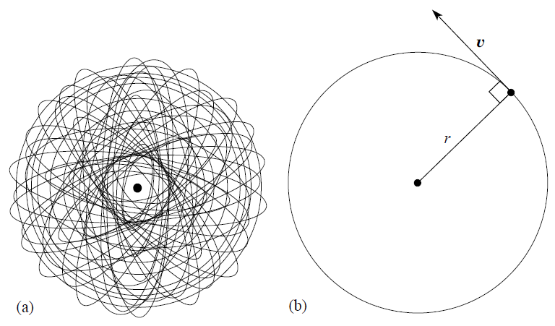
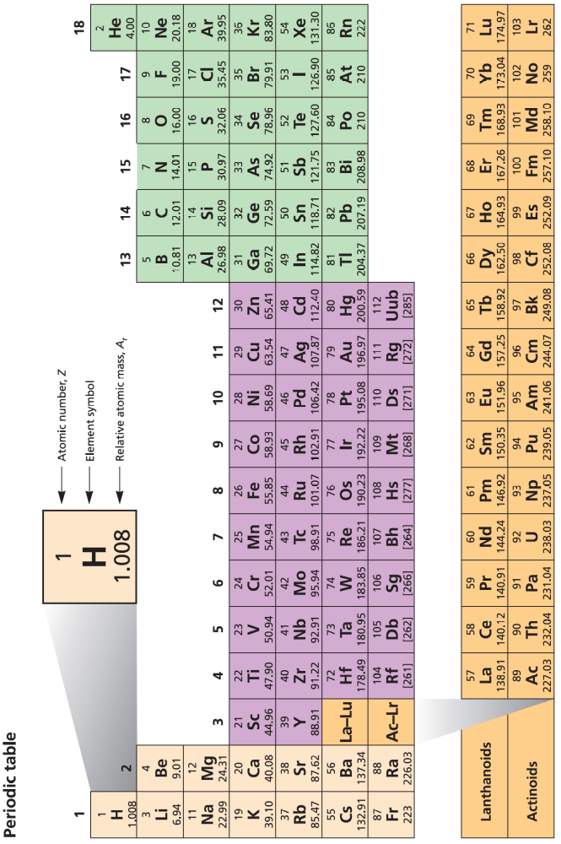
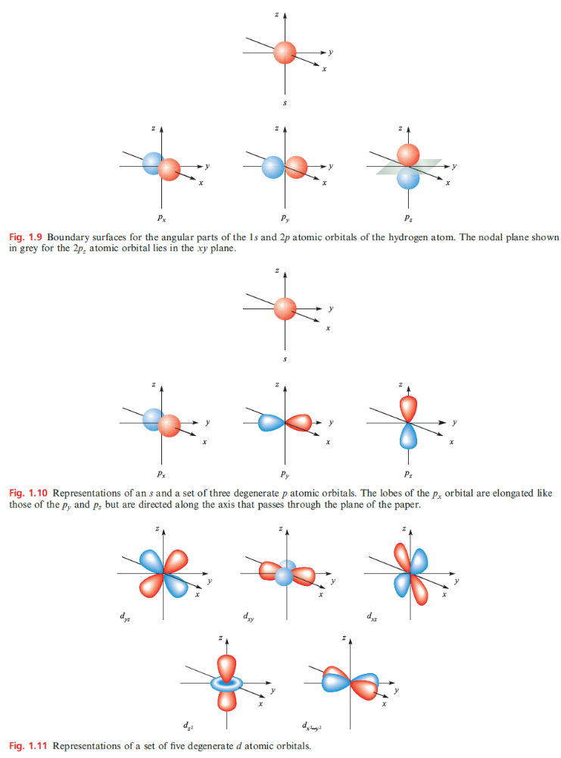
- Grating relation nλ = ndsinӨ
- Ionization energy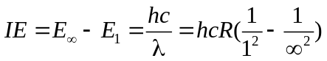 Where h = planks constant; R = Rydberg constant for hydrogen = 1.097 x 10⁷ m⁻¹ or 1.097 x 10⁵ cm⁻¹; c = 2.998 x 10⁸ ms⁻¹
- Bohr radius (r_{n}), 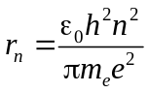
ε₀ = permittivity of vacuum = 8.854 x 10⁻¹² Fm⁻¹
h=Planks constant = 6.626 x 10⁻³⁴ Js
n = 1, 2, 3, ….describing a given orbit
m_{e} = electron rest mass = 9.109 x 10⁻³¹ kg
e = charge on an electron (elementary charge) = 1.602 x 10⁻¹⁹C

