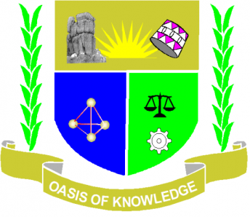

JARAMOGI OGINGA ODINGA UNIVERSITY OF SCIENCE AND TECHNOLOGY
SCHOOL OF EDUCATION
UNIVERSITY EXAMINATION FOR DEGREE OF BACHELOR OF EDUCATION ECDE
4TH YEAR 2ND SEMESTER 2017/2018 ACADEMIC YEAR
MAIN CAMPUS /UGUNJA LEARNING CENTER SCHOOL BASED

COURSE CODE: EDC 3212
COURSE TITLE: CHILD RIGHTS ADVOCACY AND WELFARE
EXAM VENUE:-- STREAM BED - ECDE
DATE: 22/12/17 EXAM SESSION: 9.00 – 11.00 AM
TIME: 2HOURS

Instruction:
1. Answer Question ONE (COMPULSORY) ANY other 2quetions
2. Candidates are advised not to write on the question paper
3. Candidates must hand in their answer booklets to the invigilator while in the examination room

Question 1

1(a) Explain the following terms as used under child rights
- Protection
- Participation
- Custody
- Advocacy(8mrks)

(b)Outline four responsibilities of the child as spelt out in the children’s act 2001(4mrks)
(c)Highlight five provisions of the African character(5mrks)
(d) Identify four strategies of promoting the implementation of convention (4mks)
(e) State four objectives of the CRC(4mks)
(f) Name five rights of children (5mks)

Question 2
2a. Inwhich ways can a teacher safeguard the right of a child to education in the ECDE center (10mks)
b. Highlight five provisions of the African character(10mrks)

Question 3
3. Explain the significance of the following rights of a parent towards the child according to the child’s act 2001
- Determining the child’s name
- Parental guidance on religion(20mrks)

Question 4
4a.What is the government’s role in enhancing children’s rights(12mks)
b. How did Kenyan Government solve commitment to the well being of the children (8mrks)

Question 5
5a. Analyze the importance of respecting human rights (10mks)
b. What are the basic instruments provided for the rights of children (10mks)

