

**JARAMOGI OGINGA ODINGA UNIVERSITY OF SCIENCE AND TECHNOLOGY**

**SCHOOL OF INFORMATICS AND INNOVATIVE SYSTEMS**

**UNIVERSITY EXAMINATION FOR THE DEGREE OF BACHELOR OF IN EDUCATION, WITH IT**

**BACHELOR OF BUSINESS ADMINISTRATION WITH I.T**

**3RD YEAR 1ST SEMESTER 2017/2018 ACADEMIC YEAR**

**KISII CAMPUS-FULL TIME & NAIROBI CITY LEARNING CENTRE**

**COURSE CODE: SCS 324**

**COURSE TITLE: STATISTICAL ANALYSIS WITH SPSS**

**EXAM VENUE: STREAM: (B. ED & BBA)**

**DATE: EXAM SESSION:**

**TIME: 2 HOURS**

**Instructions:**

1. **Answer Question ONE (COMPULSORY) and ANY other 2 questions**
2. **Candidates are advised not to write on the question paper.**
3. **Candidates must hand in their answer booklets to the invigilator while in the examination room.**

**Question One**

1. For the following ***sample*** of scores, please
   1. Calculate the standard deviation [2 marks]
   2. Convert each raw score to a standard score [2 marks]
   3. Convert each raw score to a percentile score [2 marks]

X

8

9

12

15

16

1. Find the percentile scores and T-Scores that correspond to each of the following standard scores:

+1.6, -1.6, 0.0, +2.9, -.53 [8 marks]

1. An employee has a rating of 5.7 on a measure of job performance. The mean for employees at that company is 5.5 and the standard deviation is .4. What is that employee’s percentile score for job performance? What is their T-Score? [4 marks]
2. Company XYZ manufactures ans sales four products as shown in the table below. Draw bar chart; line graph and pie chart depicting estimated sales for the first quarter of a year for the four types of products Fana, Cola, Wana and Spat (12mks)

Monthly sales in millions of four products of a company XYZ

|  |  |  |  |  |
| --- | --- | --- | --- | --- |
|  | January | February | March | April |
| Fana | 1m | 1.6m | 2m | 1.8m |
| Cola | 1.4m | 2.2m | 1.6m | 2m |
| Wana | 0.8m | 0.6m | 1.2m | 1m |
| Spat | 0.4m | 0.8m | 0.6m | 1.4m |

**Question Two**

1. Explain by giving examples some of the tools you are aware of that are used in a descriptive research to collect data for further analysis. (10mks)
2. By giving examples explain the meaning, types and uses of Non-parametric tests (10mks)

**Question Three**

1. SPSS is statistical software for data analysis. Why is it important to use SPSS?(10mks)
2. Develop a ten line questionnaire that can be coded and analyzed using SPSS on the relationship between advertising and actual sale in an organization. (10mks)

**Question Four**

A market researcher is interested in the coffee drinking habits of males and females. He asks a sample of male and female office workers to record the number of cups of coffee they consume during a week.

1. Which parametric statistical technique could the researcher use to determine if males and females differ in terms of the number of cups of coffee consumed in a week? Justify your answer and describe how you would obtain this statistic using SPSS. [4 marks]
2. What are the key values you would look for in the output? [4 marks]
3. What assumptions should you check for when using the technique that you chose in question (a), above? [4 marks]
4. What non-parametric technique could be used to address this research question?[3 marks]
5. Define Regression as used in SPSS (5mks)

**Question Five**

The following output was obtained using SPSS.

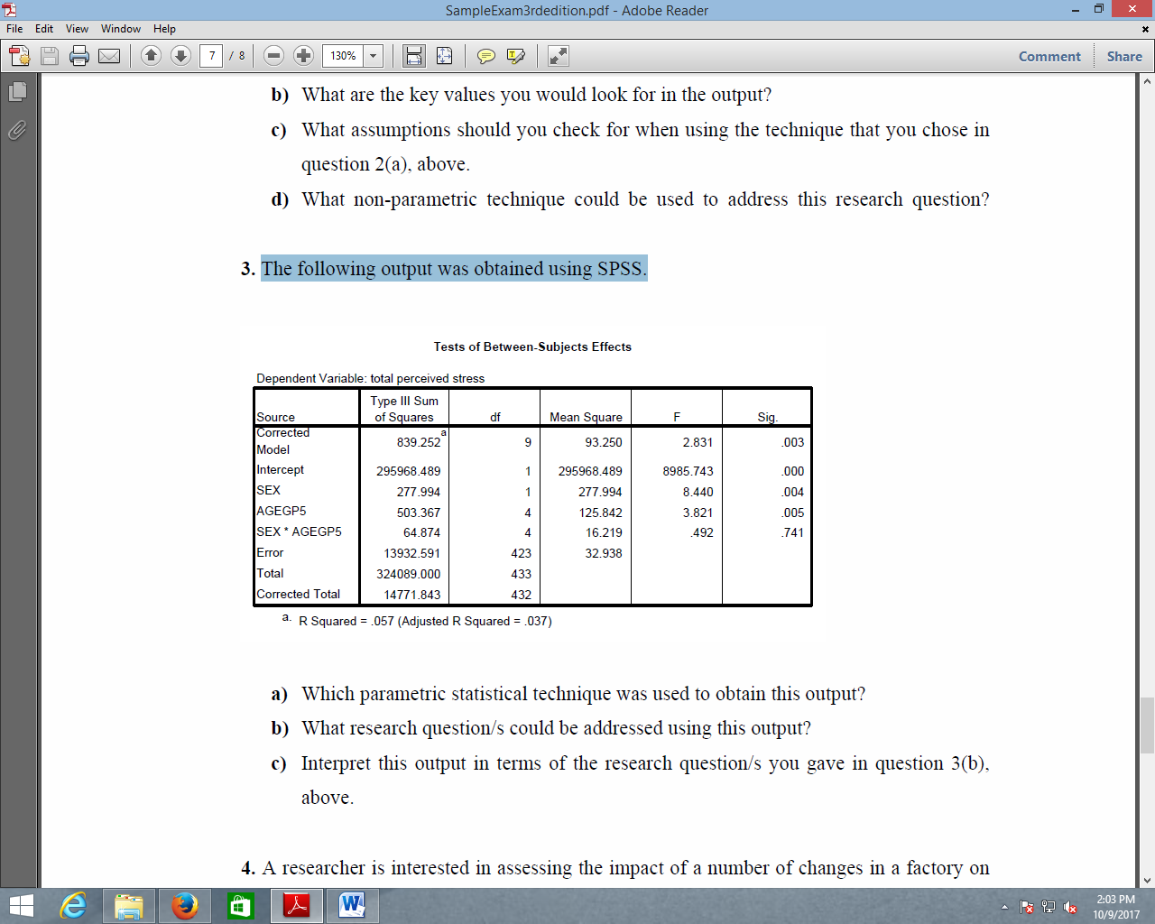

1. Which parametric statistical technique was used to obtain this output? [5 marks]
2. What research question/s could be addressed using this output? [4 marks]
3. Interpret this output in terms of the research question/s you gave in question 3(b), above. [6 marks]
4. It is perceived that people who earn higher salaries live in upmarket houses. Justify such collinearity. (5mks)