

**JARAMOGI OGINGA ODINGA UNIVERSITY OF SCIENCE AND TECHNOLOGY**

**SCHOOL INFORMATICS AND INNOVATIVE SYSTEMS**

**UNIVERSITY EXAMINATION FOR THE BACHELOR’S DEGREE**

**1ST YEAR 2ND SEMESTER 2013/2014 ACADEMIC YEAR**

**CENTRE: MAIN JAB**

**COURSE CODE: SCS 112**

**COURSE TITLE: DESKTOP PUBLISHING**

**EXAM VENUE: STREAM: BSc. BBA, BEd**

**DATE: 11/12/2013 EXAM SESSION: 2.00 – 4.00 PM**

**TIME: 2 HOURS**

**Instructions:**

1. **Answer question 1 (Compulsory) and ANY other 2 questions.**
2. **Candidates are advised not to write on the question paper.**
3. **Candidates must hand in their answer booklets to the invigilator while in the examination room.**

**QUESTION ONE**

1. Name **FOUR** common types of publications (4 Marks)
2. State the limitation of Desktop publishing (2 Marks)
3. Publication documents are categorize according to the information content, identify and describe the following documents giving examples in each case.
4. Documents that persuade (4 Marks)
5. Documents that inform (4 Marks)
6. Documents that give how to inform (4 Marks)
7. Documents that elicit response (4 Marks)
8. Document that identify (4 Marks)
9. Documents that provide reference (4 Marks)

**QUESTION TWO**

1. What does the acronym WYSIWYG stand for? (4 Marks)
2. Describe the two categories of desktop publishing software (6 Marks)
3. List **SIX** different types of desktop publishing software (6 Marks)
4. Define desktop publishing (4 Marks)

**QUESTION THREE**

Describe in detail the steps involved in the design of the document below in Microsoft publisher;

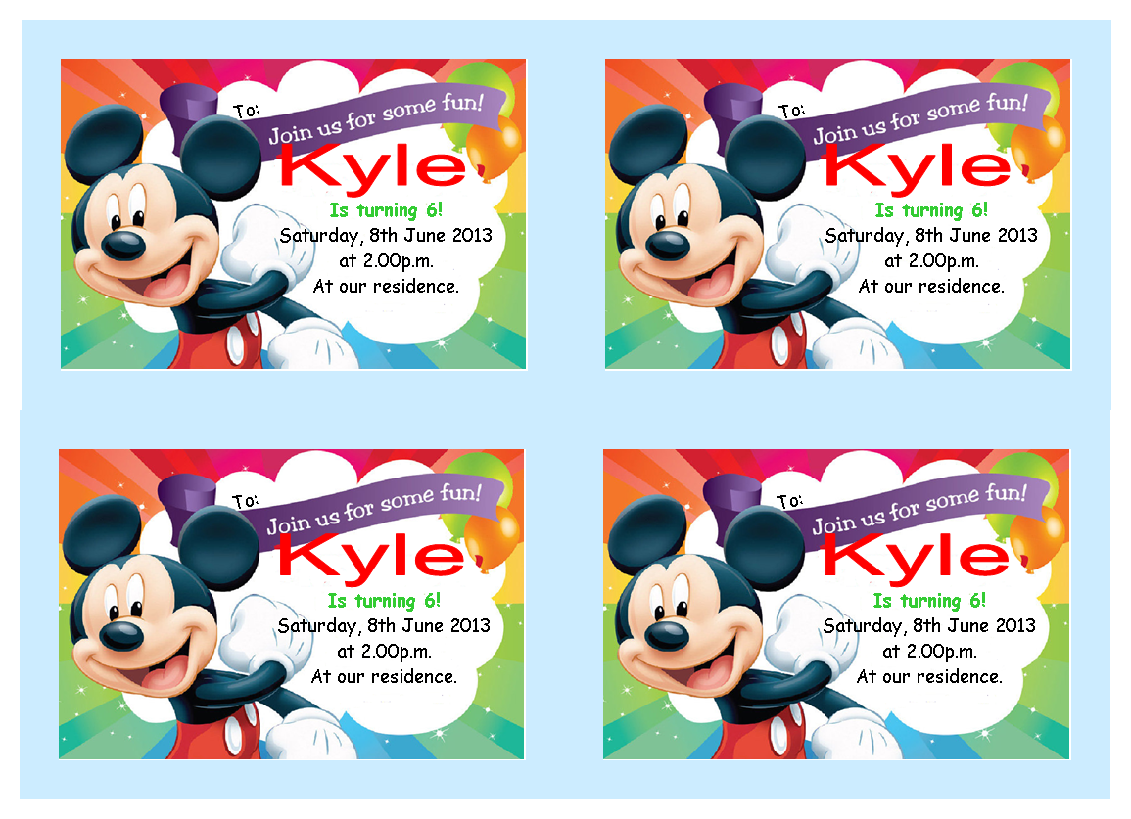

**QUESTION FOUR**

1. Highlight the capabilities which make Desktop publishing software superior to word processing software (10 Marks)
2. Define the following terms;
3. Crop a picture (3 Marks)
4. Text wrap (3 Marks)
5. Layering Object (3 Marks)
6. Text frame (1 Mark)

**QUESTION FIVE**

1. State the features of QuarkXpress and PageMaker as desktop publishing programs. (8 Marks)
2. Describe **TEN** publication checklist which you must adhere to for a good publication. . (12 Marks)