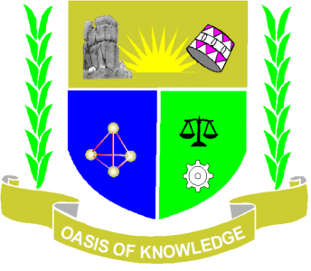

JARAMOGI OGINGA ODINGA UNIVERSITY OF SCIENCE ANDTECHNOLOGY
SCHOOL OF EDUCATION
UNIVERSITY EXAMINATION FOR THE DEGREE OF BACHELOR OF EDUCATION
4TH YEAR 2ND SEMESTER 2017 ACADEMIC YEAR
MAIN/UGUNJA SCHOOL BASED
COURSE CODE: EDC3421
COURSE TITLE: CHILD TRAUMA AND CRISIS INTERVENTION
EXAM VENUE: -- STREAM: ECDE
DATE:--- 12/17 EXAM SESSION:-- AM/PM
TIME: 2 HOURS

Instructions
- Answer Question ONE (COMPULSORY) and ANY other 2 questions
- Candidates are advised not to write on the question paper
- Candidates must hand in their answer booklets to the invigilator while in the examination room

QUESTION 1
- Give the meaning of the following
- Trauma (2marks)
- Natural disaster (2marks)
- Symptom (2marks)
b) Identify and explain three stages of trauma recovery (12marks)
c) What are the FOUR psychological symptoms of trauma. (4marks)
d) How would divorce of parent impact on a child. (8 marks)

QUESTION 2
Discuss the sources of trauma among children today. [20marks]
QUESTION 3
Identify and explain five signs and symptoms of a person suffering from trauma.
[20marks]
QUESTION 4
Discuss the ethical and legal issues considered in treating a traumatized child.
[20marks]
QUESTION 5
- Identify forms of natural disasters prevalent in Kenya. [4marks]
- Briefly discuss FOUR survival skills necessary in times of a natural disaster.
[16marks]

