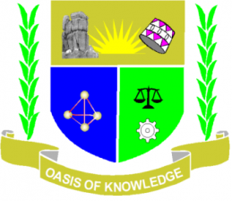

JARAMOGI OGINGA ODINGA UNIVERSITY OF SCIENCE AND TECHNOLOGY
SCHOOL OF EDUCATION
UNIVERSITY EXAMINATION FOR DEGREE OF BACHELOR OF EDUCATION ECDE
4TH YEAR 2ND SEMESTER 2017/18 ACADEMIC YEAR
MAIN CAMPUS / KENDU BAY LEARNING CENTER SCHOOL BASED

COURSE CODE: EHC 3224
COURSE TITLE: ROLE OF FAMILY IN CHANGING SOCIETY
EXAM VENUE:-- STREAM BED - ECDE
DATE: 21/12/17 EXAM SESSION: 9.00 – 11.00AM
TIME: 2 HOURS

Instruction:
1. Answer Question ONE (COMPULSORY) ANY other 2quetions
2. Candidates are advised not to write on the question paper
3. Candidates must hand in their answer booklets to the invigilator while in the examination room.

Questions
- Define the terms below
- Descent 2mks
- Family 2mks
- Resident 2mks
b) Explain four family roles in child upbringing. 8mks
c) Explain family as a system in child growth and development. 8mks
d) Discuss the perspective of the family in relation to role modeling. 8mks
- Discuss any two parenting styles stating their impacts on child growth and development. .. 20kms
- Explain how family violence affects potential achievement in young children.20mks
- As an ECDE expect, explain how you would address changes in the family system to help young children. 20mks
- a) Compare and contrast monogamous and polygamous family in relation to child growth or development. 10mks
b) Explain how residential patterns affect learning in young children. 10mks

