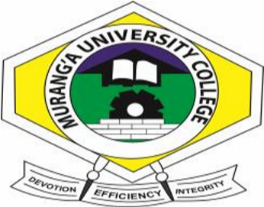

MURANG’A UNIVERSITY COLLEGE
(A constituent College of Jomo Kenyatta of Agriculture & Technology)

SCHOOL OF BUSINESS AND ECONOMICS

DEPARTMENT OF COMMERCE

TOWN CAMPUS

UNIVERSITY EXAMINATIONS
2014/2015 ACADEMIC YEAR
EXAM: END OF SEMESTER 2 EXAM
DIPLOMA IN BUSINESS MANAGEMENT
UNIT CODE : DBH 1215
UNIT TITLE : OCCUPATION HEALTH & SAFETY
SUPPLIMENTARY EXAMINATIONS
INSTRUCTIONS TO CANDIDATES TIME: 2HOURS
Answer question one and any other two questions

Q1a) Highlight Five work related causes or unsafe condition | (5marks)
b) Describe provision for ensuring health under factory act | (8marks)
c) In what ways did Second World War influence occupation health | (6marks)
d) Highlight objectives of occupation health service | (5marks)
e) Explain how hazards are recognized | (6marks)
 | Total (30marks)
Q2a) Describe how hazards are evaluated | (8marks)
b) Highlight ways you can control hazards | (8marks)
c) What does hazards do absorbed in the depend on | (6marks)
 | Total (20marks)
Q3a) Explain advantages of proper health of workers to an enterprise | (10marks)
b) Describe measures an organization would implement to ensure safety of its works (10marks)
Total (20marks)
Q4a) Light can have a phenomenon effect in work place
Explain advantages which occur to a firm which implement proper lighting
b) Explain hazards in the following classes
- Chemical
- Mechanical
- Biological
- Psychological (10marks)
Total (20marks)

